Batch: A3 Roll No.: 16010324044
Experiment / assignment / tutorial No. 10
Grade: AA / AB / BB / BC / CC / CD /DD

Signature of the Staff In-charge with date

Title: To design and simulate R-2R Ladder Network Digital to Analog Converter (DAC)

Objective:
- To design and implement 4-bit R-2R ladder DAC with Vref = 5V.

OUTCOME: Understand principle of Data Convertor

Theory (Derive the output voltage expression for 4-bit R-2R ladder network):
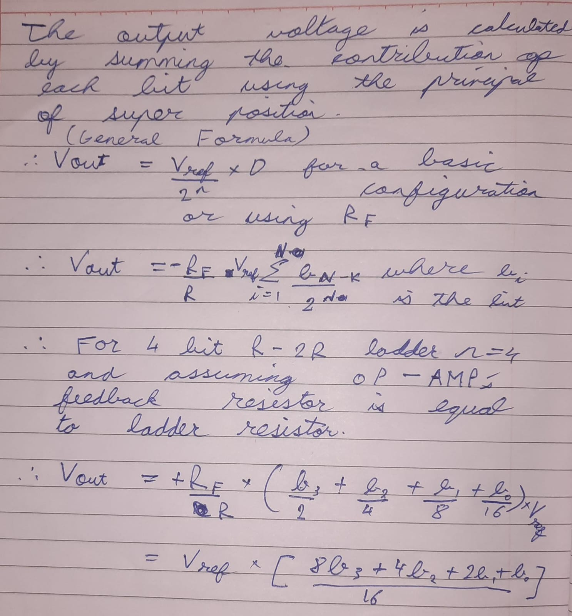
Procedure
- Design the 4-bit R-2R ladder DAC network.
- Take R = 10K, 2R = 20K and Vref = 5V.
- Implement the circuit using simulator
- Verify the theoretical and practical output voltage values for all combinations of binary input 0000 to 1111 and fill the observation table.
- Modify the circuit to get full scale voltage of -16V and verify the output voltage practically.
- Modify the circuit to 6-bit R-2R ladder DAC network. Calculate the output voltage for binary input 101100, if Rf = 2K, R = 1K and Vref = 5V.
- Write effective discussion/conclusion

Circuit Diagram
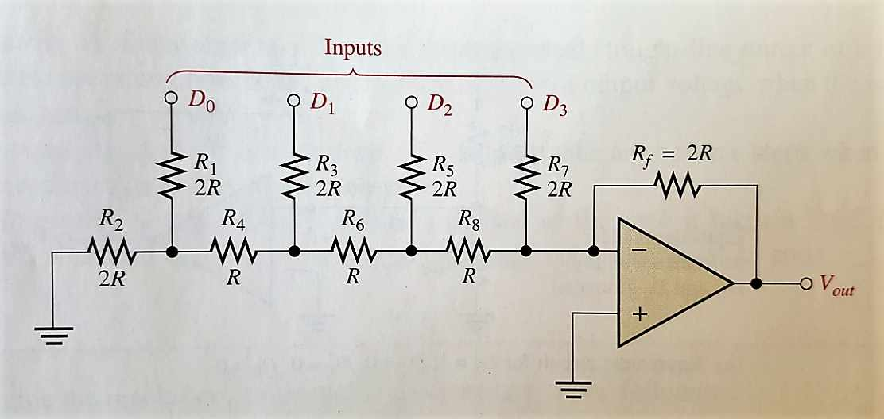

Observation Table
Decimal Equivalent of Binary Inputs | Digital Inputs |  |  |  | Theoretical Output Voltage | Practical Output Voltage
 | D3 (MSB) | D2 | D1 | D0 (LSB)
0 | 0 | 0 | 0 | 0 | 0 | 0
1 | 0 | 0 | 0 | 1 | -0.625 | -0.7
2 | 0 | 0 | 1 | 0 | -1.25 | -1.36
3 | 0 | 0 | 1 | 1 | -1.875 | -2.09
4 | 0 | 1 | 0 | 0 | -2.50 | -2.66
5 | 0 | 1 | 0 | 1 | -3.125 | -3.39
6 | 0 | 1 | 1 | 0 | -3.75 | -4.04
7 | 0 | 1 | 1 | 1 | -4.375 | -4.77
8 | 1 | 0 | 0 | 0 | -5 | -5.13
9 | 1 | 0 | 0 | 1 | -5.625 | -5.18
10 | 1 | 0 | 1 | 0 | -6.25 | -6.5
11 | 1 | 0 | 1 | 1 | -6.875 | -7.2
12 | 1 | 1 | 0 | 0 | -7.5 | -7.8
13 | 1 | 1 | 0 | 1 | -8.125 | -8.5
14 | 1 | 1 | 1 | 0 | -8.75 | -9.17
15 | 1 | 1 | 1 | 1 | -9.37 | -9.41

Conclusion
In this experiment, I learnt the R-2R Ladder DAC was successfully designed and simulated. The theoretical and practical results closely matched, confirming the linear relationship between digital input and analog output voltage. This experiment demonstrates the working principle of a Digital-to-Analog Converter and verifies accurate binary-to-analog conversion using resistor networks.

Signature of Faculty

