Batch: A3 Roll No.: 16010324044
Experiment / assignment / tutorial No.: 1
Grade: AA / AB / BB / BC / CC / CD /DD

Signature of the Staff In-charge with date

TITLE: Study of standard logic gates & Universal gates
AIM:
- To implement NOT,AND,OR gates using universal gates
- Implementation of 4 bit binary to Grey code converter using gates

OUTCOME: To solve problems in digital electronics with basic logic gates

ICs used: 7408,7432,7404,7400,7402,7486,74266
Procedure: Implement standard 2 bit input conditions for each type of two input logic gates and note down observations as per the observation table. Also measure input and output voltages for logic ‘1’ and logic ‘0’ conditions.
Draw the pin diagram of each IC used on left hand side page.
Implement each standard logic gate using universal gates: NAND and NOR
Standard symbols of Logic Gates
AND  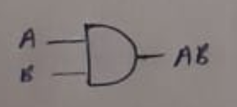 | OR  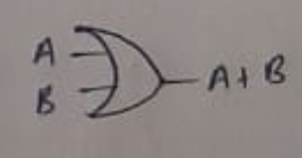 | NOT  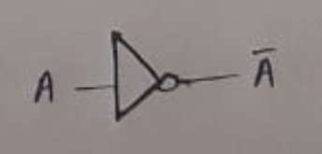 | NAND  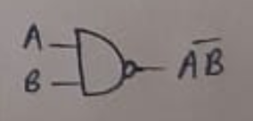
NOR  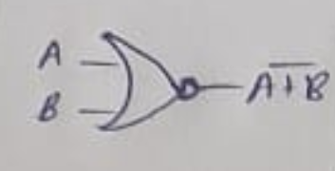 | EX-OR  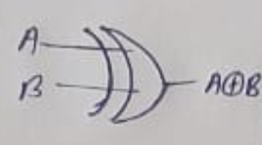 | EX-NOR  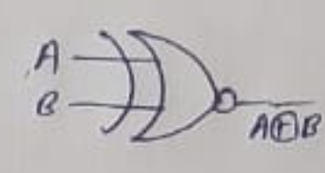

Implementation of standard Logic Gates using universal gate: NAND
AND  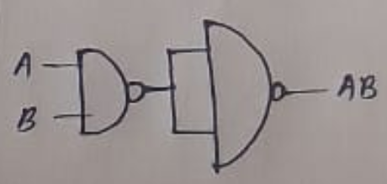 | OR  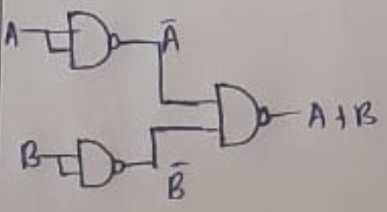 | NOT  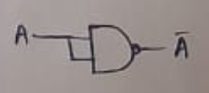

Implementation of standard Logic Gates using universal gate: NOR
AND  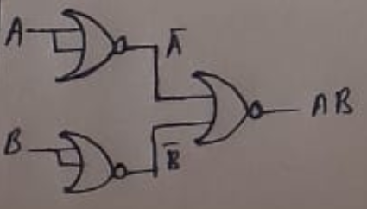 | OR  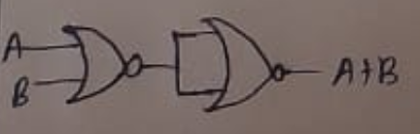 | NOT  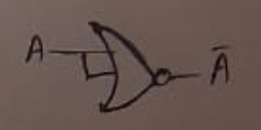

NOT Gate AND Gate
A | Y |  | A | B | Y
0 | 1 |  | 0 | 0 | 0
1 | 0 |  | 0 | 1 | 0
 |  |  | 1 | 0 | 0
 |  |  | 1 | 1 | 1

OR Gate NAND Gate
A | B | Y |  | A | B | Y
0 | 0 | 0 |  | 0 | 0 | 1
0 | 1 | 1 |  | 0 | 1 | 1
1 | 0 | 1 |  | 1 | 0 | 1
1 | 1 | 1 |  | 1 | 1 | 0

NOR Gate Ex-OR Gate
A | B | Y |  | A | B | Y
0 | 0 | 1 |  | 0 | 0 | 0
0 | 1 | 0 |  | 0 | 1 | 1
1 | 0 | 0 |  | 1 | 0 | 1
1 | 1 | 0 |  | 1 | 1 | 0

Implementation of 3 bit binary to Grey code converter using gates
Truth table Circuit diagram

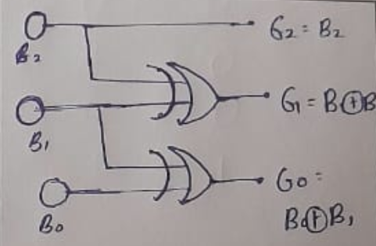
B2 | B1 | Bo | Grey code
0 | 0 | 0 | 000
0 | 0 | 1 | 001
0 | 1 | 0 | 011
0 | 1 | 1 | 010
1 | 0 | 0 | 110
1 | 0 | 1 | 111
1 | 1 | 0 | 101
1 | 1 | 1 | 100

Circuit diagram for Even parity Checker
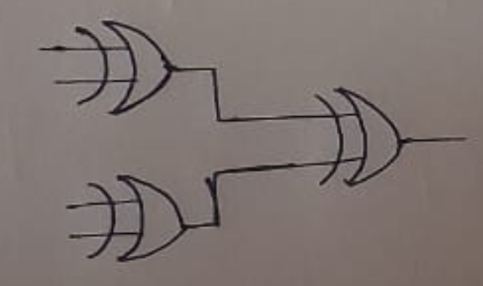

Conclusion
In this experiment, I learnt how to successfully implement standard logic gates and universal logic gates like NAND and NOR as well as the circuit design of Binary to Grey code converter.

