Batch: A3 Roll No.: 16010324044
Experiment / assignment / tutorial No.: 2
Grade: AA / AB / BB / BC / CC / CD /DD

Signature of the Staff In-charge with date

TITLE: :Binary adder and subtractor
AIM: To study and perform binary addition and binary subtraction using gates and IC 7483
OUTCOME: Design and implement combination logic circuits and their applications

ICs used: 7483,7404 (NOT gate)
- Procedure: Realize following combinational circuits using IC 7483, logic gates and verify truth table..
- 4 bit binary adder
- 4 bit Binary subtractor using 1’s complement method.
- 4 bit Binary subtractor using 2’s complement method.

4 bit binary adder

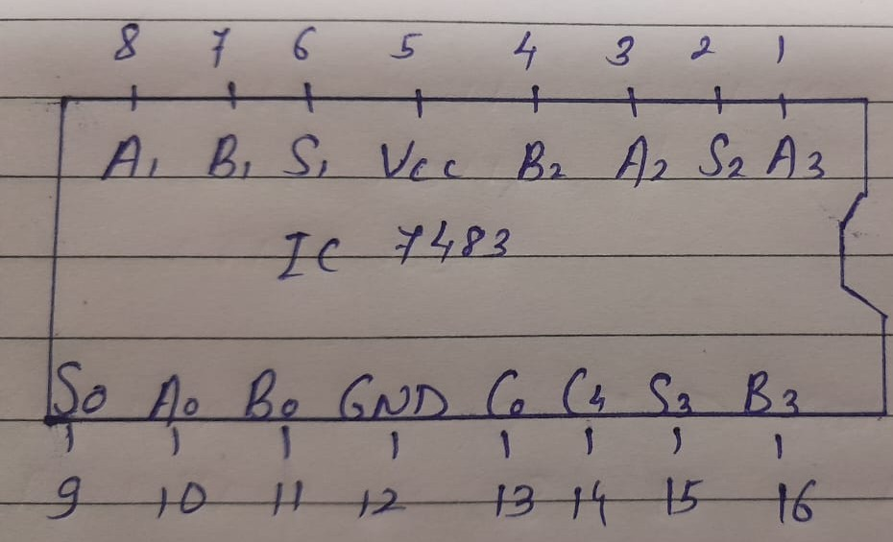

Verification for given examples:
7 + 6 = 0111
+0110
1101 = 13

Binary subtraction: Using 1’s complement method using IC 7483
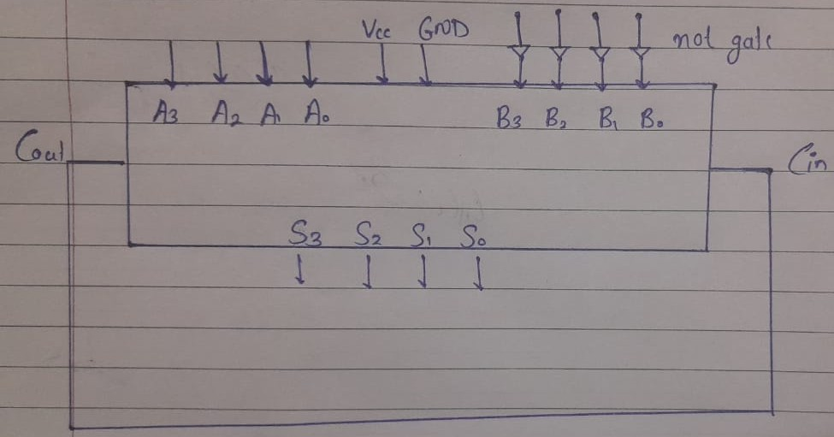

Verification for given examples:
(at least one example with positive subtraction and one with negative)
7 - 6 = 1
7 = 0111
6 = 0110
1’s complement of 6 = 1001
7 + (-6) = 0111
+1001
1 0000
+ 1
0001

6 - 7 = -1
6 = 0110
7 = 0111
1’s complement of 7 = 1000
6 + (-7) = 0110
+1000
1110
taking 1’s complement = 0001

Binary subtraction: Using 2’s complement method using IC 7483
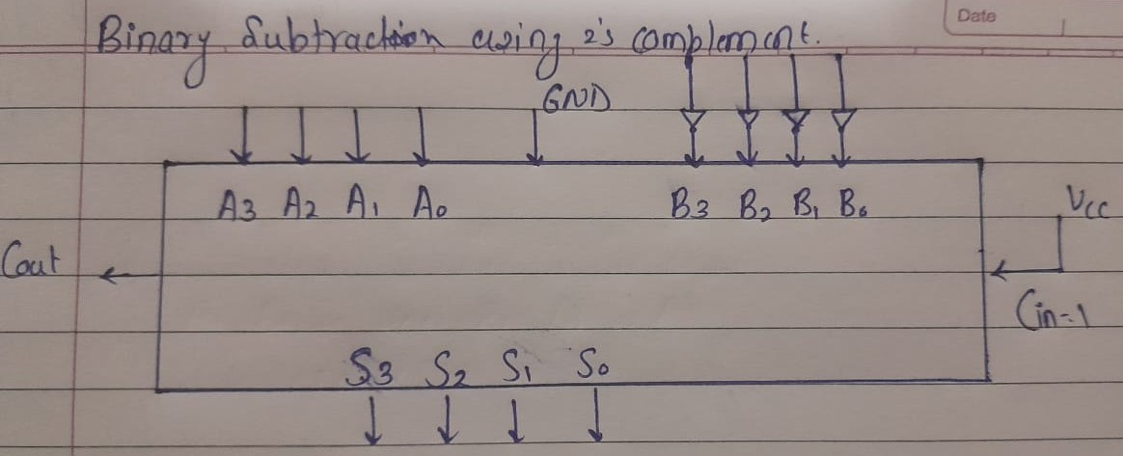

Verification for given examples:
(at least one example with positive subtraction and one with negative)
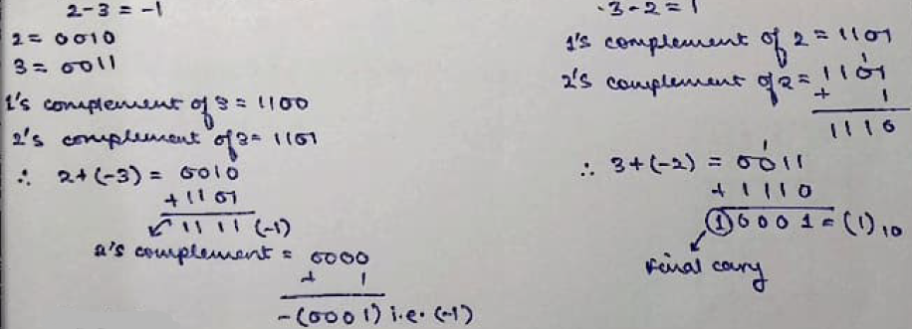
Conclusion:
In this experiment, I learnt binary concepts of addition and subtraction by 1’s and 2’s complement.

