Batch: A3 Roll No.: 16010324044
Experiment / assignment / tutorial No._______
Grade: AA / AB / BB / BC / CC / CD /DD

Signature of the Staff In-charge with date

TITLE: :Minimization and realization of logic function
AIM: To realize the given logic function using standard and universal gates
OUTCOME: Design and implement combination logic circuits and their applications

ICs used:
Procedure:
- Minimize given logic function using reduction techniques
- Using universal gates realize the minimized logic function and verify its truth table. Draw circuit diagram and note down observations in observation table.
Circuit diagram and observation table: Y= ( 0, 1, 2, 5 )
A | B | C | Y
0 | 0 | 0 | 1
0 | 0 | 1 | 1
0 | 1 | 0 | 1
0 | 1 | 1 | 0
1 | 0 | 0 | 0
1 | 0 | 1 | 1
1 | 1 | 0 | 0
1 | 1 | 1 | 0
Truth table

Y₁ = Σ m ( 0, 1, 2, 5 )
Implementation Using standard gates
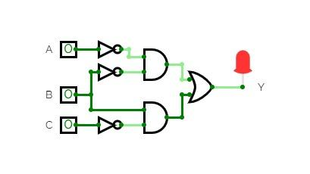

Implementation Using only NAND
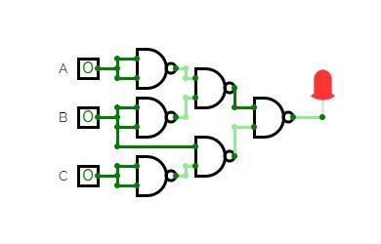
Truth table
Y2=Π M ( 3, 4, 6, 7 )
Y | 1 | 1 | 1 | 0 | 0 | 1 | 0 | 0
C | 0 | 1 | 0 | 1 | 0 | 1 | 0 | 1
B | 0 | 0 | 1 | 1 | 0 | 0 | 1 | 1
A | 0 | 0 | 0 | 0 | 1 | 1 | 1 | 1
(Use only NOR gates)
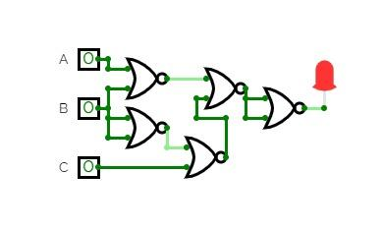
Conclusion:
In this experiment, I learnt how to minimize the given function using boolean algebra. I was successfully able to implement the minimized function using standard gates as well as NAND and NOR gates and verify the results with the truth table.
Roll No: 44 Signature of faculty in-charge with date

