Batch: A3 Roll No.: 16010324044
Experiment / assignment / tutorial No._______
Grade: AA / AB / BB / BC / CC / CD /DD

Signature of the Staff In-charge with date

TITLE: Multiplexer and Decoder
AIM: To study, design and implement logic functions using Multiplexer and Decoder
OUTCOME: Design and implement combinational logic circuits and their applications

ICs used:
Procedure:
- Realize following combinational logic circuits using IC 74151 and logic gates and verify the working by providing different combinations of inputs.
  - Using only one 8:1
- Realize following combinational logic circuits using IC 74138 and logic gates and verify the working by providing different combinations of inputs.

F₁ (A, B, C,D) = Σ m ( 1, 4, 5, 6, 9, 11, 15 ) using only one 8:1multiplexer
Circuit diagram
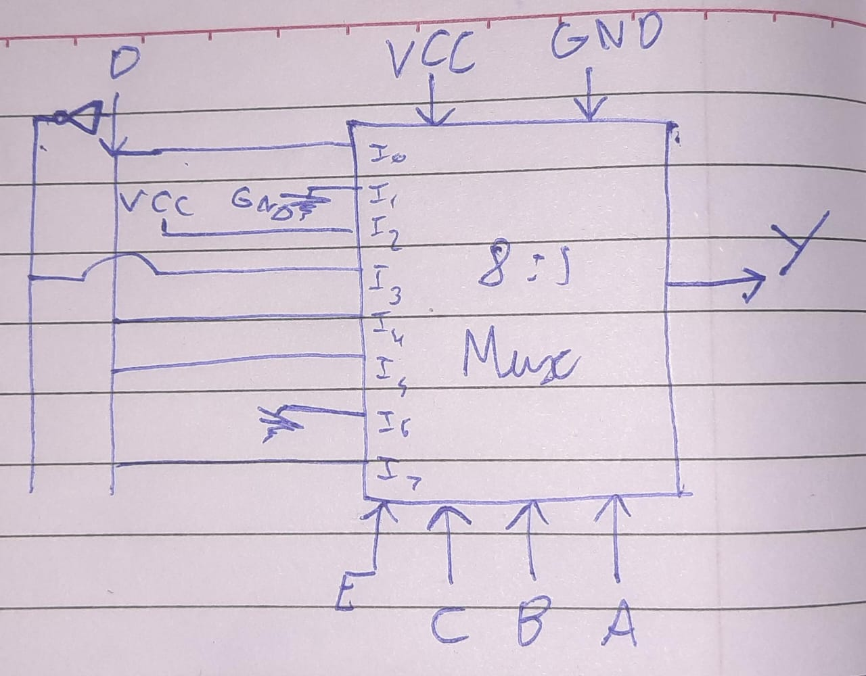
Truth Table
Y | D |  | 0 |  | 1 |  | D’ |  | D |  | D |  | 0 |  | D
A | 0 | 1 | 0 | 1 | 0 | 1 | 0 | 1 | 0 | 1 | 0 | 1 | 0 | 1 | 0 | 1
B | 0 | 0 | 1 | 1 | 0 | 0 | 1 | 1 | 0 | 0 | 1 | 1 | 0 | 0 | 1 | 1
C | 0 | 0 | 0 | 0 | 1 | 1 | 1 | 1 | 0 | 0 | 0 | 0 | 1 | 1 | 1 | 1
D | 0 | 0 | 0 | 0 | 0 | 0 | 0 | 0 | 1 | 1 | 1 | 1 | 1 | 1 | 1 | 1

Pin diagram of IC 74151
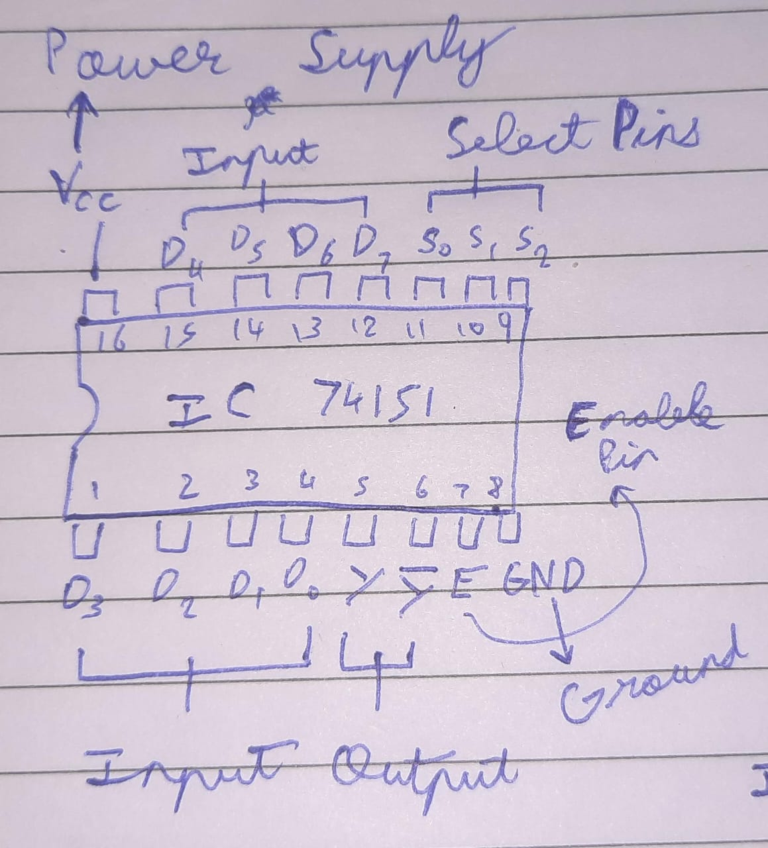
Pin diagram of IC 74138
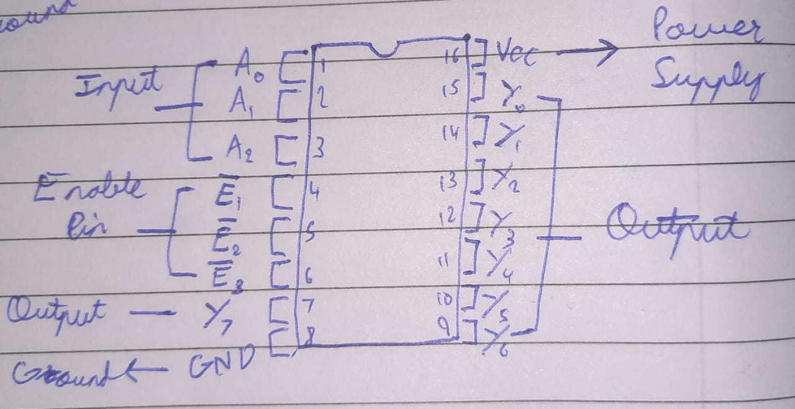

F₂= Σ m ( 0, 2, 4, 6, 7 ) using IC 74138 decoder
Circuit diagram using decoder
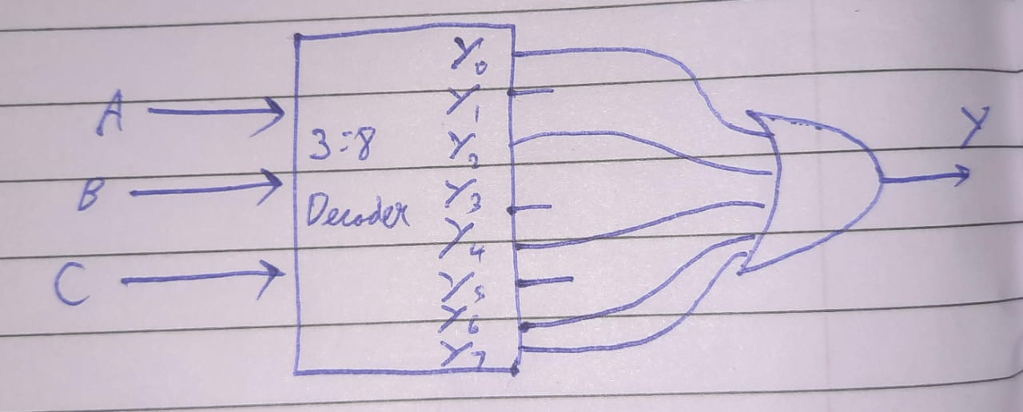

Truth Table
A | B | C | Y
0 | 0 | 0 | 1
0 | 0 | 1 | 0
0 | 1 | 0 | 1
0 | 1 | 1 | 0
1 | 0 | 0 | 1
1 | 0 | 1 | 0
1 | 1 | 0 | 1
1 | 1 | 1 | 1

Conclusion:
We have successfully designed and implemented the specified function using an 8:1 multiplexer. Additionally, we have implemented another given function using a 3:8 decoder. Afterward, we documented the output obtained from both implementations and included the pin diagrams for both the IC 74151 (Multiplexer) and the IC 74138 (Decoder).

Roll No: 16010324044 Signature of faculty in-charge with date

