Batch: A3 Roll No.: 16010324044
Experiment / assignment / tutorial No. 5
Grade: AA / AB / BB / BC / CC / CD /DD

Signature of the Staff In-charge with date

TITLE: Combinational circuits Design
AIM: To design and implement:
Two bit binary comparator using basic gates
Four bit binary comparator using IC 7485
OUTCOME: Design and implement combinational logic circuits and their applications

ICs used
Pin diagram- 4 bit magnitude comparator IC 7485 and function table
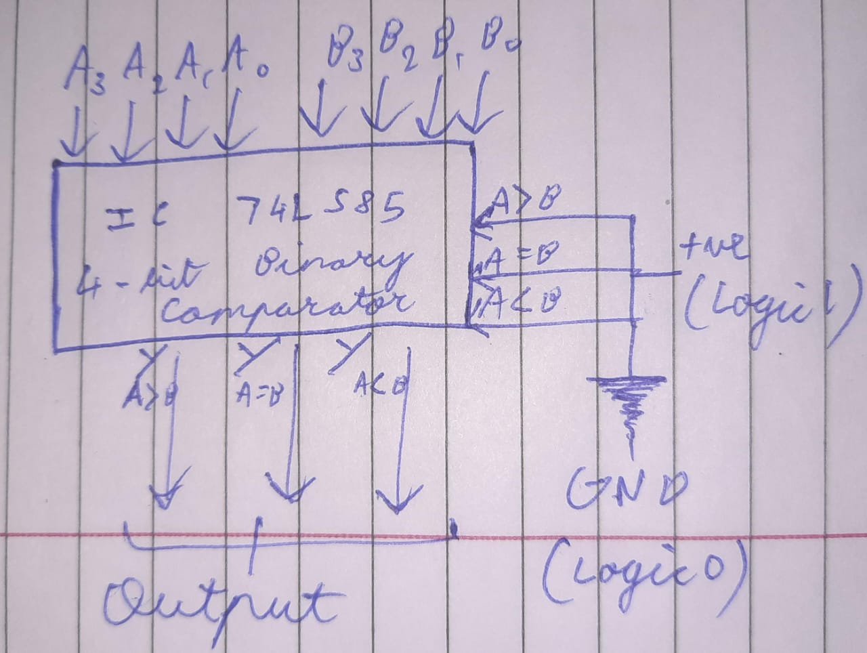

A |  |  |  | B |  |  |  | YA>B | YA=B | YA<B
A3 | A2 | A1 | Ao | B3 | B2 | B1 | Bo
1 | 0 | 0 | 0 | 0 | 0 | 1 | 0 | 1 | 0 | 0
0 | 1 | 0 | 0 | 0 | 1 | 0 | 0 | 0 | 1 | 0
0 | 0 | 1 | 0 | 1 | 0 | 0 | 0 | 0 | 0 | 1
0 | 1 | 0 | 0 | 0 | 0 | 1 | 0 | 1 | 0 | 0
0 | 0 | 1 | 0 | 0 | 1 | 0 | 0 | 0 | 0 | 1

Design of 2 bit comparator using basic gates
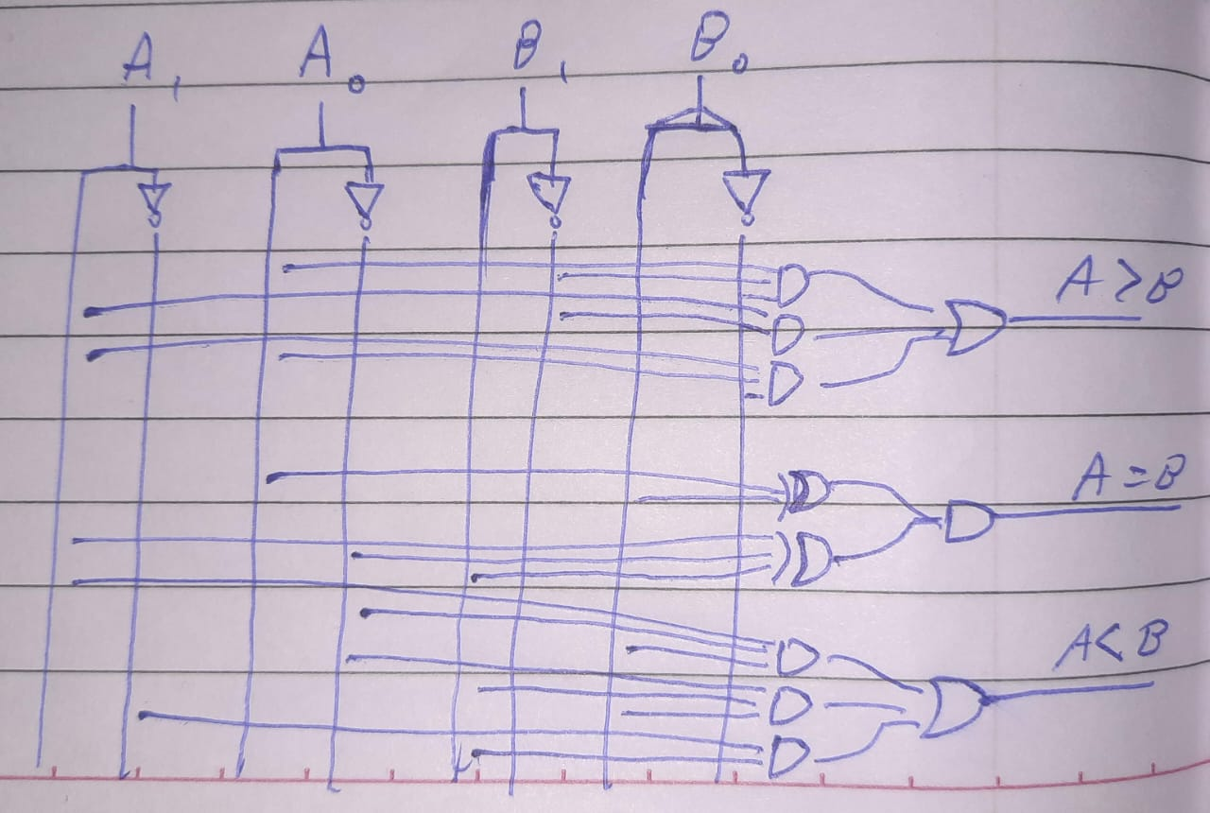
Circuit of 2 bit comparator using basic gates
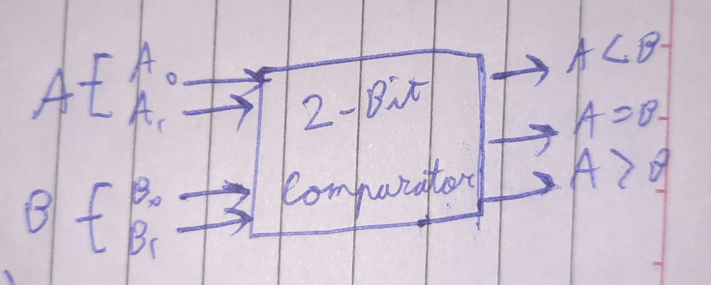

A |  | B |  | YA>B | YA=B | YA<B
A1 | Ao | B1 | Bo
0 | 1 | 1 | 0 | 0 | 0 | 1
0 | 0 | 0 | 0 | 0 | 1 | 0
1 | 0 | 0 | 1 | 1 | 0 | 0
0 | 0 | 1 | 1 | 0 | 0 | 1
1 | 1 | 0 | 0 | 1 | 0 | 0

Conclusion:
In this experiment, I have learnt about the IC 7485 ie. 4 bit comparator and how each bit is compared to check which number has greater magnitude

Roll No: 16010324044 Signature of faculty in-charge with date

