Batch: A3 Roll No.: 16010324044
Experiment / assignment / tutorial No. 6
Grade: AA / AB / BB / BC / CC / CD /DD

Signature of the Staff In-charge with date

TITLE: Study of Flip-Flops
AIM: Study of S-R , J-K, T and D flip-flops and their conversions with VLAB and using ICs
OUTCOME : Design and implement sequential logic circuits and their applications

Procedure:
- Study of Flip Flops using Virtual Lab
Using following link perform the experiment:
Virtual Labs (vlabs.ac.in)
Add the screen shorts of the circuits and the results here
- SR Flip Flop
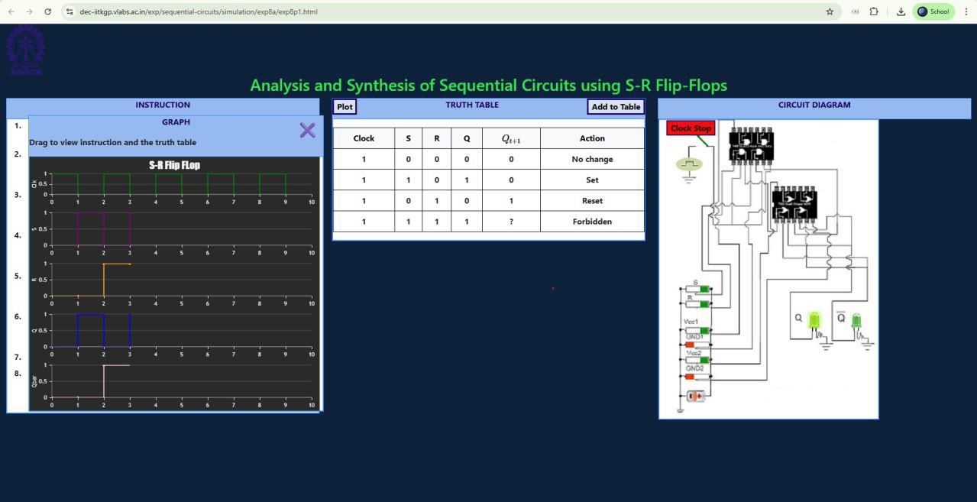
- JK Flip Flop

- D Flip Flop


- Realize following flip-flops using MSI ICs and verify their truth table as per the observation table.
  - SR flip flop using basic gates
  - JK flip flop using MSI IC
  - D flip Flop using JK FF MSI IC
  - T flip flop using JK FF MSI IC
- Verify the truth tables for following.
  - Implement T,D Flip-flops using JK Flip flop IC
Circuit diagram
CLK | S | R | Q
0 | X | X | No Change
↑ | 0 | 0 | No Change
↑ | 0 | 1 | 0 | 1
↑ | 1 | 0 | 1 | 0
↑ | 1 | 1 | Forbidden
SR Flip flop using gates Truth table
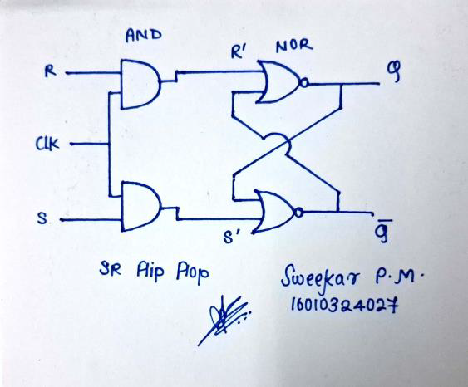

Pin diagram of IC Truth Table
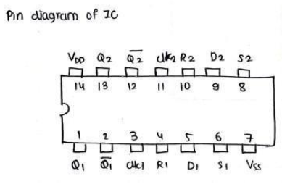
- IC

CLK | J | K | Pr | Clr | Q
↑ | 0 | 0 | 1 | 1 | 0 | 0
↑ | 0 | 0 | 1 | 1 | 1 | 1
↑ | 0 | 1 | 1 | 1 | 0 | 0
↑ | 0 | 1 | 1 | 1 | 1 | 0
↑ | 1 | 0 | 1 | 1 | 0 | 1
↑ | 1 | 0 | 1 | 1 | 1 | 1
↑ | 1 | 1 | 1 | 1 | 0 | 1
↑ | 1 | 1 | 1 | 1 | 1 | 0

Circuit diagram of JK Flip flop using gates

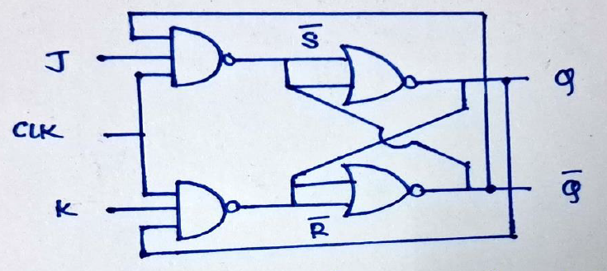

Circuit diagram of
D Flip flop using JK FF IC Truth Table
CLK | D | Q
0 | X | No Change
↑ | 0 | 0 | 0
↑ | 1 | 1 | 1
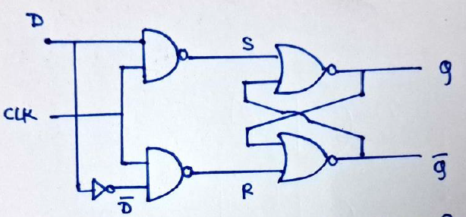

Circuit diagram
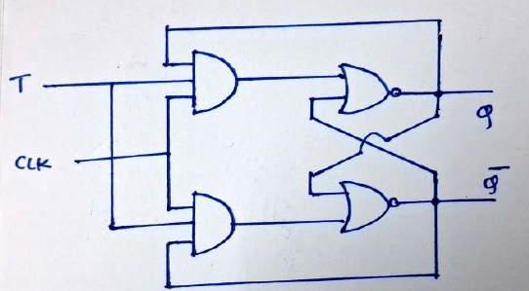
T Flip flop using JK FF IC Truth Table

CLK | T | Q
0 | X | No Change
↑ | 0 | Hold
↑ | 1 | Toggle

Conversion of Flip Flops
1 Convert D flip to T flip flop
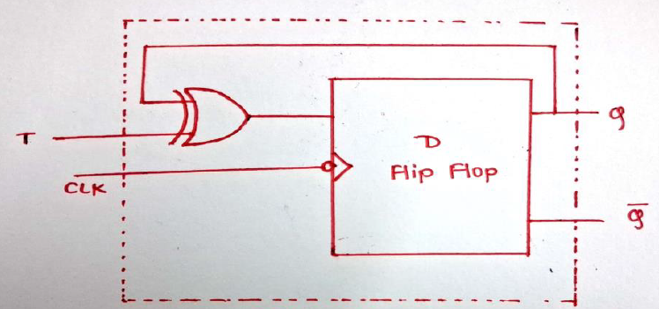

Conclusion:
In this experiment, I learnt how to design Sequential logic circuits and also design one from another and implemented them successfully. I learned that flip flops are building blocks of sequential circuits.

