Batch: A3 Roll No.: 16010324044
Experiment / assignment / tutorial No. 7
Grade: AA / AB / BB / BC / CC / CD /DD

Signature of the Staff In-charge with date

TITLE: Shift Registers
AIM: Design and implementation of shift registers using VLAB
OUTCOME: Design and implement sequential logic circuits and their applications

Design and Verify the 4-Bit Serial In - Parallel Out Shift Registers using VLAB

To analyse the circuit and truth table of 4-bit SIPO (serial input parallel output) shift register by using IC 7474 (D flip flop).

Procedure:
Use the following link to implement and verify the above circuit
Virtual Labs (vlabs.ac.in)
Screenshot of the diagram from VLAB
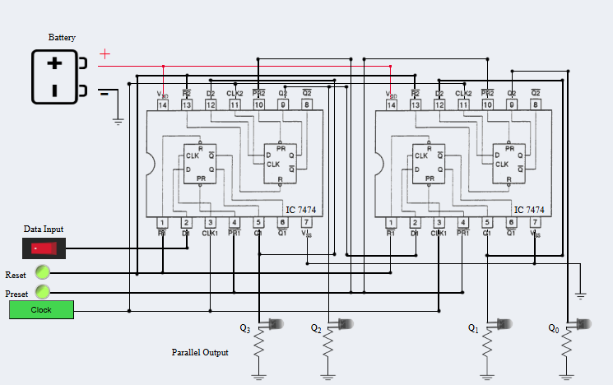

Screenshots of the results from VLAB
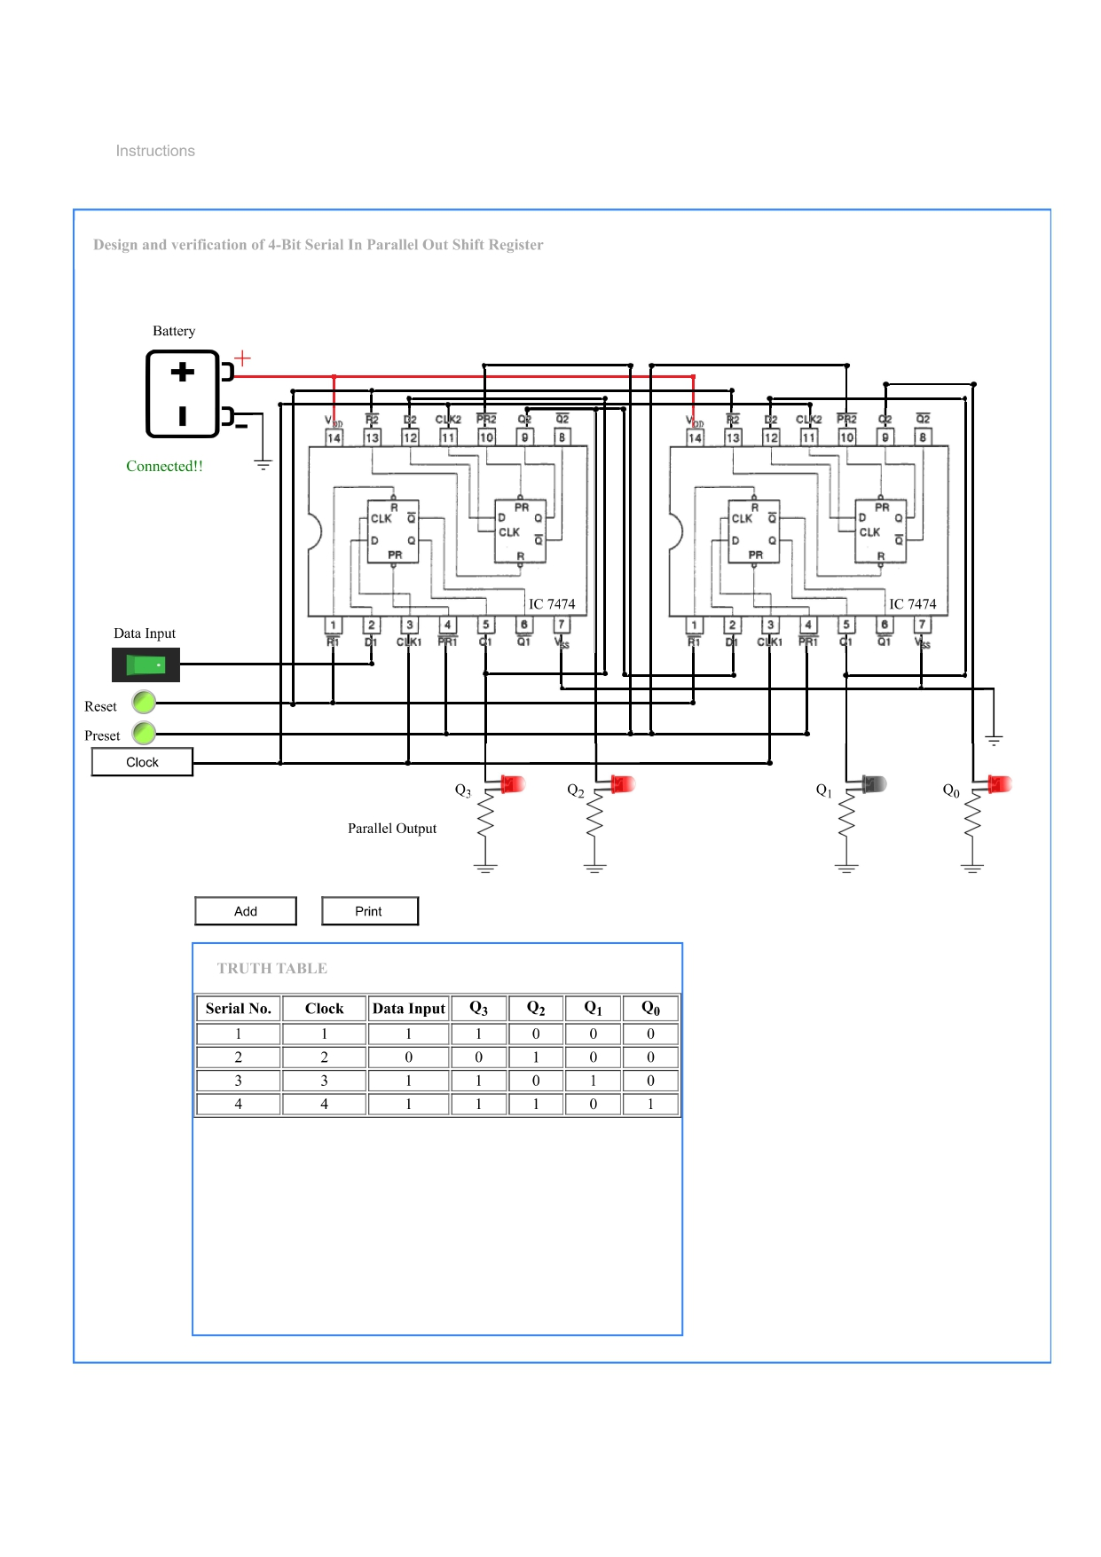
Truth Table: (For all 1s)

Serial No. | Clock | Data Input | Q3 | Q2 | Q1 | Q0
0 | - | - | 0 | 0 | 0 | 0
1 | ↑ | 1 | 1 | 0 | 0 | 0
2 | ↑ | 1 | 1 | 1 | 0 | 0
3 | ↑ | 1 | 1 | 1 | 1 | 0
4 | ↑ | 1 | 1 | 1 | 1 | 1

Conclusion:
In this experiment, I learnt how a 4-bit Serial-In Parallel-Out (SIPO) shift register takes in data, one bit at a time through the serial input at Q3 with every new clock pulse and shifts the previously stored bits one position to the right. After four clock pulses, all four bits of the input data are stored in the register and can be accessed together as the parallel output.

