Batch: A3 Roll No.: 16010324044
Experiment / assignment / tutorial No. 8
Grade: AA / AB / BB / BC / CC / CD /DD

Signature of the Staff In-charge with date

TITLE: Universal Shift Registers
AIM: : : Design and implementation of different modes of shift registers and application as counter using universal shift register MSI IC 74194 and SISO shift register using VLAB
OUTCOME: : Design and implement sequential logic circuits and their applications

ICs used:
Procedure:
1) 4) Study of 74194(4 bit universal shift register) and operate the various modes available
2) Left shift register using 74194 (4 bit universal shift register)
3) Right shift register
3) Parallel in parallel out shift register
4) Study of 74194(4 bit universal shift register) and operate the various modes available.
Pin diagram of IC 74194 and Function table

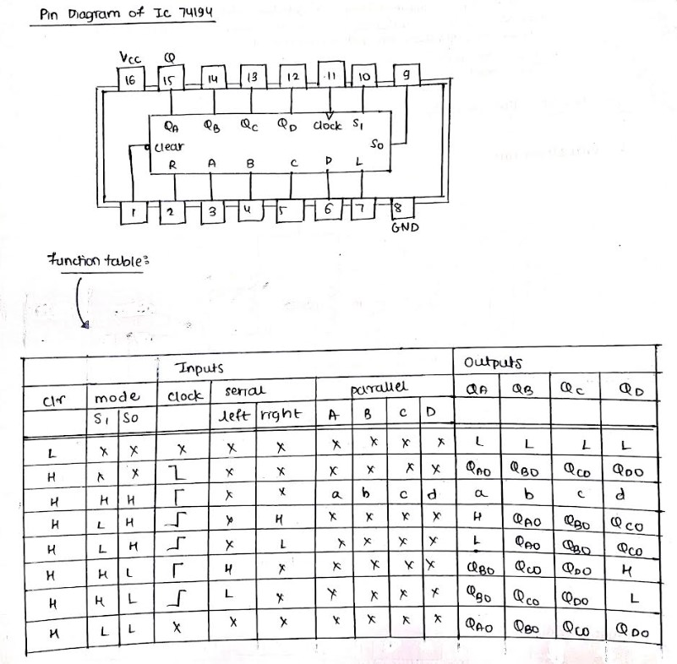
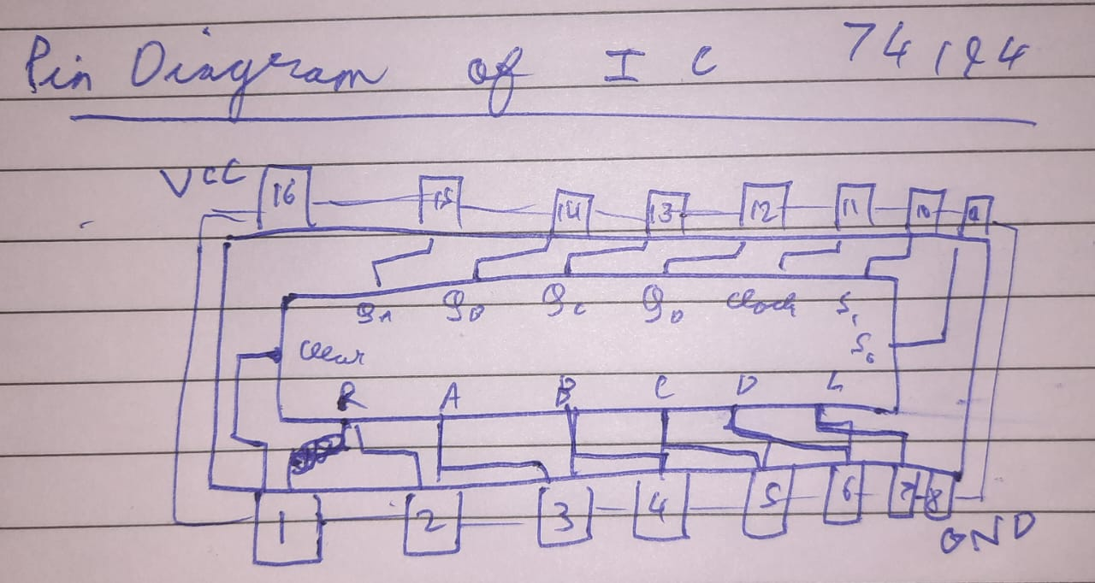

Circuit diagram: Serial left shift
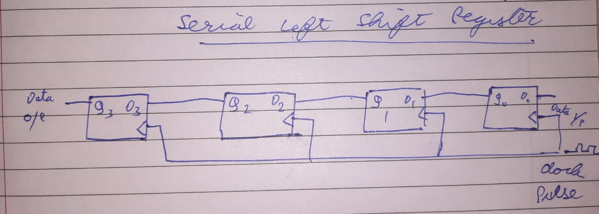

clk | A | B | C | D
0 | 0 | 0 | 0 | 0
1 | 0 | 0 | 0 | 1
2 | 0 | 0 | 1 | 1
3 | 0 | 1 | 1 | 0
4 | 0 | 0 | 0 | 1

Circuit diagram: Serial right shift
clk | A | B | C | D
0 | 0 | 0 | 0 | 0
1 | 1 | 0 | 0 | 0
2 | 1 | 1 | 0 | 0
3 | 0 | 1 | 1 | 0
4 | 1 | 0 | 1 | 1
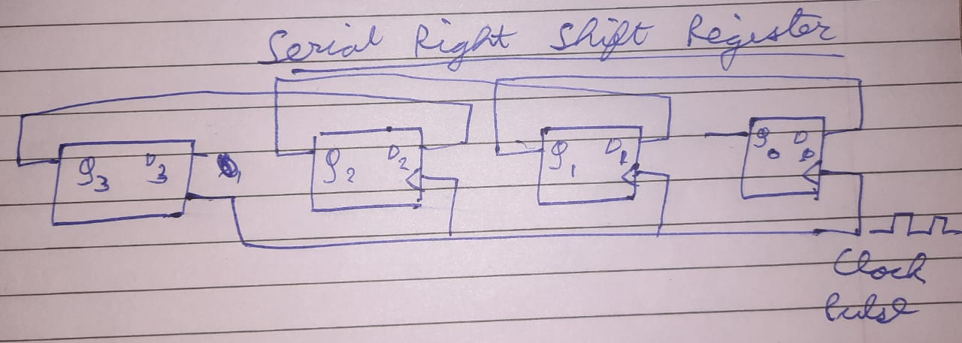

Parallel in Parallel out
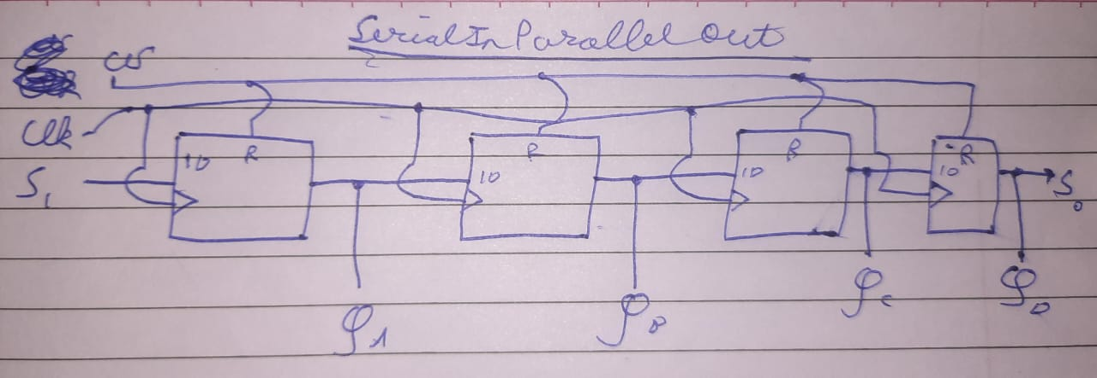

clk | QA | QB | QC | QD
0 | 0 | 0 | 0 | 0
1 | 1 | 1 | 0 | 1

Design and Verify the 4-Bit Serial In - Parallel Out Shift Registers using VLAB

To analyse the circuit and truth table of 4-bit SIPO (serial input parallel output) shift register by using IC 7474 (D flip flop).
Use the following link to implement and verify the above circuit
Virtual Labs (vlabs.ac.in)
Screenshot of the diagram from VLAB
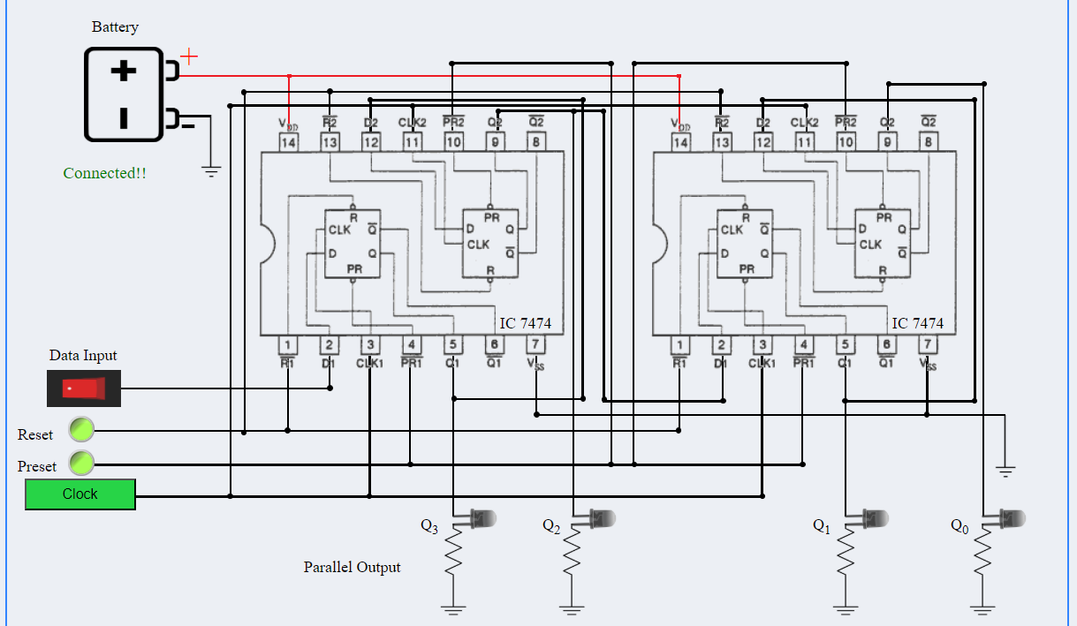
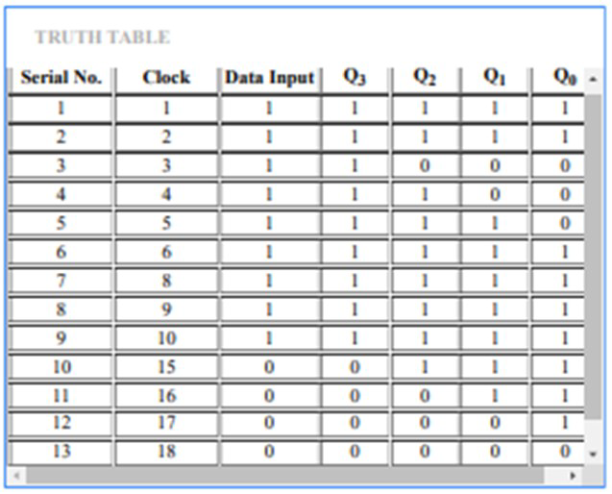

Conclusion:
Design and implementation of different modes of shift registers and application as counter
using universal shift register MSI IC 74194 and SISO shift register using VLAB Is completed
successfully. The desired outputs are verified.

