Batch: A3 Roll No.: 16010324044
Experiment / assignment / tutorial No. 9
Grade: AA / AB / BB / BC / CC / CD /DD

Signature of the Staff In-charge with date

TITLE: Asynchronous and Synchronous counters using VLAB

AIM: Design and verify the 4- Bit Synchronous/ Asynchronous Counter using JK flip flop using VLAB
OUTCOME: Design and implement sequential logic circuits and their applications

Link to be used:
Virtual Labs (vlabs.ac.in)
Procedure:
- Design and implement 3 bit up asynchronous counter using flip flops using VLAB
- Design and implement MOD n asynchronous counter using flip flops and additional gates if required and verify the working by application of clock.

Circuit diagram and observation table:
4 - bit up asynchronous counter using J-K flip flops
Screenshot of the circuit from VLAB
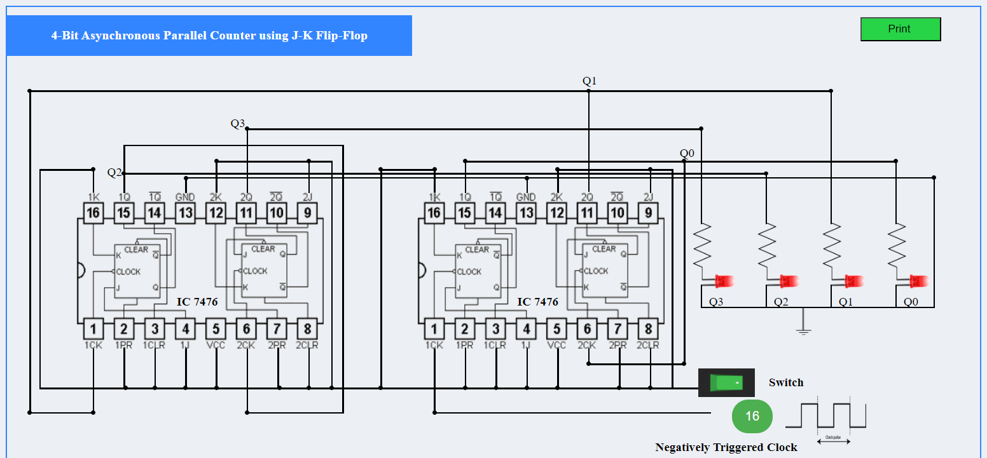

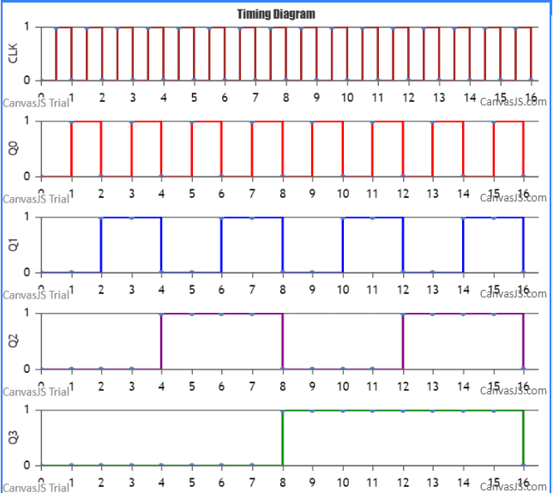
Observation table
Clk | Q3 | Q2 | Q1 | Q0
0 | X | X | X | X
1 | 0 | 0 | 0 | 0
2 | 0 | 0 | 0 | 1
3 | 0 | 0 | 1 | 0
4 | 0 | 0 | 1 | 1
5 | 0 | 1 | 0 | 0
6 | 0 | 1 | 0 | 1
7 | 0 | 1 | 1 | 0
8 | 0 | 1 | 1 | 1
9 | 1 | 0 | 0 | 0
10 | 1 | 0 | 0 | 1
11 | 1 | 0 | 1 | 0
12 | 1 | 0 | 1 | 1
13 | 1 | 1 | 0 | 0
14 | 1 | 1 | 0 | 1
15 | 1 | 1 | 1 | 0
16 | 1 | 1 | 1 | 1

4-Bit Synchronous counter using J-K flip flops

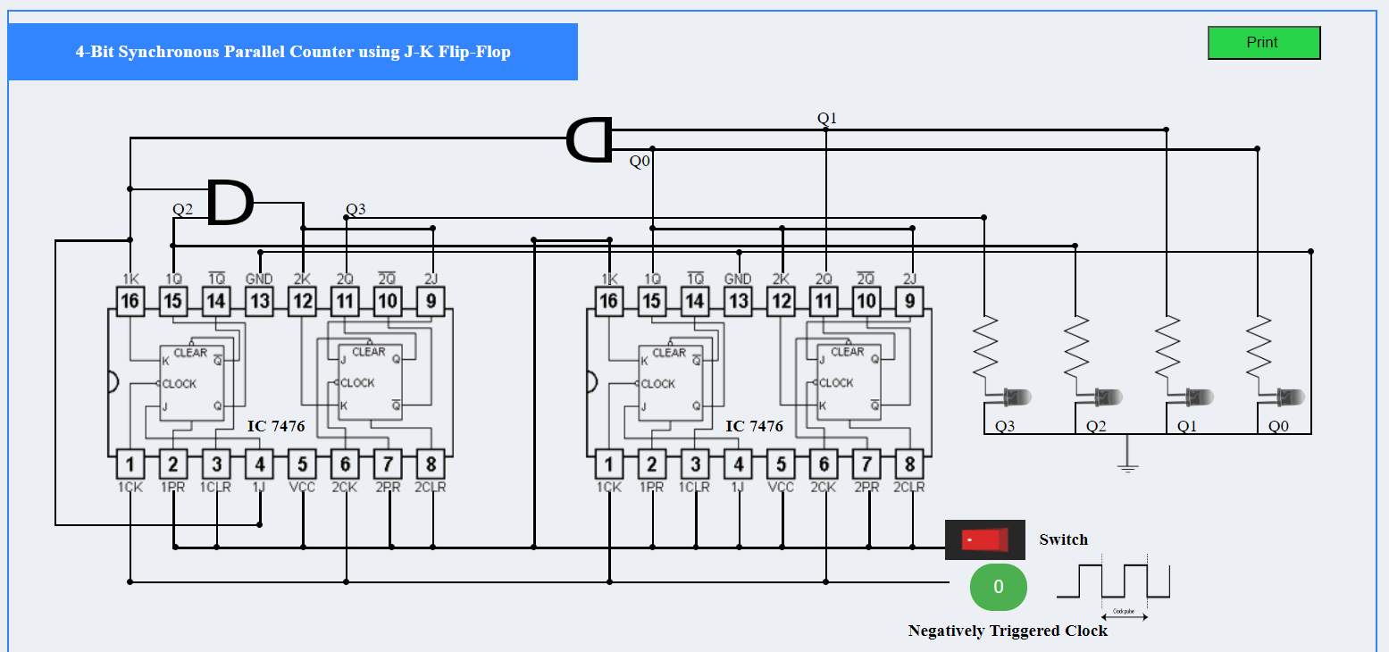

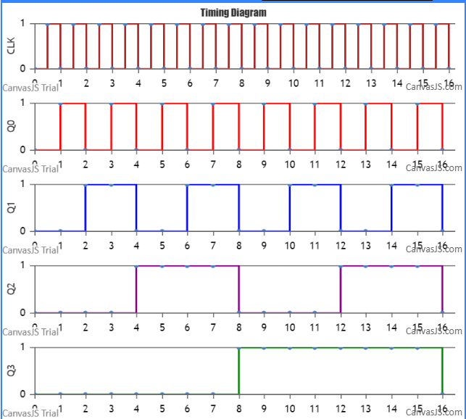

Clk | Q3 | Q2 | Q1 | Q0
0 | X | X | X | X
1 | 0 | 0 | 0 | 0
2 | 0 | 0 | 0 | 1
3 | 0 | 0 | 1 | 0
4 | 0 | 0 | 1 | 1
5 | 0 | 1 | 0 | 0
6 | 0 | 1 | 0 | 1
7 | 0 | 1 | 1 | 0
8 | 0 | 1 | 1 | 1
9 | 1 | 0 | 0 | 0
10 | 1 | 0 | 0 | 1
11 | 1 | 0 | 1 | 0
12 | 1 | 0 | 1 | 1
13 | 1 | 1 | 0 | 0
14 | 1 | 1 | 0 | 1
15 | 1 | 1 | 1 | 0
16 | 1 | 1 | 1 | 1

Conclusion:
The 4 - Bit Synchronous and Asynchronous Counter using JK flip flop using VLAB is designed and verified.

