
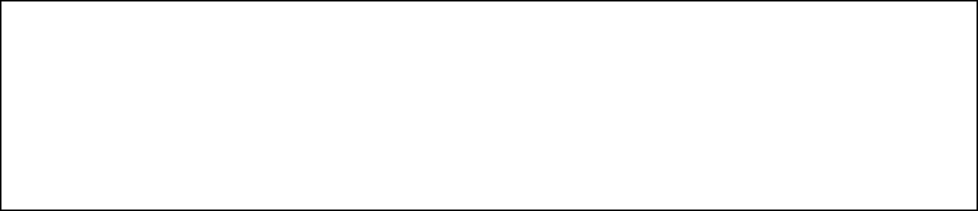

Title: WAP to form an array of elements, perform Sorting on it and analyze the performance of
Algorithm

AIM: To implement Bubble Sort using C & Python Programming
OUTCOME: Students will be able to recognize Performance evaluation for sorting techniques
Theoretical Background:
Batch: A3 Roll No.: 16010324044
Experiment / assignment / tutorial No. 1
Grade: AA / AB / BB / BC / CC / CD /DD

Signature of the Staff In-charge with date

Bubble Sort

Bubble sort is a very simple method that sorts the array elements by repeatedly moving the largest element to the highest index position of the array segment (in case of arranging elements in ascending order). In bubble sorting, consecutive adjacent pairs of elements in the array are compared with each other. If the element at the lower index is greater than the element at the higher index, the two elements are interchanged so that the element is placed before the bigger one. This process will continue till the list of unsorted elements exhausts.

This procedure of sorting is called bubble sorting because elements ‘bubble’ to the top of the list. Note that at the end of the first pass, the largest element in the list will be placed at its proper position (i.e., at the end of the list).

The basic methodology of the working of bubble sort is given as follows:

In Pass 1, A[0] and A[1] are compared, then A[1] is compared with A[2], A[2] is compared with A[3], and so on. Finally, A[N–2] is compared with A[N–1]. Pass 1 involves n–1 comparisons and places the biggest element at the highest index of the array.

In Pass 2, A[0] and A[1] are compared, then A[1] is compared with A[2], A[2] is compared with A[3], and so on. Finally, A[N–3] is compared with A[N–2]. Pass 2 involves n–2 comparisons and places the second biggest element at the second highest index of the array.

In Pass 3, A[0] and A[1] are compared, then A[1] is compared with A[2], A[2] is compared with A[3], and so on. Finally, A[N–4] is compared with A[N–3]. Pass 3 involves n–3 comparisons and places the third biggest element at the third highest index of the array.

In Pass n–1, A[0] and A[1] are compared so that A[0]<A[1]. After this step, all the elements of the array are arranged in ascending order

Problem statement 1: Sort given array of data in increasing order using bubble sort and write its worst case time complexity.

Code:

C:
#include <stdio.h>
int main()
{
int i, j, swap, n, arr[10];
printf("Enter the number of elements in array:\n");
scanf("%d",&n);
printf("Enter the elements:\n");
for(i=0;i<n;i++)
{
scanf("%d", &arr[i]);
}
for(i=0;i<n;i++)
{
for(j=0;j<n-1-i;j++)
{
if(arr[j] > arr[j+1])
{
swap = arr[j];
arr[j] = arr[j+1];
arr[j+1] = swap;
}
}
}
printf("\n The array sorted in ascending order is:\n");
for(i=0;i<n;i++)
{
printf("%d ", arr[i]);
}
return 0;
}

Python:
n = int(input("Enter the number of elements in array:\n"))

arr = []
print("Enter the elements:")
for i in range(n):
num = int(input())
arr.append(num)

for i in range(n):
for j in range(n - 1 - i):
if arr[j] > arr[j + 1]:
swap = arr[j]
arr[j] = arr[j + 1]
arr[j + 1] = swap

print("\nThe array sorted in ascending order is:")
for i in range(n):
print(arr[i], end=' ')

Problem statement 2: Give time complexity Analysis for bubble sort? Explain.
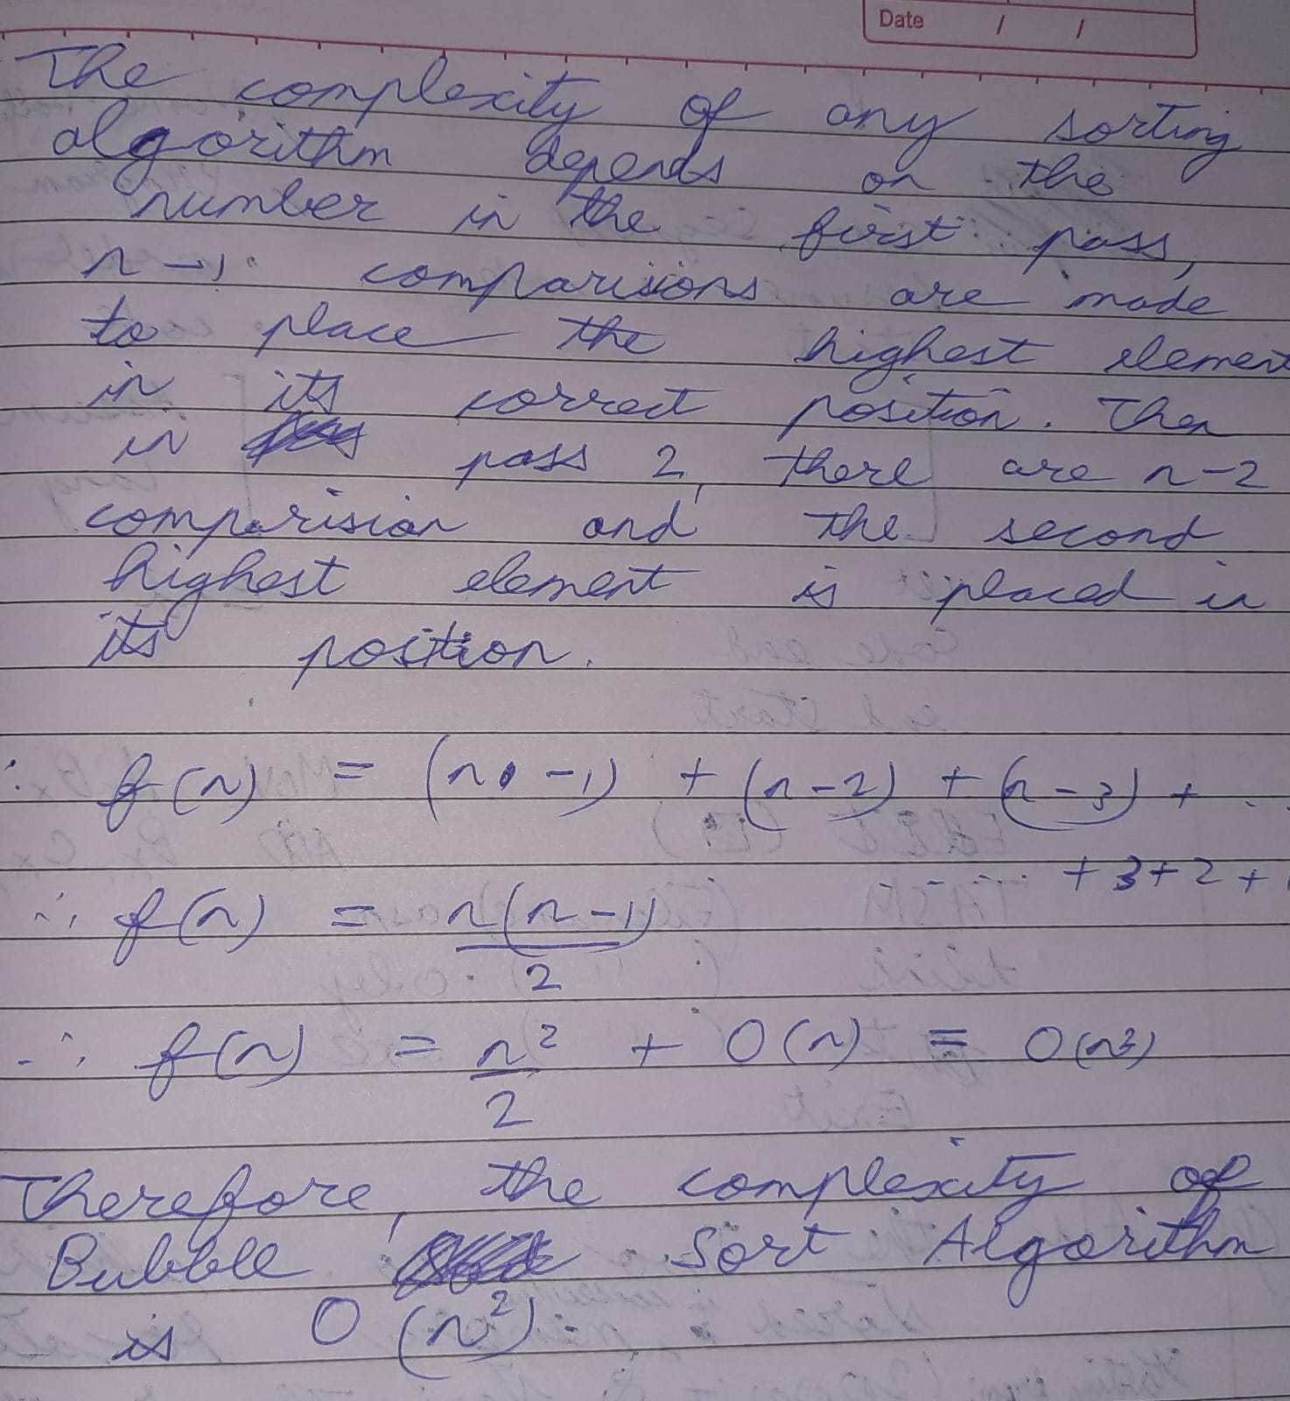

Screenshot of Output:
C:
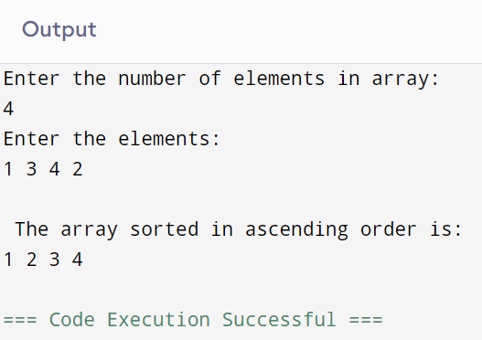

Python:
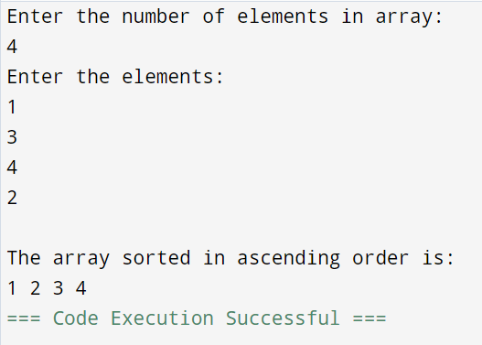

Conclusion
- Understood the working of Bubble sort and to program it in C and python

Signature of the faculty in charge

