
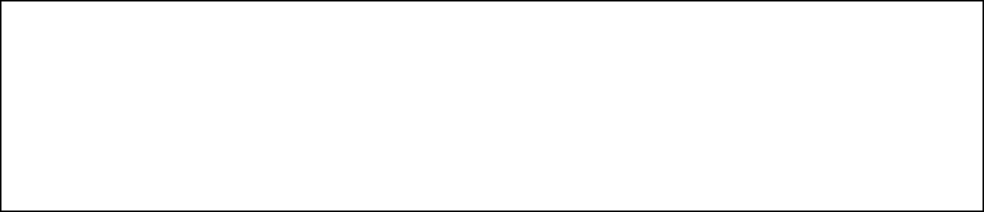
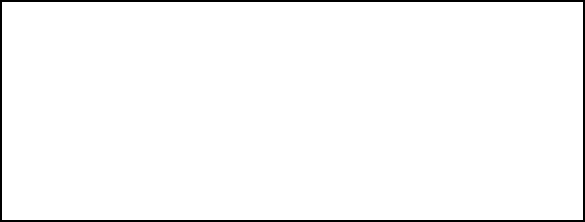

Title: WAP to form an array of elements, perform Insertion and Selection Sorting on it and analyze the performance of Algorithm

Objective: To implement Insertion Sort using C & Python Programming
OUTCOME: Students will be able to recognize Performance evaluation for sorting techniques
Theoretical Background:

Batch: A3
Roll No.: 16010324044
Experiment / assignment / tutorial No.: 2 Grade: AA / AB / BB / BC / CC / CD /DD
Signature of the Staff In-charge with date

Insertion Sort:

This algorithm considers the elements one at a time, inserting each in its suitable place among those already considered (keeping them sorted). Insertion sort is an example of an incremental algorithm. It builds the sorted sequence one number at a time. This is a suitable sorting technique in playing card games.

Selection sort is a simple and efficient sorting algorithm that works by repeatedly selecting the smallest (or largest) element from the unsorted portion of the list and moving it to the sorted portion of the list.
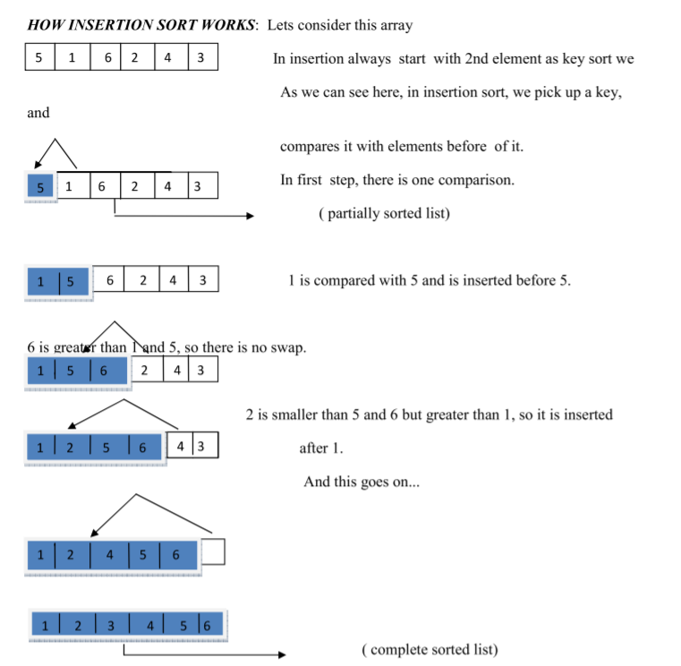

Problem statement 1: Sort given array of data in increasing order using insertion sort and write its worst case time complexity

Code in C:
#include <stdio.h>

int main() {
int arr[] = {9, 5, 4, 3, 2, 1};
int n = sizeof(arr) / sizeof(arr[0]);

for (int i = 1; i < n; i++) {
int current = arr[i];
int j = i - 1;

while (j >= 0 && arr[j] > current) {
arr[j + 1] = arr[j];
j--;
}

arr[j + 1] = current;
}

printf("Sorted array:\n");
for (int i = 0; i < n; i++) {
printf("%d ", arr[i]);
}

return 0;
}

Code in Python:
arr = [9, 5, 4, 3, 2, 1]
n = len(arr)

for i in range(1, n):
current = arr[i]
j = i - 1

while j >= 0 and arr[j] > current:
arr[j + 1] = arr[j]
j -= 1

arr[j + 1] = current

print("Sorted array:")
print(arr)

Analysis of Algorithm:

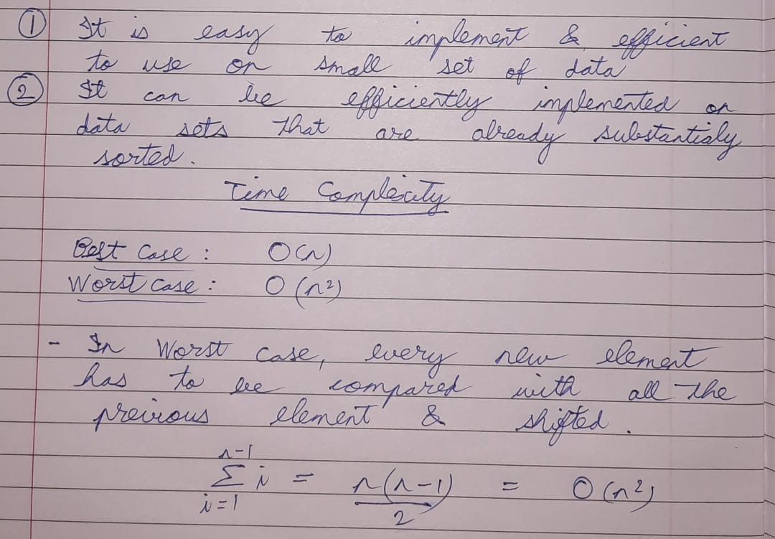

Problem statement 2: Which sorting algorithm among Bubble sort and Insertion sort is having less time complexity for nearly sorted data? Explain.

- Insertion sort has less time complexity than bubble sort for nearly sorted data.
Insertion sort: the sorted list is made with one item at a time and only one or few comparisons are made per pair. Best Case: O(n)
Bubble sort: repeatedly sorts every pair even if they might be in correct order. Best Case: O(n^2)

Screenshot of Output:
C:
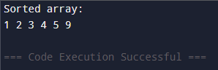

Python:
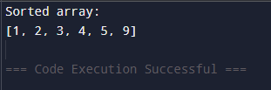

Conclusion:
I learnt to implement insertion sort and how it’s different to bubble sort in C and Python programming.

Signature of the faculty incharge

