Batch: Roll No.: 16010324044
Experiment / assignment / tutorial No.: 3
Grade: AA / AB / BB / BC / CC / CD /DD
Signature of the Staff In-charge with date

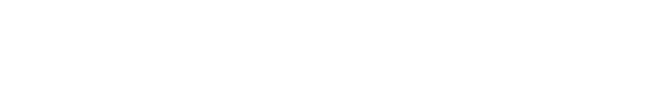


Title: Stack Implementation using arrays
Objectives: Perform Push, Pop and Display operations on a Stack using C & Python programming.
OUTCOME: Use of different data structures and select appropriate data structure for the given application

Theoretical Background:
Stack:
A stack is a linear data structure in which insertion and deletion of elements are done at only one end, which is known as the top of the stack. Stack is called a last-in, first-out (LIFO) structure because the last element which is added to the stack is the first element which is deleted from the stack. In the computer’s memory, stacks can be implemented using arrays or linked lists. Figure shows the array implementation of a stack. Every stack has a variable top associated with it. Top is used to store the address of the topmost element of the stack. It is this position from where the element will be added or deleted. There is another variable MAX, which is used to store the maximum number of elements that the stack can store. If top = NULL, then it indicates that the stack is empty and if top = MAX–1, then the stack is full.

44 | 70 | 56 | 57 | 22

0
1
2
3
Top= 4

In Figure, top = 4, so insertions and deletions will be done at this position. A stack supports two basic operations: push, pop. The push operation adds an element to the top of the stack. The pop operation removes the element from the top of the stack. However, before inserting an element in the stack, we must check for overflow conditions. An overflow occurs when we try to insert an element into a stack that is already full. Similarly, before deleting an element from the stack, we must check for underflow conditions. An underflow condition occurs when we try to delete an element from a stack that is already empty.
Operations:
- Push
- Pop
- Peek
- Display

- Algorithm for push:
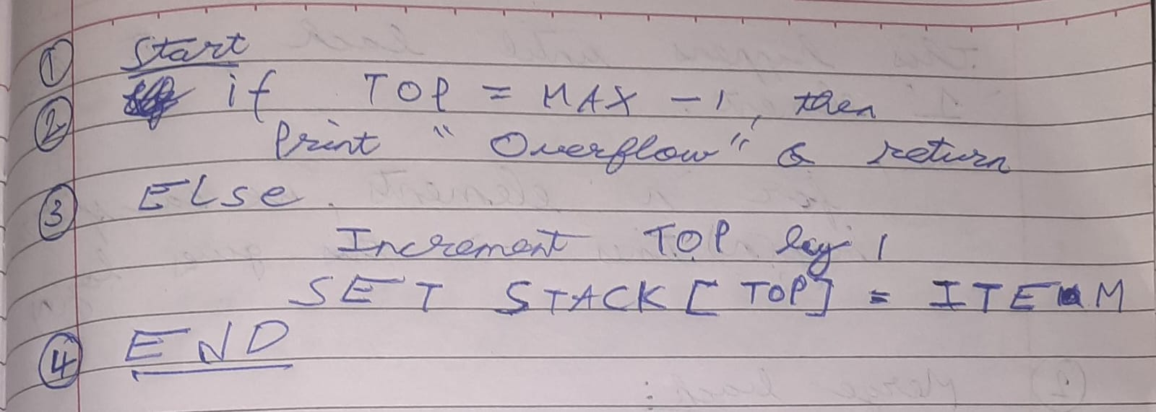
- Algorithm for pop
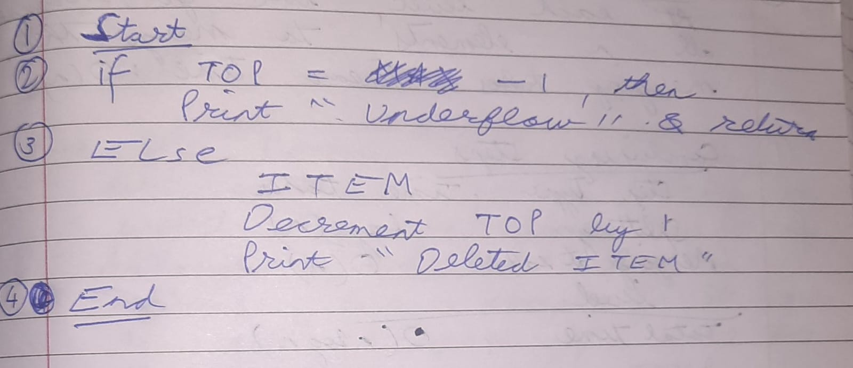

Code:
In C:
#include<stdio.h>
#define MAX 5

int stack[MAX], top = -1;

void push(int item) {
if (top == MAX - 1) {
printf("Stack Overflow\n");
} else {
stack[++top] = item;
printf("%d pushed to stack\n", item);
}
}

void pop() {
if (top == -1) {
printf("Stack Underflow\n");
} else {
printf("%d popped from stack\n", stack[top--]);
}
}

void peek() {
if (top == -1) {
printf("Stack Underflow\n");
} else {
int item = stack[top-1];
printf("%d peeked from stack\n", item);
}
}

void display() {
if (top == -1) {
printf("Stack is empty\n");
} else {
printf("Stack elements are: ");
for (int i = top; i >= 0; i--)
printf("%d ", stack[i]);
printf("\n");
}
}

int main() {
push(1);
push(2);
push(3);
display();
pop();
peek();
pop();
push(5);
display();
return 0;
}

In Python:
MAX = 5
stack = []

def push(item):
if len(stack) == MAX:
print("Stack Overflow")
else:
stack.append(item)
print(item," pushed to stack")

def pop():
if not stack:
print("Stack Underflow")
else:
item = stack.pop()
print(item," popped from stack")

def peek():
if not stack:
print("Stack Underflow")
else:
item = stack[len(stack)-1]
print(item," peeked from stack")

def display():
if not stack:
print("Stack is empty")
else:
print("Stack: ", stack[::1])

push(1)
push(2)
push(3)
display()
pop()
peek()
pop()
push(5)
display()

Algorithm analysis:
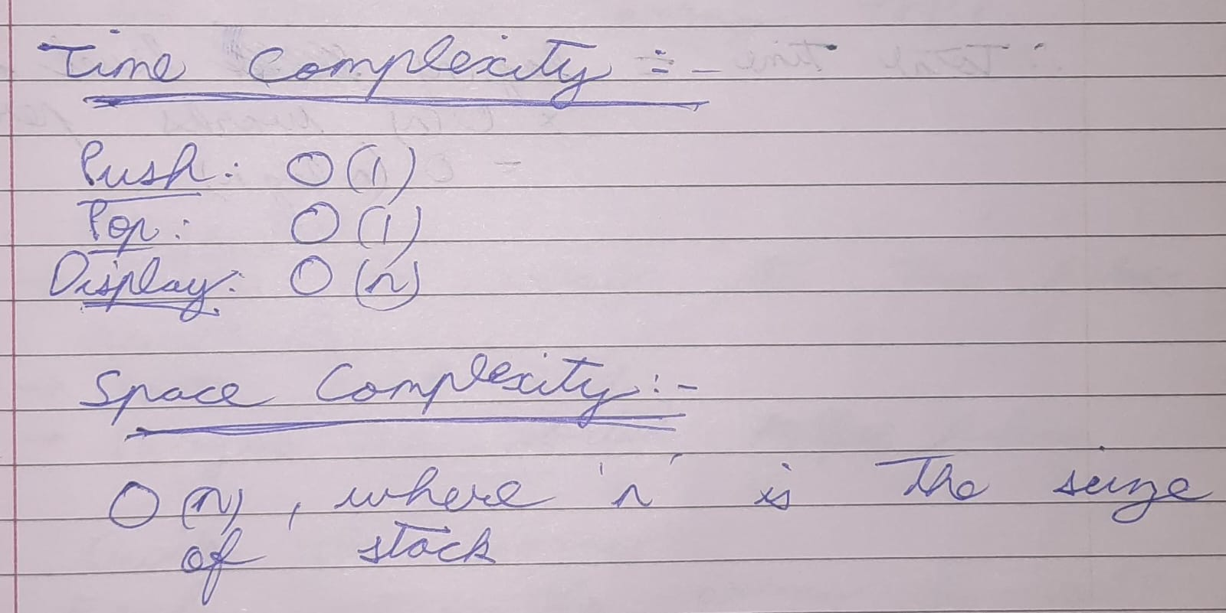

Output:
In C:
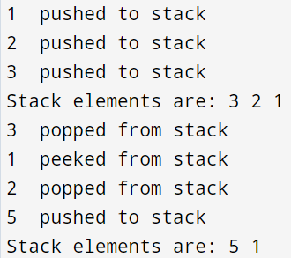
In Python:
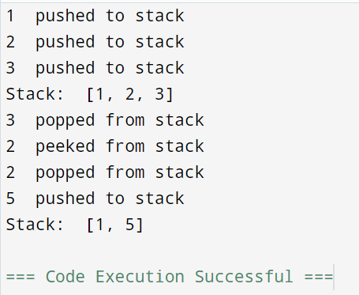

Conclusion:
In this exp, I learnt about Stack which is based on the LIFO (Last In First Out) principle. I implemented stack operations such as push, pop, peek and display in C and Python programming.
The analysis shows that stack operations are very efficient with constant time complexity - O(1), for insertion, peeking and deletion.

Signature of faculty in-charge

