

Batch: A3
Roll No.: 16010324044
Experiment / assignment / tutorial No. 4 Grade: AA / AB / BB / BC / CC / CD /DD
Signature of the Staff In-charge with date




Title: WAP to form an array of elements, perform Sorting on it and analyze the performance of
Algorithm

Objectives: To implement Merge Sort using C and Python programming.
OUTCOME: Students will be able to analyze the complexity involved in merge sort

Theoretical Background:

Merge sort is a sorting algorithm that uses the divide, conquer, and combine algorithmic paradigm.

Divide means partitioning the n-element array to be sorted into two sub-arrays of n/2 elements. If A is an array containing zero or one element, then it is already sorted. However, if there are more elements in the array, divide A into two sub-arrays, A1 and A2, each containing about half of the elements of A.
Conquer means sorting the two sub-arrays recursively using merge sort.
Combine means merging the two sorted sub-arrays of size n/2 to produce the sorted array of n elements.
Merge sort algorithm focuses on two main concepts to improve its performance (running time):
- A smaller list takes fewer steps and thus less time to sort than a large list.
- As number of steps is relatively less, thus less time is needed to create a sorted list from two sorted lists rather than creating it using two unsorted lists.
The basic steps of a merge sort algorithm are as follows:
- If the array is of length 0 or 1, then it is already sorted.
- Otherwise, divide the unsorted array into two sub-arrays of about half the size.
- Use merge sort algorithm recursively to sort each sub-array.
- Merge the two sub-arrays to form a single sorted list.
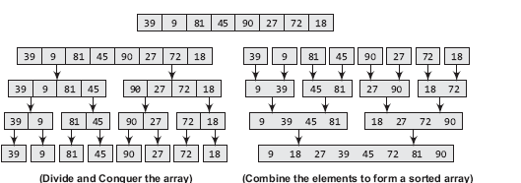

K. J. Somaiya College of Engineering, Mumbai-77
(Autonomous College Affiliated to University of Mumbai)

Algorithm:
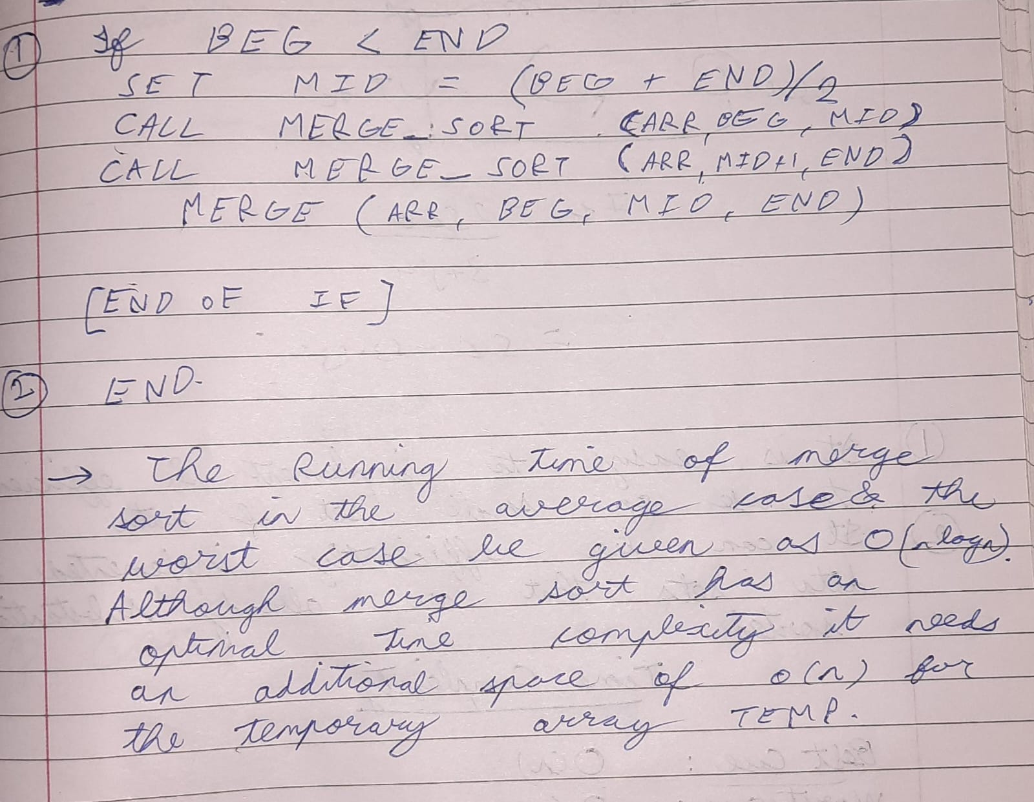

Analysis of Algorithm
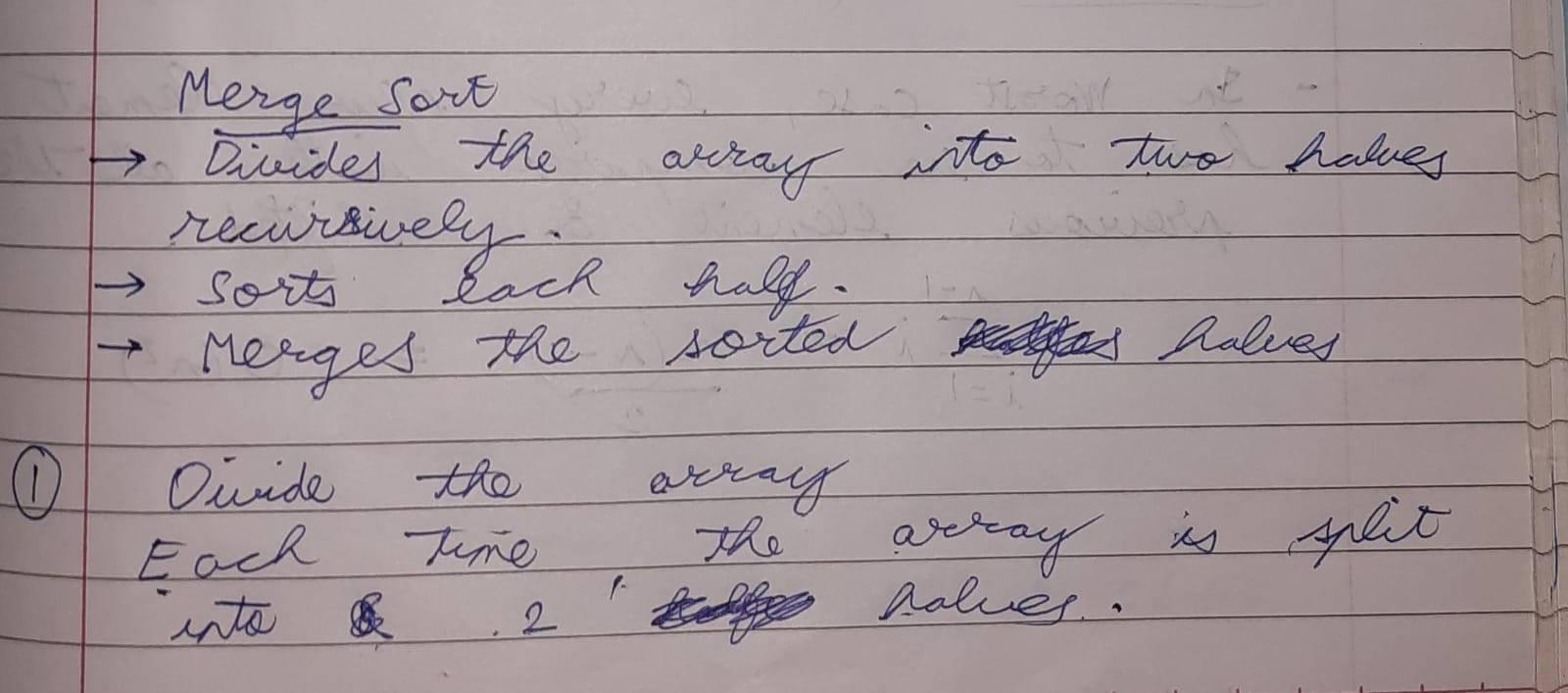
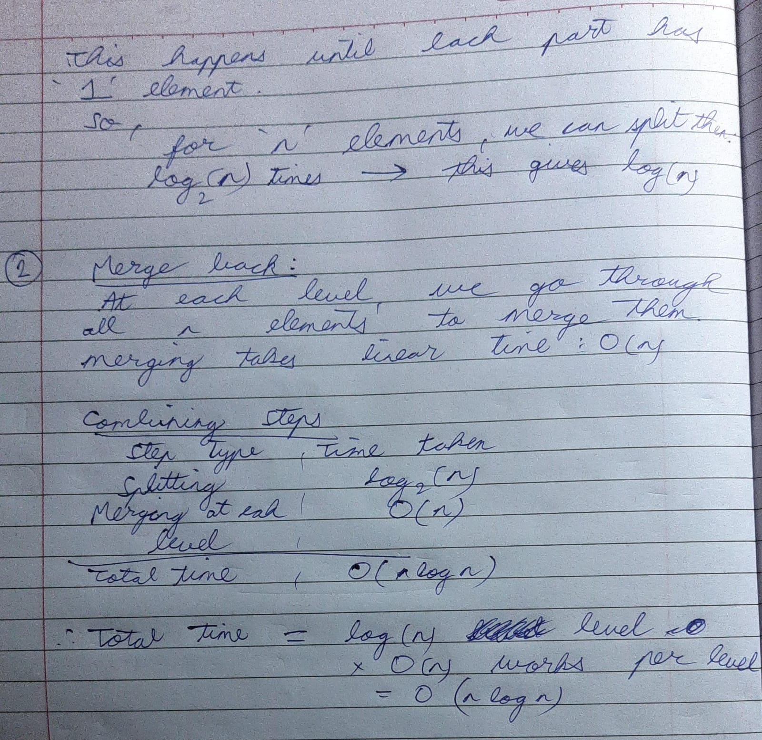

Code:
C:
#include <stdio.h>

int main() {
int list[] = {5, 2, 9, 1};
int n = 4;

for (int size = 1; size < n; size *= 2) {
for (int start = 0; start < n - 1; start += 2 * size) {
int mid = start + size - 1;
if (mid >= n) mid = n - 1;
int end = (start + 2 * size - 1 < n) ? (start + 2 * size - 1) : (n - 1);

int leftLen = mid - start + 1;
int rightLen = end - mid;
int left[10], right[10];

for (int i = 0; i < leftLen; i++)
left[i] = list[start + i];
for (int i = 0; i < rightLen; i++)
right[i] = list[mid + 1 + i];

int i = 0, j = 0, k = start;
while (i < leftLen && j < rightLen) {
if (left[i] <= right[j])
list[k++] = left[i++];
else
list[k++] = right[j++];
}
while (i < leftLen)
list[k++] = left[i++];
while (j < rightLen)
list[k++] = right[j++];
}
}

printf("Sorted list:\n");
for (int i = 0; i < n; i++)
printf("%d ", list[i]);
return 0;
}

Python:

lst = [9, 5, 2, 4, 3, 1]

n = len(lst)

size = 1

while size < n:

start = 0

while start < n - 1:

mid = min(start + size - 1, n - 1)

end = min(start + 2 * size - 1, n - 1)

left = lst[start:mid+1]

right = lst[mid+1:end+1]

i = j = 0

k = start

while i < len(left) and j < len(right):

if left[i] <= right[j]:

lst[k] = left[i]

i += 1

else:

lst[k] = right[j]

j += 1

k += 1

while i < len(left):

lst[k] = left[i]

i += 1

k += 1

while j < len(right):

lst[k] = right[j]

j += 1

k += 1

start += 2 * size

size *= 2

print("Sorted list:")

print(lst)

Output:

C:

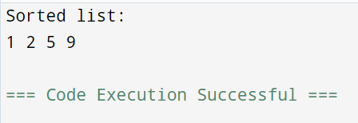

Python:
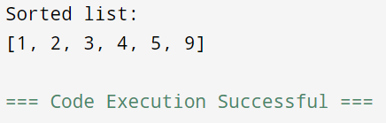

Conclusion:
I learnt the working of merge sort and also a little about space complexity in C and Python programming.

Signature of faculty incharge

