Batch: A3 Roll No.: 16010324044
Experiment / assignment / tutorial No._______
Grade: AA / AB / BB / BC / CC / CD /DD
Signature of the Staff In-charge with date



Title: Linear and Binary search
Objectives: Perform Search operations using arrays and implement in C & Python.
OUTCOME: Use of different data structures and select appropriate data structure for the given application

Theoretical Background:
Linear Search Algorithm:--
Linear Search is defined as a sequential search algorithm that starts at one end and goes through each element of a list until the desired element is found, otherwise the search continues till the end of the data set.
How Does Linear Search Algorithm Work?
In Linear Search Algorithm,
Every element is considered as a potential match for the key and checked for the same.
If any element is found equal to the key, the search is successful and the index of that element is returned.
If no element is found equal to the key, the search yields “No match found”.
Binary Search Algorithm:---

Binary Search is defined as a searching algorithm used in a sorted array by repeatedly dividing the search interval in half. The idea of binary search is to use the information that the array is sorted and reduce the time complexity to O(log N).
Binary Search Algorithm:--
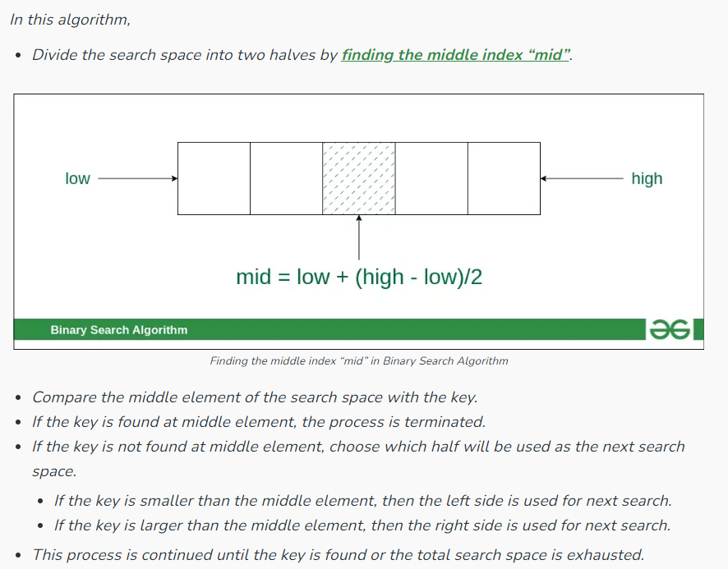
Code:
C:
#include <stdio.h>

int linearSearch(int arr[], int n, int key) {
for (int i = 0; i < n; i++) {
if (arr[i] == key)
return i;
}
return -1;
}

int binarySearch(int arr[], int n, int key) {
int low = 0, high = n - 1;
while (low <= high) {
int mid = (low + high) / 2;
if (arr[mid] == key)
return mid;
else if (arr[mid] < key)
low = mid + 1;
else
high = mid - 1;
}
return -1;
}

int main() {
int arr[] = {2, 4, 6, 8, 10, 12, 14};
int n = sizeof(arr) / sizeof(arr[0]);
int key, i;

printf("Enter the value of key:\n");
scanf("%d", &key);
printf("key: %d\n", key);

printf("Elemnets of array: \n");
for (i=0; i<n; i++) {
printf("%d ", arr[i]); } printf("\n");

int result = linearSearch(arr, n, key);
if (result != -1)
printf("Linear Search: Element found at index %d\n", result);
else
printf("Linear Search: Element not found\n");

result = binarySearch(arr, n, key);
if (result != -1)
printf("Binary Search: Element found at index %d\n", result);
else
printf("Binary Search: Element not found\n");

return 0;
}

Python:
def linearSearch(arr, key):
for i in range(len(arr)):
if arr[i] == key:
return i
return -1

def binarySearch(arr, key):
low, high = 0, len(arr) - 1
while low <= high:
mid = (low + high) // 2
if arr[mid] == key:
return mid
elif arr[mid] < key:
low = mid + 1
else:
high = mid - 1
return -1

arr = [2, 4, 6, 8, 10, 12, 14]

print("Enter the value of key:")
key = int(input())

print("Key: ",key)
print("Array: ",arr)

result = linearSearch(arr, key)
if result != -1:
print(f"Linear Search: Element found at index {result}")
else:
print("Linear Search: Element not found")

result = binarySearch(arr, key)
if result != -1:
print(f"Binary Search: Element found at index {result}")
else:
print("Binary Search: Element not found")

Output:
C:
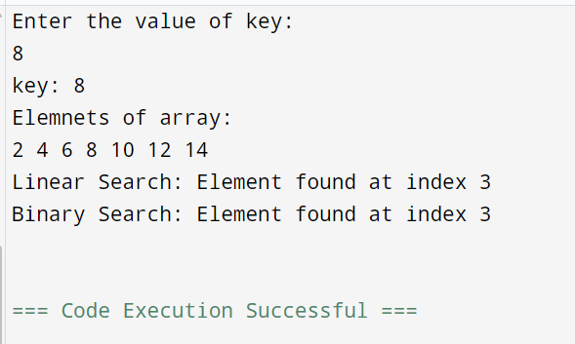

Python:
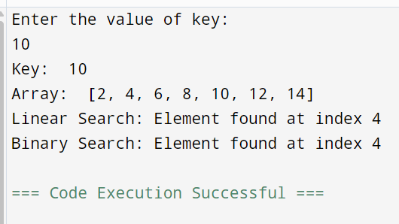
Conclusion:
Linear Search is simple and works on unsorted data, but it has a time complexity of O(n), making it inefficient for large datasets.
Binary Search, on the other hand, is more efficient with a time complexity of O(log n) but requires the array to be sorted.
Thus, the choice of search algorithm depends on whether the dataset is sorted and the efficiency required.
Signature of faculty in-charge

