Batch: A3 Roll No.: 16010324044
Experiment / assignment / tutorial No. 6
Grade: AA / AB / BB / BC / CC / CD /DD
Signature of the Staff In-charge with date




Title: Queue and Circular Queue Implementation
Objectives: Perform Enqueue, Dequeue and Display operations on Circular Queue
OUTCOME: Use of different data structures and select appropriate data structure for the given application

Theoretical Background:
Queue:
A queue is a first-in, first-out (FIFO) data structure in which the element that is inserted first is the first one to be taken out. The elements in a queue are added at one end called the rear and removed from the other end called the front. Like stacks, queues can be implemented by using either arrays or linked lists. Every queue has front and rear variables that point to the position from where deletions and insertions can be done, respectively. Consider the queue shown in Fig.
Front
Rear

44 | 70 | 56 | 57 | 22

0
1
2
3
4
5

Enqueue Operation:
Here, front = 0 and rear = 5. If we want to add one more value to the list, say, if we want to add another element with the value 45, then the rear would be incremented by 1 and the value would be stored at the position pointed by the rear. The queue, after the addition, would be as shown in Fig.
Rear
Front
44 | 70 | 56 | 57 | 22 | 45

0
1
2
3
4
5

Dequeue Operation:
Now, if we want to delete an element from the queue, then the value of front will be incremented. Deletions are done only from this end of the queue. The queue after the deletion will be as shown in Fig.

Front
Rear
 | 70 | 56 | 57 | 22 | 45

0
1
2
3
4
5

However, before inserting an element in the queue, we must check for overflow conditions. An overflow occurs when we try to insert an element into a queue that is already full. A queue is full when rear = MAX – 1, where MAX is the size of the queue, that is MAX specifies the maximum number of elements in the queue. Similarly, before deleting an element from the queue, we must check for underflow conditions. An underflow condition occurs when we try to delete an element from a queue that is already empty. If front = NULL and rear = NULL, then there is no element in the queue.

Types of Queues
A queue data structure can be classified into the following types:
- Circular Queue 2. Deque 3. Priority Queue 4. Multiple Queue

- Algorithm to insert and delete an element from a queue
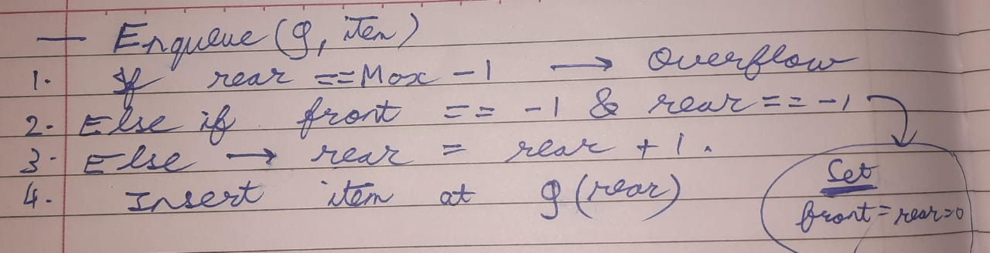
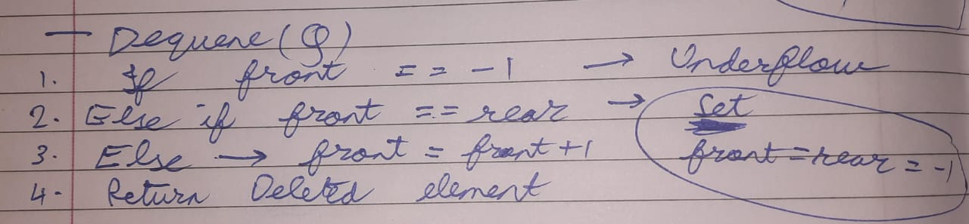
- Algorithm to delete an element from a circular queue
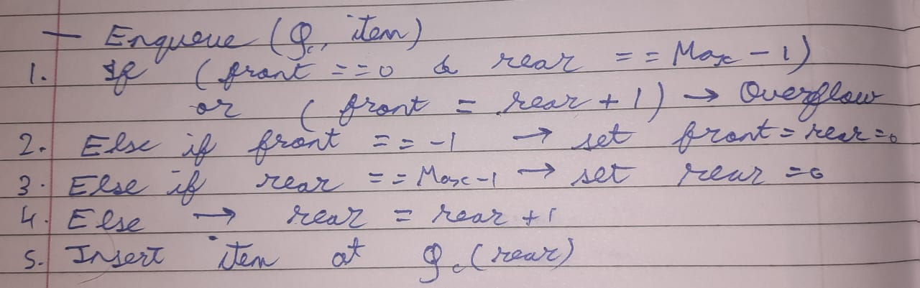
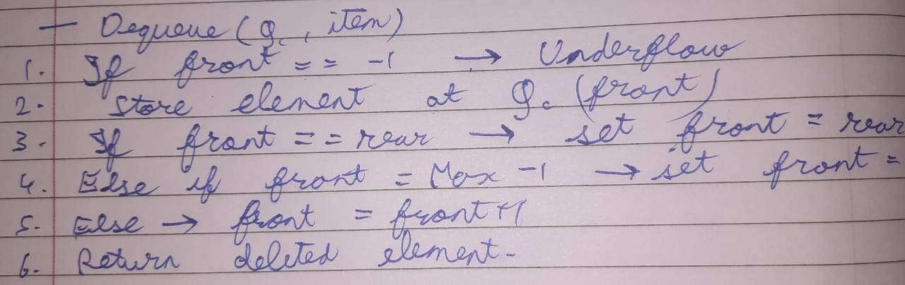

Code
- Queue: Enqueue(), Dequeue()
In C:
#include <stdio.h>
#define MAX 5

int queue[MAX];
int front = -1, rear = -1;

void enqueue(int item) {
if (rear == MAX - 1) {
printf("Queue Overflow\n");
} else {
if (front == -1) front = 0;
queue[++rear] = item;
printf("Added: %d\n", item);
}
}

void dequeue() {
if (front == -1 || front > rear) {
printf("Queue Underflow\n");
} else {
printf("Deleted: %d\n", queue[front++]);
}
}

void display() {
if (front == -1 || front > rear) {
printf("Queue Empty\n");
} else {
for (int i = front; i <= rear; i++)
printf("%d ", queue[i]);
printf("\n");
}
}

int main() {
enqueue(10);
enqueue(20);
enqueue(30);
enqueue(40);
display();
dequeue();
enqueue(50);
display();
return 0;
}

In Python:
MAX = 5
queue = []
front = -1
rear = -1

def enqueue(item):
global rear, front
if len(queue) == MAX:
print("Queue Overflow")
else:
if front == -1:
front = 0
rear = len(queue)
queue.append(item)
print("Added:", item)

def dequeue():
global front, rear
if not queue:
print("Queue Underflow")
else:
print("Deleted:", queue.pop(0))
if not queue:
front = rear = -1

def display():
if not queue:
print("Queue Empty")
else:
print(queue)

enqueue(10)
enqueue(20)
enqueue(30)
display()
enqueue(40)
dequeue()
enqueue(50)
display()

- Circular Queue: Enqueue(), Dequeue()

In C:
#include <stdio.h>
#define MAX 5

int cqueue[MAX];
int front = -1, rear = -1;

void enqueue(int item) {
if ((front == 0 && rear == MAX-1) || (rear+1)%MAX == front) {
printf("Circular Queue Overflow\n");
} else {
if (front == -1)
front = rear = 0;
else
rear = (rear+1)%MAX;
cqueue[rear] = item;
printf("Added: %d\n", item);
}
}

void dequeue() {
if (front == -1) {
printf("Circular Queue Underflow\n");
} else {
printf("Deleted: %d\n", cqueue[front]);
if (front == rear)
front = rear = -1;
else
front = (front+1)%MAX;
}
}

void display() {
if (front == -1) {
printf("Circular Queue Empty\n");
} else {
int i = front;
while (1) {
printf("%d ", cqueue[i]);
if (i == rear) break;
i = (i+1)%MAX;
}
printf("\n");
}
}

int main() {
enqueue(11);
enqueue(22);
enqueue(33);
display();
enqueue(44);
dequeue();
enqueue(55);
display();
return 0;
}

In Python:
MAX = 5
cqueue = [None]*MAX
front = -1
rear = -1

def enqueue(item):
global front, rear
if (front == 0 and rear == MAX-1) or (rear+1)%MAX == front:
print("Circular Queue Overflow")
else:
if front == -1:
front = rear = 0
else:
rear = (rear+1)%MAX
cqueue[rear] = item
print("Added:", item)

def dequeue():
global front, rear
if front == -1:
print("Circular Queue Underflow")
else:
print("Deleted:", cqueue[front])
if front == rear:
front = rear = -1
else:
front = (front+1)%MAX

def display():
if front == -1:
print("Circular Queue Empty")
else:
i = front
while True:
print(cqueue[i], end=" ")
if i == rear:
break
i = (i+1)%MAX
print()

enqueue(11)
enqueue(22)
enqueue(33)
display()
enqueue(44)
dequeue()
enqueue(55)
display()

Output
i.
In C:
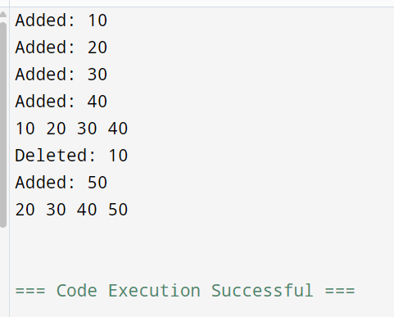

In Python:
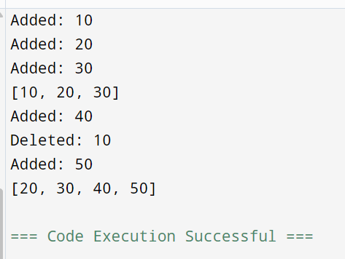

ii.
In C:
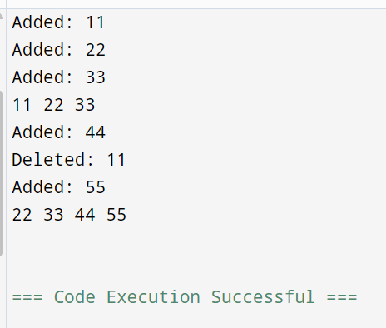

In Python:
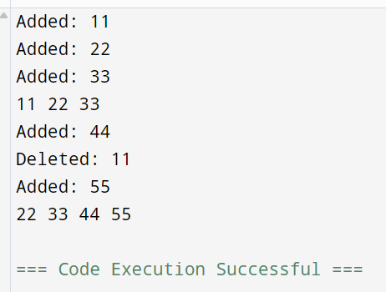

Conclusion:
In this experiment, I learnt how to implement Queue and Circular Queue in C and Python programming. I performed Enqueue, Dequeue, and Display operations while handling overflow and underflow conditions. Circular Queue utilizes memory better than linear queue.

Signature of faculty in-charge

