Batch: A3 Roll No.: 16010324044
Experiment / assignment / tutorial No._______
Grade: AA / AB / BB / BC / CC / CD /DD
Signature of the Staff In-charge with date




Title: Write a program to create a Singly Linked List and perform various operations on Linked List
Objectives: Perform Insertions, Deletions on Singly Linked List and Sort a list.
OUTCOME: Student will be able to implement Linked list

Theoretical Background:
Linked List:
A linked list is a very flexible, dynamic data structure in which elements (called nodes) form a sequential list. In contrast to static arrays, a programmer need not worry about how many elements will be stored in the linked list. This feature enables the programmers to write robust programs which require less maintenance. In a linked list, each node is allocated space as it is added to the list. Every node in the list points to the next node in the list. Therefore, in a linked list, every node contains the following two types of data:
- The value of the node or any other data that corresponds to that node
- A pointer or link to the next node in the list
The last node in the list contains a NULL pointer to indicate that it is the end or tail of the list. Since the memory for a node is dynamically allocated when it is added to the list, the total number of nodes that may be added to a list is limited only by the amount of memory available. Figure shows a linked list of three nodes.

1 2 3 N

In C, a node in linked list is represented as:
struct node
{
int data;
struct node *next;
};

Singly Linked List:
A singly linked list is the simplest type of linked list in which every node contains some data and a pointer to the next node of the same data type. By saying that the node contains a pointer to the next node, we mean that the node stores the address of the next node in sequence. A singly linked list allows traversal of data only in one way.
Operations:
Insertion:
- The new node is inserted at the beginning.
- The new node is inserted at the end.
- The new node is inserted after a given node.
- The new node is inserted before a given node.
Deletion:
- The first node is deleted.
- The last node is deleted.
- The node after a given node is deleted
Traverse

Algorithm:
- Algorithm for traversing a linked list

- Algorithm to insert a new node after a node that has value NUM

- Algorithm to delete the node after a given node

Code:
In C:
#include <stdio.h>
#include <stdlib.h>

struct Node {
int data;
struct Node* next;
};

struct Node* head = NULL;

void insertEnd(int value) {
struct Node* newNode = (struct Node*)malloc(sizeof(struct Node));
newNode->data = value;
newNode->next = NULL;

if (head == NULL) {
head = newNode;
return;
}
struct Node* temp = head;
while (temp->next != NULL) {
temp = temp->next;
}
temp->next = newNode;
}

void deleteFirst() {
if (head == NULL) {
printf("List is empty\n");
return;
}
struct Node* temp = head;
head = head->next;
free(temp);
}

void display() {
struct Node* temp = head;
while (temp != NULL) {
printf("%d -> ", temp->data);
temp = temp->next;
}
printf("NULL\n");
}

int main() {
insertEnd(10);
insertEnd(20);
insertEnd(30);
display();
deleteFirst();
display();
return 0;
}

In Python:
class Node:
def __init__(self, data):
self.data = data
self.next = None

class SinglyLinkedList:
def __init__(self):
self.head = None

def insert_end(self, data):
new_node = Node(data)
if self.head is None:
self.head = new_node
return
temp = self.head
while temp.next:
temp = temp.next
temp.next = new_node

def delete_first(self):
if self.head is None:
print("List is empty")
return
self.head = self.head.next

def display(self):
temp = self.head
while temp:
print(temp.data, end=" -> ")
temp = temp.next
print("NULL")

sll = SinglyLinkedList()
sll.insert_end(10)
sll.insert_end(20)
sll.insert_end(30)
sll.display()
sll.delete_first()
sll.display()

Output:
In C:
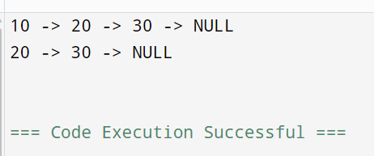
In Python:
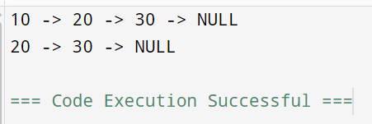

Conclusion:
In this experiment, I learnt how to implement a Singly Linked List in both C and Python. I performed fundamental operations such as insertion, deletion, and traversal. It shows that linked lists manage memory dynamically and provide flexibility compared to static arrays.

Signature of faculty in-charge

