Batch: A3 Roll No.: 16010324044
Experiment / assignment / tutorial No. 9
Grade: AA / AB / BB / BC / CC / CD /DD
Signature of the Staff In-charge with date



Title: Binary Search Tree
Objective: Perform Insert, Inorder Traversal, Delete and Search operations on Binary Search Tree
OUTCOME: Use of different data structures and select appropriate data structure for the given application

Theoretical Background:
Tree: A tree is a non-linear data structure which consists of a collection of nodes arranged in a hierarchical order. One of the nodes is designated as the root node, and the remaining nodes can be partitioned into disjoint sets such that each set is a sub-tree of the root.
The simplest form of a tree is a binary tree.

A binary tree, T, is either empty or such that
  - T has a special node called the root node
  - T has two sets of nodes L_{T} and R_{T}, called the left subtree and right subtree of T, respectively.
  - L_{T} and R_{T} are binary trees.

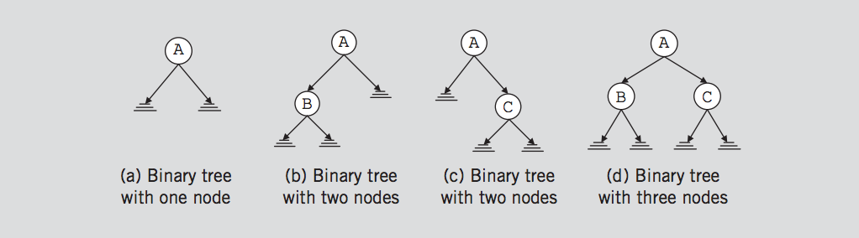

A binary search tree (BST) is a binary tree that is either empty or in which every node contains a key (value) and satisfies the following conditions:
  - All keys in the left sub-tree of the root are smaller than the key in the root node
  - All keys in the right sub-tree of the root are greater than the key in the root node
  - The left and right sub-trees of the root are again binary search trees
Following Figure shows a Binary Search Tree
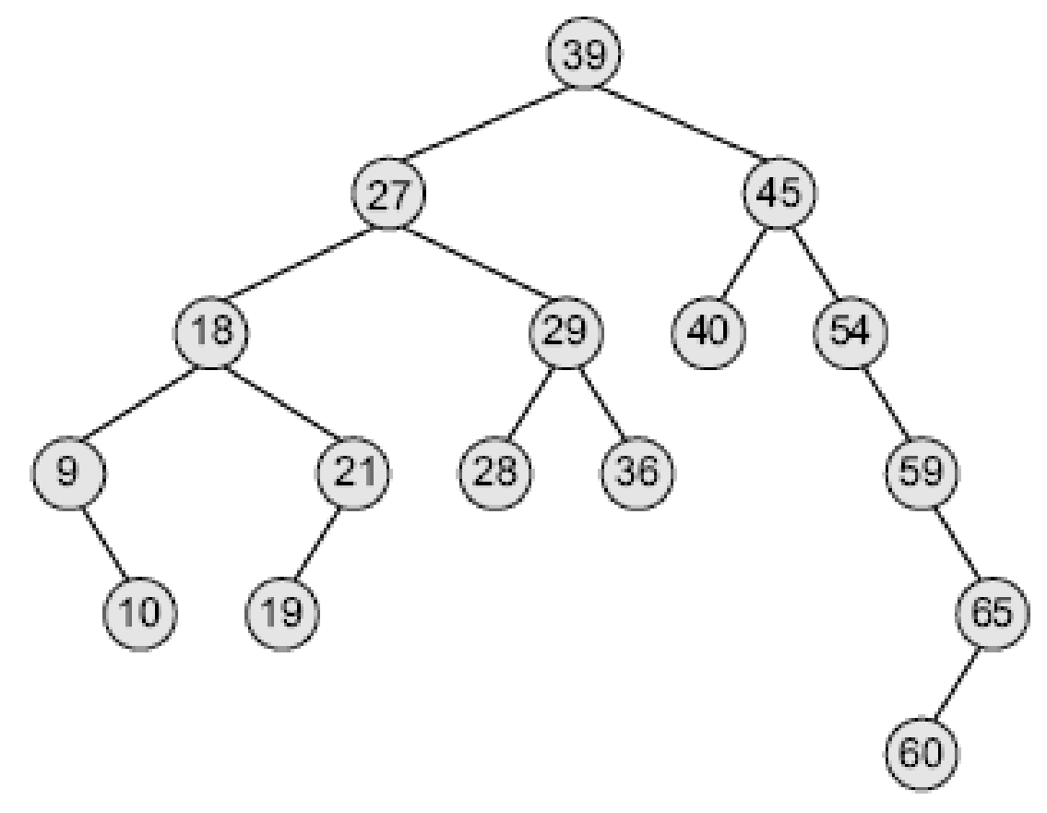

Operations:
    - Traversal
      - In-order
      - Pre-order
      - Post-order
    - Searching for a node in BST
    - Inserting a new node
    - Delete
      - Node that has no children
      - Node with one child
      - Node with two child

- Algorithm for Pre-order Traversal
- Start from the root node.
- If the tree is empty, exit.
- Visit (process/print) the root node.
- Recursively traverse the left subtree.
- Recursively traverse the right subtree.
- End.

- Algorithm for Searching
- Start from the root node.
- If the root is NULL, the element is not found.
- If the key to be searched is equal to the root’s data, element is found.
- If the key is smaller than the root’s data, search in the left subtree.
- If the key is greater than the root’s data, search in the right subtree.
- Repeat until the node is found or subtree becomes NULL.
- End.

- Algorithm for delete node with two child
- Find the node to be deleted.
- If the node has two children:
a. Find the inorder successor (smallest value in right subtree).
b. Replace the node’s value with the inorder successor’s value.
c. Recursively delete the inorder successor from the right subtree.
- Return the modified tree.
- End.

Code in C:
#include <stdio.h>
#include <stdlib.h>

struct Node {
int data;
struct Node* left;
struct Node* right;
};

// Create a new node
struct Node* newNode(int item) {
struct Node* temp = (struct Node*)malloc(sizeof(struct Node));
temp->data = item;
temp->left = temp->right = NULL;
return temp;
}

// Insert node
struct Node* insert(struct Node* node, int data) {
if (node == NULL) return newNode(data);
if (data < node->data)
node->left = insert(node->left, data);
else if (data > node->data)
node->right = insert(node->right, data);
return node;
}

// Preorder traversal
void preorder(struct Node* root) {
if (root != NULL) {
printf("%d ", root->data);
preorder(root->left);
preorder(root->right);
}
}

// Search node
struct Node* search(struct Node* root, int key) {
if (root == NULL || root->data == key)
return root;
if (key < root->data)
return search(root->left, key);
return search(root->right, key);
}

// Find minimum value node
struct Node* minValueNode(struct Node* node) {
struct Node* current = node;
while (current && current->left != NULL)
current = current->left;
return current;
}

// Delete a node
struct Node* deleteNode(struct Node* root, int key) {
if (root == NULL) return root;
if (key < root->data)
root->left = deleteNode(root->left, key);
else if (key > root->data)
root->right = deleteNode(root->right, key);
else {
if (root->left == NULL) {
struct Node* temp = root->right;
free(root);
return temp;
} else if (root->right == NULL) {
struct Node* temp = root->left;
free(root);
return temp;
}
struct Node* temp = minValueNode(root->right);
root->data = temp->data;
root->right = deleteNode(root->right, temp->data);
}
return root;
}

// Main function
int main() {
struct Node* root = NULL;
root = insert(root, 50);
insert(root, 30);
insert(root, 70);
insert(root, 20);
insert(root, 40);
insert(root, 60);
insert(root, 80);

printf("Preorder traversal: ");
preorder(root);

printf("\nDeleting 50 (node with two children)\n");
root = deleteNode(root, 50);

printf("Preorder traversal after deletion: ");
preorder(root);

return 0;
}

Code in Python:
class Node:
def __init__(self, key):
self.key = key
self.left = None
self.right = None

def insert(root, key):
if root is None:
return Node(key)
if key < root.key:
root.left = insert(root.left, key)
elif key > root.key:
root.right = insert(root.right, key)
return root

def preorder(root):
if root:
print(root.key, end=" ")
preorder(root.left)
preorder(root.right)

def search(root, key):
if root is None or root.key == key:
return root
if key < root.key:
return search(root.left, key)
return search(root.right, key)

def minValueNode(node):
current = node
while current.left is not None:
current = current.left
return current

def deleteNode(root, key):
if root is None:
return root
if key < root.key:
root.left = deleteNode(root.left, key)
elif key > root.key:
root.right = deleteNode(root.right, key)
else:
if root.left is None:
return root.right
elif root.right is None:
return root.left
temp = minValueNode(root.right)
root.key = temp.key
root.right = deleteNode(root.right, temp.key)
return root

# Driver code
root = None
root = insert(root, 50)
root = insert(root, 30)
root = insert(root, 70)
root = insert(root, 20)
root = insert(root, 40)
root = insert(root, 60)
root = insert(root, 80)

print("Preorder traversal:")
preorder(root)

print("\nDeleting 50 (node with two children)")
root = deleteNode(root, 50)

print("Preorder traversal after deletion:")
preorder(root)

Output in C:
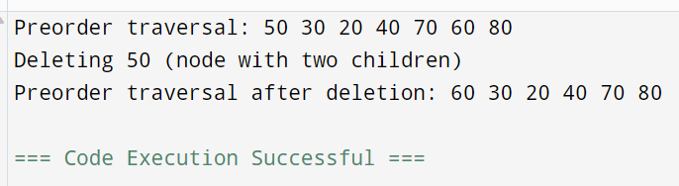
Output in Python:
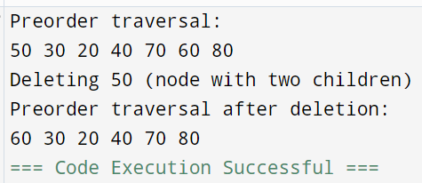
Conclusion:
In this experiment, I learnt how efficient Binary Search Tree is, for performing dynamic set operations such as insertion, searching, and deletion. It maintains elements in sorted order, enabling faster operations compared to linear structures. Traversal methods like preorder help in systematically visiting each node.
Signature of faculty in-charge

