Name: Dhairya Shah
Roll No: 16010324044
Batch: A3
# Question 1:
# Find the following limit and plot the graph of the function: # lim_{x -> 0} (sin(x) / x)
x = var('x')
f = sin(x) / x
# Limit at x=0
lim_value = limit(f, x=0)
print("Limit as x -> 0 of sin(x)/x =", lim_value)
# Plot
p = plot(f(x), (x, -pi, pi), ymin=-0.5, ymax=1.5, title=r'Plot of $\frac{\sin(x)}{x}$',
axes_labels=['x','f(x)'],
detect_poles=True)
p += point((0, lim_value), color='red', size=30) p.show()
Limit as x -> 0 of sin(x)/x = 1
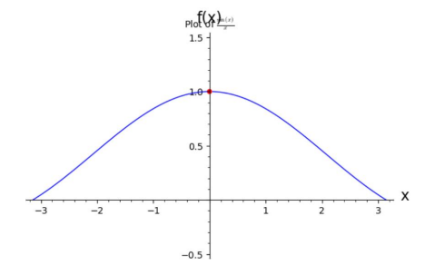
# Question 2:
# Find the first two derivatives of f(t) = log(1 + t^2) # and plot them along with the graph of f(t).
t = var('t')
f = log(1 + t^2)
f1 = diff(f, t)
f2 = diff(f, t, 2)
print("f(t) =", f)
print("f'(t) =", f1)
print("f''(t) =", f2)
plot(f, (t, -5, 5), legend_label='f(t)') + \ plot(f1, (t, -5, 5), linestyle='--', color='red', legend_label="f'(t)")+\plot(f2, (t, -5, 5), linestyle=':', color='green', legend_label="f''(t)")
f(t) = log(t^2 + 1)
f'(t) = 2*t/(t^2 + 1)
f''(t) = -4*t^2/(t^2 + 1)^2 + 2/(t^2 + 1)
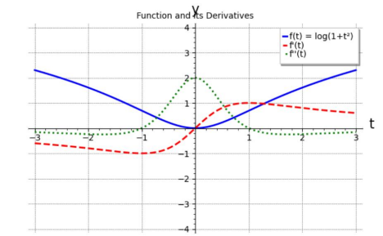
# Question 3:
# Consider f(x) = e^(-x) * cos(2x)
# Find Taylor’s series up to power 10 at the point x = 1.
x = var('x')
f = exp(-x) * cos(2*x)
u = var('u')
f_shift = f(x = u + 1)
series_f = f_shift.series(u, 11) # expand around u = 0 up to u^10 series_at_1 = series_f.subs(u = x - 1)
print(series_at_1)
T10 = sum([f.diff(x, n).subs(x = 1)/factorial(n) * (x - 1)**n for n in range(0, 11)])
print(T10.expand())
1/3628800*(237*cos(2)*e^(-1) - 3116*e^(-1)*sin(2))*(x - 1)^10 + 1/362880*(1199*cos(2)*e^(-1) + 718*e^(-1)*sin(2))*(x - 1)^9 - 1/40320*(527*cos(2)*e^(-1) - 336*e^(-1)*sin(2))*(x - 1)^8 - 1/5040*(29*cos(2)*e^(-1) + 278*e^(-1)*sin(2))*(x - 1)^7 + 1/720*(117*cos(2)*e^(-1) + 44*e^(-1)*sin(2))*(x - 1)^6 - 1/120*(41*cos(2)*e^(-1) - 38*e^(-1)*sin(2))*(x - 1)^5 - 1/24*(7*cos(2)*e^(-1)+ 24*e^(-1)*sin(2))*(x - 1)^4 + 1/6*(11*cos(2)*e^(-1) + 2*e^(-1)*sin(2))*(x-1)^3 - 1/2*(3*cos(2)*e^(-1) - 4*e^(-1)*sin(2))*(x - 1)^2 - (cos(2)*e^(-1)+
2*e^(-1)*sin(2))*(x - 1) + cos(2)*e^(-1)
79/1209600*x^10*cos(2)*e^(-1) - 779/907200*x^10*e^(-1)*sin(2) + 481/181440*x^9*cos(2)*e^(-1) + 71/6720*x^9*e^(-1)*sin(2) - 643/16128*x^8*cos(2)*e^(-1) - 97/2016*x^8*e^(-1)*sin(2) + 529/2520*x^7*cos(2)*e^(-1) + 793/15120*x^7*e^(-1)*sin(2) - 7379/17280*x^6*cos(2)*e^(-1) + 481/1440*x^6*e^(-1)*sin(2) - 2201/7200*x^5*cos(2)*e^(-1) - 8707/7200*x^5*e^(-1)*sin(2) + 5257/1920*x^4*cos(2)*e^(-1) + 451/1080*x^4*e^(-1)*sin(2) - 2167/756*x^3*cos(2)*e^(-1) + 4183/1008*x^3*e^(-1)*sin(2) - 262643/80640*x^2*cos(2)*e^(-1) - 120319/20160*x^2*e^(-1)*sin(2) + 367519/60480*x*cos(2)*e^(-1) - 38051/181440*x*e^(-1)*sin(2) - 4105583/3628800*cos(2)*e^(-1) + 124577/50400*e^(-1)*sin(2)
# Question 4: Evaluate the following definite integral: ∫ from 1 to 4 of[3x/ sqrt(3x - 1)] dx
x = var('x')
expr = (3*x) / sqrt(3*x - 1)
result = integrate(expr, (x, 1, 4))
print(result)
28/9*sqrt(11) - 10/9*sqrt(2)
# Question 5:
# Find the area that the curve r = 3(1 - cos(2θ)), 0 ≤ θ ≤ 2π, encloses.
theta = var('theta')
r = 3*(1 - cos(2*theta))
area = (1/2) * integrate(r^2, (theta, 0, 2*pi))
print(simplify(area))
polar_plot(r, (theta, 0, 2*pi), thickness=2).show() 27/2*pi
# Question 6:
# Find the roots of x^3 - 2x^2 - 5x + 6 = 0 for x.
x = var('x')
poly = x^3 - 2*x^2 - 5*x + 6
roots = solve(poly == 0, x)
print(roots)
[
x == 3,
x == -2,
x == 1
]

