Report on Internal Assessment 2
Class: SY EXTC Course : MPMC(216U03C304)

Name: Dhairya Manish Shah Roll No.: 16010324044

Task 1: Write a program for 8051 to serially transmit your first name (First letter in capital ) at the baud rate of 9600 . Assume crystal frequency =11.059MHz Execute the same in KEIL software. (Provide appropriate delay after every character so that ASCII value of each character can be viewed in SBUF register in KEIL.)

Program: (You can add screen shot of your program or copy paste the program)
Note:- in program first line should be comment stating your name and roll no
Eg:- //Name:- Savita Raut Roll no - 1234
//PROGRAM TO SERIALLY TRANSMIT THE WORD "DHAIRYA"
//Dhairya Shah,16010324044,MPMC-IA2
again: MOV TMOD, #20H ;Timer 1, mode 2
MOV SCON, #50H ;8-bit, 1 stop bit (model), REN enabled
SETB TR1 ;start timer 1
//to send letter "D"
MOV A, #'D'
ACALL SEND
ACALL DELAY
//to send Letter "H"
Mov A, #'H'
ACALL SEND
ACALL DELAY
//to send letter "A"
MOV A, #'A'
ACALL SEND
ACALL DELAY
//to send letter "I"
MOV A, #'I'
ACALL SEND
ACALL DELAY
//to send letter "R"
MOV A, #'R'
ACALL SEND
ACALL DELAY
//to send letter "Y"
MOV A, #'Y'
ACALL SEND
ACALL DELAY
//to send letter "A"
MOV A, #'A'
ACALL SEND
ACALL DELAY
//to send space at the end of the word " "
MOV A, #' '
ACALL SEND
ACALL DELAY
sjmp again
//Subroutine: SERIAL DATA TRANSFER
SEND: MOV SBUF, A
HERE: JNB TI, HERE
CLR TI
RET
//DELAY SUBROUTINE
DELAY: MOV R2, #0FFH
GO: MOV R3, #0FFH
GO1: DJNZ R4, GO1
DJNZ R2,GO
RET
End
Output:- ( Add screen shot of peripheral serial and timer)
.
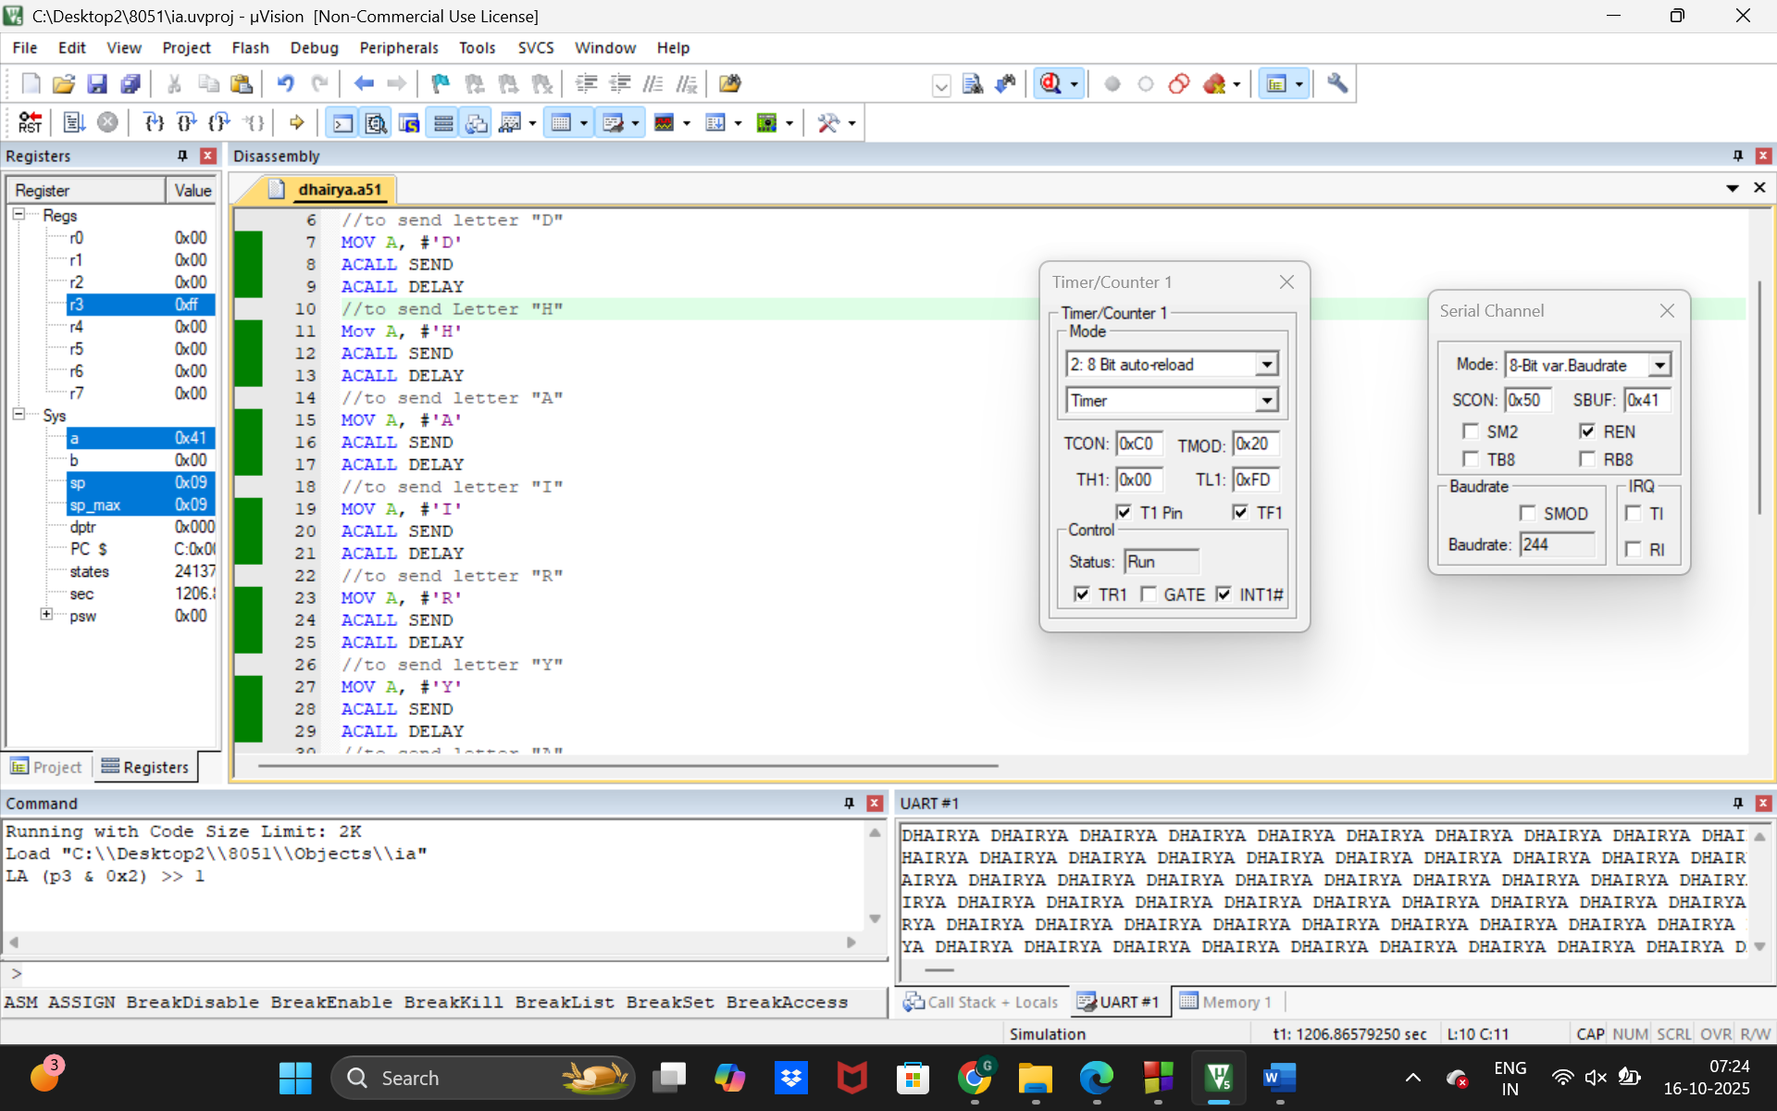

Task-2: Write a program to generate a single pulse of 15 mSec at port pin P3.1 (assume crystal freq=24MHz,use timer 0 in mode 1). Execute the same in KEIL.
.
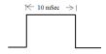

Program: (You can add screen shot of your program or copy paste the program)
Note:- in program first line should be comment stating your name and roll no
Eg:- //Name:- XYZ Roll no:- 1234

//Program to generate a single pulse of 15 mSec at port pin P3.1
//Crystal frequency = 24MHz, using Timer 0 in Mode 1
//DHAIRYA SHAH 16010324044
ORG 0000H
LJMP MAIN

ORG 0030H
MAIN: MOV TMOD, #01H ;TIMER 0, MODE 1
CLR P3.1
SETB P3.1

//LOAD TIMER 0 FOR 15 mSec DELAY
MOV TH0, #08AH ;HIGH BYTE OF 8AE0H
MOV TL0, #0E0H ;LOW BYTE OF 8AE0H
SETB TR0 ;START TIMER 0

WAIT: JNB TF0, WAIT
CLR TR0 ;STOP TIMER 0
CLR TF0 ;CLEAR TIMER FLAG

CLR P3.1 ;MAKE P3.1 LOW (END OF PULSE)

HERE: SJMP HERE ;STOP PROGRAM

END

Output:- ( Add screen shot of Logic Analyzer showing wave and time period)

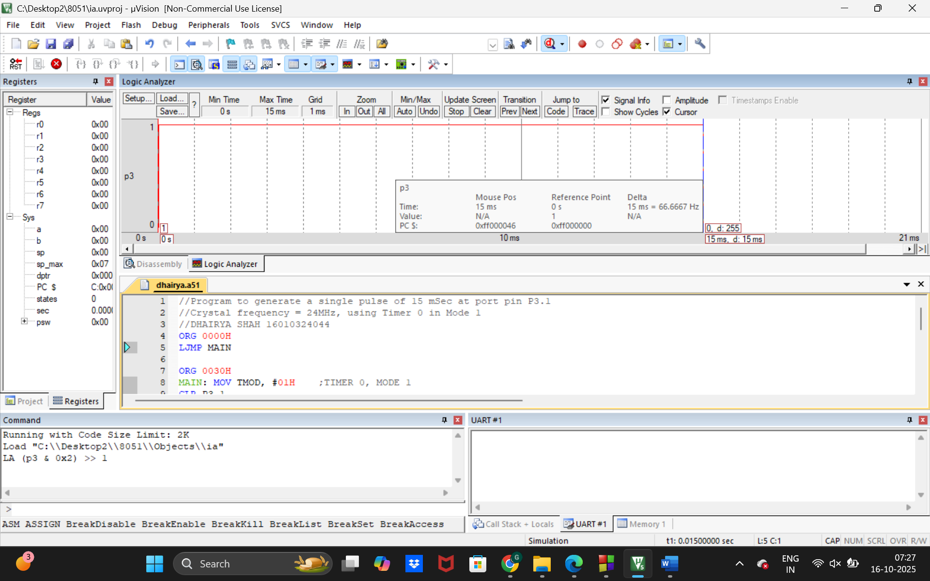

PART 2:
;Dhairya Shah 16010324044 A2
ORG 0000H
LJMP MAIN

ORG 0030H
MAIN: MOV TMOD, #01H ; Timer0 mode 1 (16-bit timer)
CLR P3.1 ; Ensure P3.1 is LOW

; --- Initial delay before pulse (10 ms) ---
ACALL DELAY_10MS

; --- Generate pulse of 15 ms ---
SETB P3.1 ; Set P3.1 HIGH
ACALL DELAY_15MS ; Keep HIGH for 15 ms
CLR P3.1 ; Back to LOW

HERE: SJMP HERE ; Infinite loop / stop program

;--------------------------------------------------
; Delay routines (11.0592 MHz crystal -> 921.6 ticks/ms)
; 10 ms preload = 0xDC00
; 15 ms preload = 0xCA00
;--------------------------------------------------
DELAY_10MS:
MOV TH0, #0DCH
MOV TL0, #00H
CLR TF0 ; Clear overflow flag before starting
SETB TR0 ; Start Timer0
WAIT10: JNB TF0, WAIT10 ; Wait until TF0 = 1
CLR TR0 ; Stop Timer0
CLR TF0 ; Clear overflow flag
RET

DELAY_15MS:
MOV TH0, #0CAH
MOV TL0, #00H
CLR TF0
SETB TR0
WAIT15: JNB TF0, WAIT15
CLR TR0
CLR TF0
RET
END

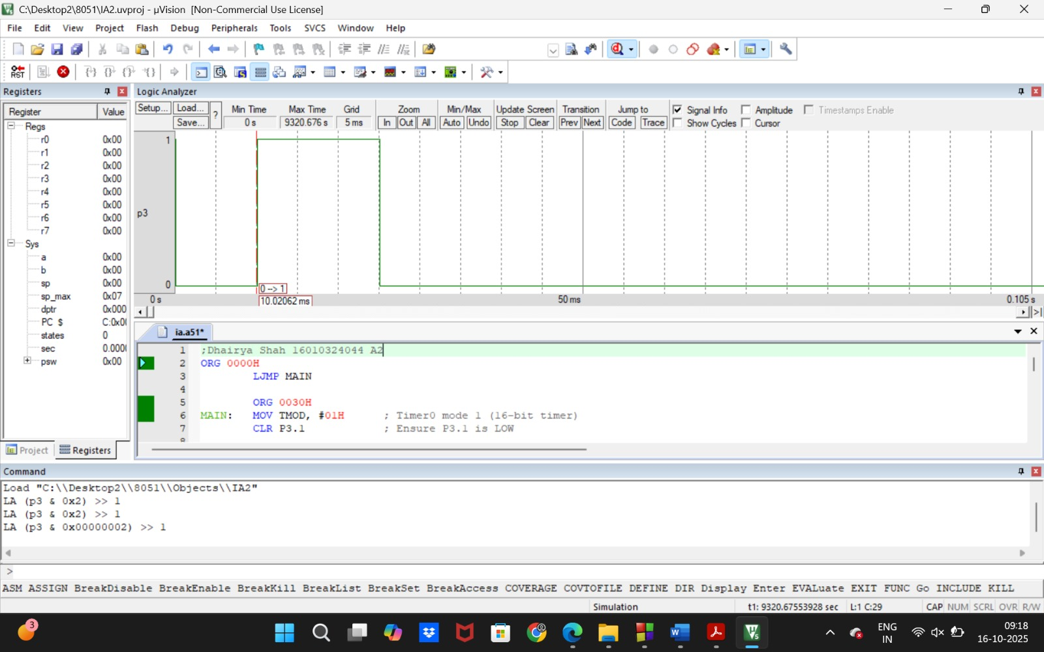

.
🧠 DSA Concept:
Uses structures (collection of related data under one name).
Allows us to group attributes like name, seat, and showtime together.

2️⃣ declaration.c
Lists all function prototypes so the compiler knows them before use.
It’s like a manual “header file” — improves modularity.
🧠 DSA Concept:
Demonstrates modular programming and separation of concerns — keeps code organized.

3️⃣ simple_ticketing_system.c

Global variables
struct moviedetails person[300];
int count = 0;
int id2 = 1000;

Stores all bookings and automatically increments booking IDs.

Main Function
Creates dynamic arrays (int **seat) to track seat availability for each of 3 movies.
seat = (int **)calloc(3, sizeof(int *));
for (i = 0; i < 3; i++)
*(seat + i) = (int *)calloc(101, sizeof(int));
- Each movie has 100 seats.
  - 0 = available
  - 1 = booked
🧠 DSA Concept:
- Dynamic memory allocation using calloc().
- 2D arrays simulated using pointers.

choice1()
Displays the main menu and gets user choice.

adminmenu()
Handles all admin operations after correct password entry.
- Option 1 → change ticket price (calls changeprize())
- Option 2 → view all booking details (details())
- Option 3 → view total revenue
- Option 4 → exit admin menu
🧠 DSA Concept:
Conditional branching (menu-driven control structure).

changeprize()
Lets admin select which movie’s price to update.
currentPrice[movieChoice - 1] = newPrice;

showsAvailable()
Displays showtimes based on real system time using <time.h>:
time_t t = time(NULL);
struct tm *tm = localtime(&t);
int hour = tm->tm_hour;

If current time = 3 PM, it marks:
11 AM – Finished
2 PM – Finished
6 PM – Available
9 PM – Available

and ensures the user cannot pick past shows.
🧠 DSA Concept:
- Conditional logic
- Real-time system interaction

reservation()
Main booking function:
- Calls showsAvailable()
- Displays seat layout (loops through array)
- Gets user info and seat choice
- Stores everything in person[count]
- Calls the correct ticket() function to print a formatted ticket
🧠 DSA Concept:
- Array traversal
- Structure manipulation
- Function modularity

cancel()
User enters booking ID.
Program searches for it in person[] array and frees the seat.
🧠 DSA Concept:
- Linear search algorithm (searches by ID)
- Array indexing

details()
Admin view — prints all booked users with seat, name, movie, date, and time.

movie() and cmovie()
Menus for selecting movie during booking or cancellation.

ticket1(), ticket2(), ticket3()
These print formatted “realistic” tickets for each movie:
+------------------------------------------------------------+
| 🎬 CINEMA BOOKING TICKET 🎟️ |
| Booking ID : 1002 Show : Toy Story 6 |
| Customer : Krish |
| Date : 15-10-2025 Time : 06:00 PM |
| Hall : 02 Seat : 23 |
| Ticket Price : ₹500 |
+------------------------------------------------------------+
| Thank you for choosing Simple Cinemas! |
+------------------------------------------------------------+

🧠 DSA Concept:
Formatted output, string handling.

🧠 4. DSA CONCEPTS USED
Concept | Where Used | Purpose
Structure | moviedetails | Store all info about a booking
Array | person[], seat[][] | Manage multiple users & seats
Pointer | seat | Dynamic memory for multiple movie seat charts
Dynamic Memory (calloc) | In main() | Allocate 2D seat array
Function Decomposition | All over | Modular, readable design
Linear Search | cancel() | Find booking by ID
Conditional Branching | showsAvailable(), menus | Flow control
Looping | Seat display, admin menu | Repeated logic
Real-Time Data | time.h | Display date/time correctly

⚙️ 5. PROGRAM EXECUTION FLOW (SUMMARY DIAGRAM)
+---------------------------------------+
| START PROGRAM |
+---------------------------------------+
|
v
+-------------------+
| MAIN MENU |
| 1. Admin |
| 2. Book Ticket |
| 3. Cancel Ticket |
| 4. Exit |
+-------------------+
|
+--------+---------+
| | |
v v v
ADMIN BOOK TICKET CANCEL
MENU | |
v v
SELECT MOVIE ENTER ID
|
v
SHOW AVAILABLE
|
v
CHOOSE SEAT & TIME
|
v
PRINT TICKET
|
v
BACK TO MENU

🧩 6. OUTPUT SNAPSHOT
============= MOVIE TICKETING SYSTEM =============
1. Admin Menu
2. Purchase Ticket
3. Cancel Ticket
4. Exit
=================================================
Enter your choice: 2

Select the movie:
1. Toy Story 6
2. Pokemon
3. Naruto: Movie 1
Enter choice: 1

🎬 Shows available for 15-10-2025
1. 11:00 AM (Finished)
2. 02:00 PM (Finished)
3. 06:00 PM
4. 09:00 PM
Select your showtime (1-4): 3
...

🧠 7. TIME COMPLEXITY
Operation | Function | Complexity
Booking a ticket | reservation() | O(1) (constant seat marking)
Cancelling a ticket | cancel() | O(n) (linear search through bookings)
Viewing details | details() | O(n)
Checking available shows | showsAvailable() | O(1)

✅ 8. CONCLUSION
This project demonstrates:
- Real-time application logic
- Modular design with multiple files
- Use of arrays, structures, dynamic memory, and time libraries
- Practical DSA usage (searching, arrays, structure manipulation)
- Menu-driven user interface
It’s a mini real-world simulation of a ticketing system and an excellent example of combining data structures, control logic, and system interaction in C.

🗂 Why We Use declaration.c and moviedetails.c Along With simple_ticketing_system.c
In professional C programming, large projects are never kept in one single file.
We divide the code into logical modules — each handling a specific purpose.
That’s exactly why your project uses three .c files:

🧩 1️⃣ moviedetails.c — Data Structure Definition Module

📄 Purpose:
This file defines the struct moviedetails, which holds all details related to one booking.
struct moviedetails {
char name[25];
char phone[15];
int seat;
int id;
char showDate[15];
char showtime[10];
char movieName[30];
};

💡 Why separate this?
- Because this structure is a blueprint used by many functions (booking, cancellation, admin view, ticket printing, etc.).
- If you ever want to change what information a ticket stores (e.g. add “email” or “payment mode”),
you only modify this one file, and the rest of the program automatically adapts.

⚙️ Think of it as:
The “database schema” of your system — it defines what data each booking record contains.

🧠 Benefit:
- Encapsulation: Keeps data definitions separate from logic.
- Reusability: Other programs can include this file to reuse your structure.
- Maintenance: Easier to edit or expand later.

🧩 2️⃣ declaration.c — Function Declaration / Interface Module

📄 Purpose:
This file contains function prototypes, i.e. the “signatures” of every function used in the system.
Example:
int changeprize(int, int[]);
void reservation(int *, int, int, int);
int choice1(void);
void cancel(int *);
void ticket1(int, char[10], int, int, char[15], char[10]);
...

💡 Why separate this?
Because when C compiles your code, it needs to know beforehand what functions exist and what their parameter types are.
Instead of declaring them all inside the main file, we keep them in one clean place.

⚙️ Think of it as:
The “interface” or “function catalog” of your project — like an API header.

🧠 Benefit:
- Avoids compiler errors (“implicit declaration of function”).
- Improves modularity: If another program wants to reuse your ticketing logic, it just includes this file.
- Documentation: Developers can easily see all available functions and what parameters they expect.

🧩 3️⃣ simple_ticketing_system.c — Main Logic / Execution Module

📄 Purpose:
This file contains all the logic:
- Menus
- Booking and cancellation functions
- Admin operations
- Seat and ticket printing

⚙️ Think of it as:
The “engine” that drives the whole ticketing system.

🧠 How They Work Together
When you compile your project, all three .c files are linked together into a single executable.
gcc simple_ticketing_system.c declaration.c moviedetails.c -o ticket_system

👉 Here’s the logical flow:
moviedetails.c → defines data (struct)
declaration.c → declares function prototypes
simple_ticketing_system.c → implements logic using both

At compile time, the compiler reads:
- Function declarations (from declaration.c)
- Structure definitions (from moviedetails.c)
- Main logic (from simple_ticketing_system.c)
- Then links them together into one final program.

📚 In Simpler Terms
File | What it Contains | Role in Project
moviedetails.c | Structure definition (struct moviedetails) | Defines what a booking record looks like
declaration.c | All function prototypes | Lets compiler know about functions in advance
simple_ticketing_system.c | All actual logic and function definitions | Runs the system, main driver

✅ Benefits of Splitting into Multiple Files
Benefit | Explanation
Modularity | Each file handles one specific task.
Reusability | Other projects can reuse parts easily.
Maintainability | Easier to find and fix bugs.
Scalability | Large projects can grow without confusion.
Cleaner Compilation | No “implicit function” or “struct unknown” errors.

🧩 Analogy
Imagine building a car:
Component | Real-world role | In your code
Engine | Does all the work | simple_ticketing_system.c
Blueprint | Defines structure | moviedetails.c
Manual | Lists all controls & functions | declaration.c
When you combine them — you get a complete, working car 🚗 (or in our case, a working ticket system 🎟️).

Would you like me to show how to convert this structure into a header-based professional version
(i.e. moviedetails.h + functions.h) — so that you can include them cleanly instead of including .c files directly?

You said:
can you give an overview of all the the algorithm and then the functions where a particular DSA concept is used and also provide a flowchart for the code

ChatGPT said:
Perfect — this is the kind of analysis that helps you not only understand the program, but also connect it to your Data Structures and Algorithms (DSA) concepts.
Let’s go step-by-step:

🎟️ OVERVIEW OF THE WHOLE SYSTEM (Algorithm Summary)

Goal:
To simulate an Event / Movie Ticket Booking System in C — where:
- Users can book, cancel, and view tickets.
- Admins can change prices, see revenue, and view all bookings.

🧩 1️⃣ HIGH-LEVEL ALGORITHM (Step-by-Step)

Step 1: Start the Program
- Show Main Menu:
  - 1️⃣ Admin Login
  - 2️⃣ User Booking
  - 3️⃣ Cancel Booking
  - 4️⃣ Exit

Step 2: Admin Login
Algorithm:
- Ask for admin username and password.
- Verify credentials.
- If correct → Show Admin Menu, else deny access.
Admin Menu:
- 1️⃣ Change Ticket Prices
- 2️⃣ View All Bookings
- 3️⃣ View Total Revenue
- 4️⃣ Exit Admin Panel

Step 3: User Booking Flow
Algorithm:
- Display available movies and showtimes (depending on today’s date).
- For each movie, check real time → mark past shows as “FINISHED”.
- User selects a movie and time.
- Display number of available seats.
- Take user details (name, phone, etc.).
- Confirm and generate ticket.
- Save booking to file for persistence.

Step 4: Cancellation Flow
Algorithm:
- Ask for ticket ID or phone number.
- Search in file (sequential search).
- If found → cancel booking (mark seat as available, remove entry).
- Show cancellation confirmation.

Step 5: Admin Operations
Algorithm:
- Change Ticket Price: Admin selects a movie → enter new price → update array.
- View All Bookings: Display file contents (all users, movie, time, seat).
- View Revenue: Sum all ticket prices and show total.

Step 6: Ticket Printing
Algorithm:
- After successful booking, call ticket() function.
- Display formatted border design with:
  - Movie name
  - User name
  - Seat number
  - Date and Time
  - Unique Ticket ID
- Print in a “realistic” pass-like design on screen.

Step 7: End Program
- Return to main menu or exit cleanly.

⚙️ 2️⃣ DSA CONCEPTS USED IN THE PROGRAM
Even though this is a small project, many DSA fundamentals are applied implicitly.
DSA Concept | Where Used | Description
Arrays | Storing prices, seats | Used to store ticket prices for multiple shows and seat statuses (e.g., int seat[100])
Structures | struct moviedetails | Combines multiple pieces of info (name, phone, movie name, time, etc.) into one composite unit.
File Handling (Sequential Storage) | Saving bookings | Acts as a persistent linear data structure, storing all bookings sequentially in a text file.
Linear Search | During cancellation or viewing | Searches through the file or array to find a specific ticket ID or seat.
Functions / Modular Programming | All major operations | Each operation is modularized into its own function (booking, cancel, view, etc.) — like ADTs.
Conditional Logic | In showtime validation | Used to determine if a showtime has “FINISHED” or is available.
String Handling (Character Arrays) | User names, movie names, phone numbers | Operations like strcmp, strcpy, etc., are used for data comparison and copying.

