


Batch: A3 Roll No.: 16010324044
Experiment No. 2
Grade: AA / AB / BB / BC / CC / CD /DD


Signature of the Staff In-charge with date

TITLE: Block Transfer

AIM: Write an Assembly Language Program of 8086 to to transfer the block of ___ Bytes from M.L starting from _______________to the M.L. starting from ________________

OUTCOME:
Student will be able to develop programming skills using instruction set of microprocessor 8086

Program:
Code:
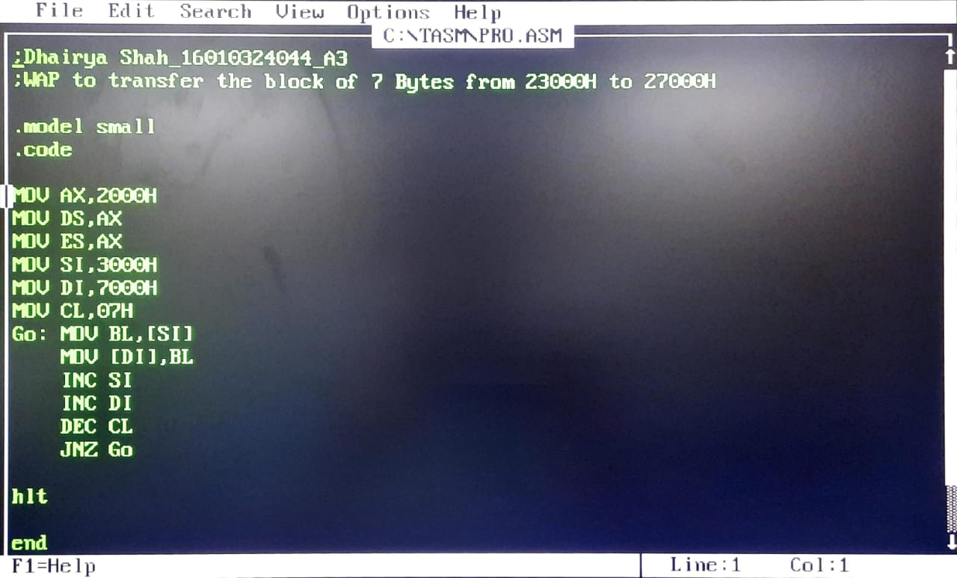

Input:
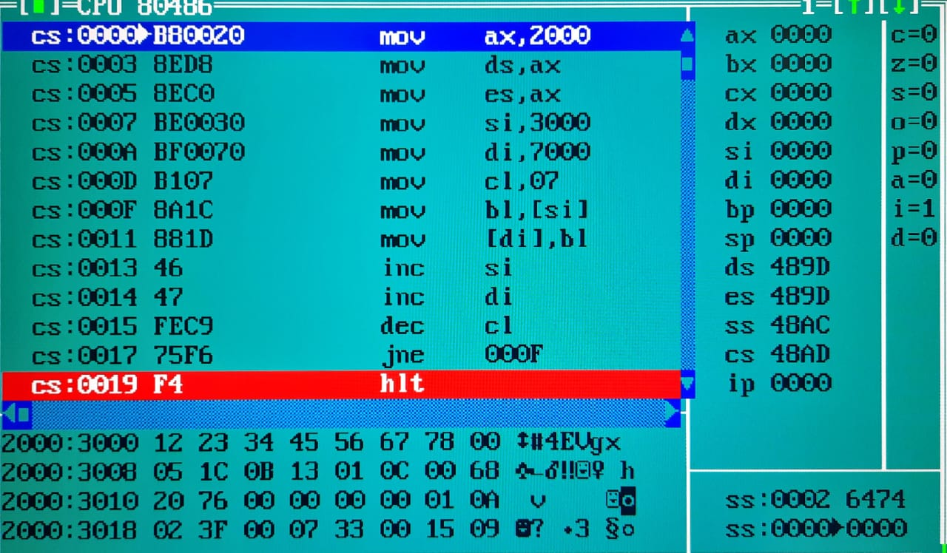

Output:
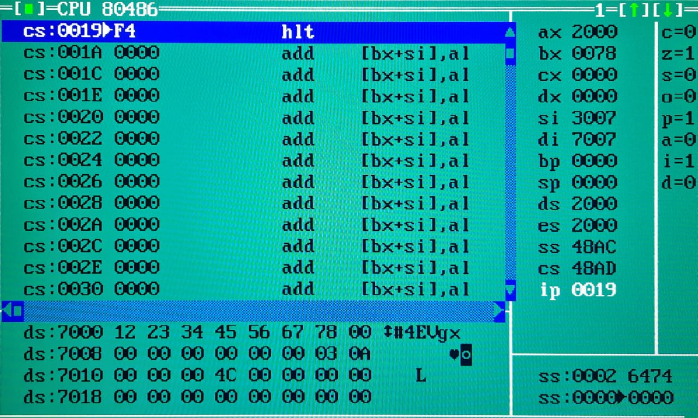

Result:
Before Execution After Execution

Memory Location Address | Data |  | Memory Location Address | Data
2000:3000 | 12 |  | 2000:7000 | 12
2000:3001 | 23 |  | 2000:7001 | 23
2000:3002 | 34 |  | 2000:7002 | 34
2000:3003 | 45 |  | 2000:7003 | 45
2000:3004 | 56 |  | 2000:7004 | 56
2000:3005 | 67 |  | 2000:7005 | 67
2000:3006 | 78 |  | 2000:7006 | 78
2000:3007 | 00 |  | 2000:7007 | 00

Conclusion: (specify the concepts learnt in this experiment)
In this experiment, I learned how to perform a block transfer in 8086 Assembly Language. We used source index (SI) and destination index (DI) registers for sequential data transfer, along with loop control using the CL register and conditional jumps.
We also used data movement instructions (MOV), pointer incrementation (INC) and loop control (DEC, JNZ).

Signature of faculty in-charge

