


Batch: A3 Roll No.: 16010324044
Experiment No. 3
Grade: AA / AB / BB / BC / CC / CD /DD


Signature of the Staff In-charge with date

TITLE: Find count of POSITIVE and NEGATIVE number stored in consecutive memory locations
AIM: Write an Assembly Language Program of 8086 to find the no of POSITIVE and NEGATIVE numbers stored in consecutive memory locations.

OUTCOME:

Student will be able to develop programming skills using instruction set of microprocessor 8086.

Assumptions about data:
Before Execution

Memory Location | Data
2000 | 10
2001 | 01
2002 | A1
2003 | B3
2004 | 67
2005 | 95
2006 | 84
2007 | 32
2008 | C4
2009 | FF

Code:
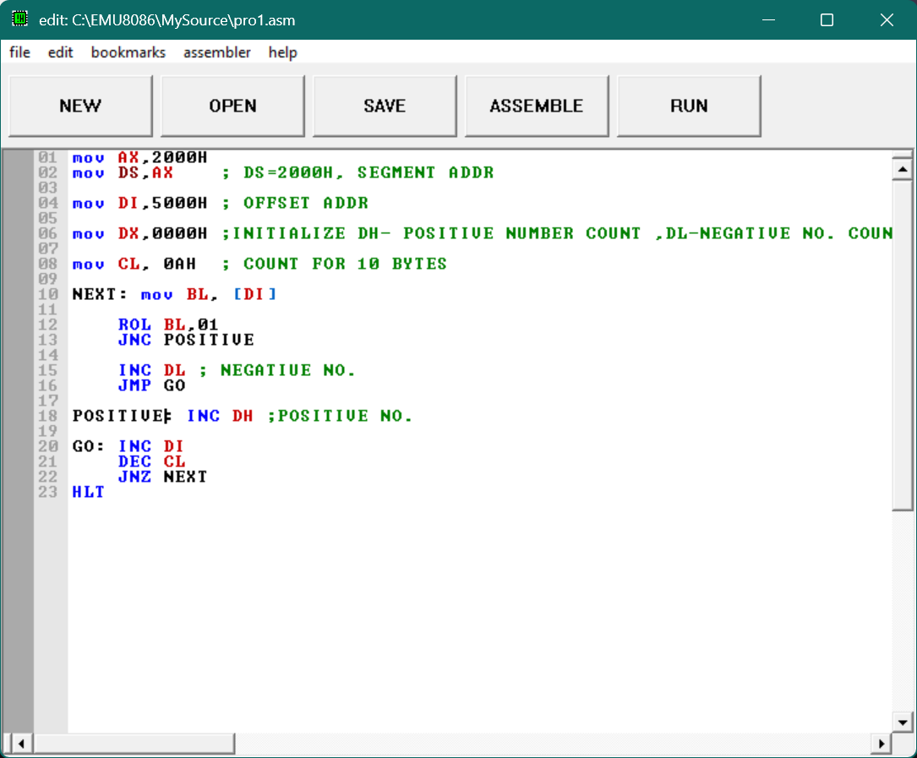
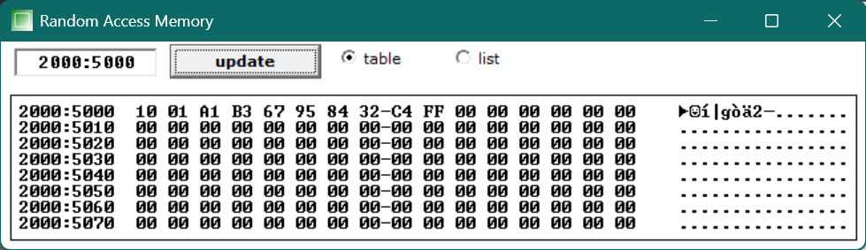

Output:
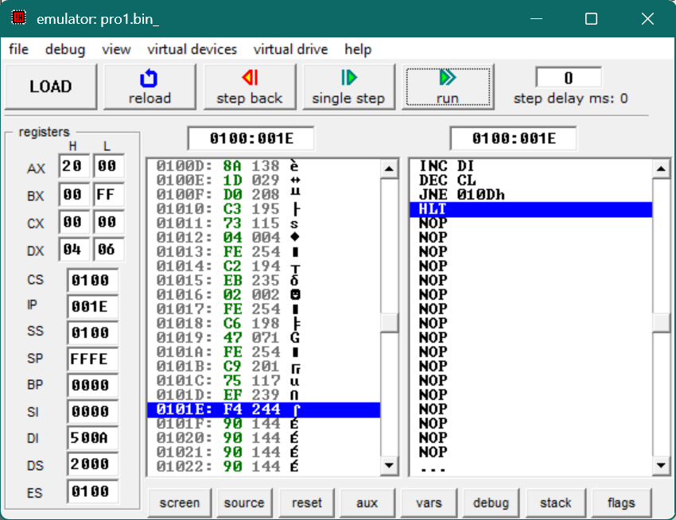

Result:

4 - positive numbers (01, 10, 67, 32) and 6 - negative numbers (A1, B3 C4, FF, 95, 84)

Conclusion: (specify the concepts learnt in this experiment)

In this experiment, I learnt how to count positive and negative numbers stored in memory, signed number representation, conditional jumps and practiced loop construction in 8086 assembly language..

Signature of faculty in-charge

