Batch: A3 Roll No.: 16010324044
Experiment No. 04
Grade: AA / AB / BB / BC / CC / CD /DD

Signature of the Staff In-charge with date

TITLE: Palindrome

AIM: Write an Assembly Language Program of 8086 to find whether the given string is palindrome or not.

OUTCOME:
Student will be able to develop programming skills using instruction set of microprocessor 8086.

Assumptions about data:
Before Execution

Memory Location Address | Data
1000:2000 | 11
1000:2001 | 22
1000:2002 | 33
1000:2003 | 44
1000:2004 | 11

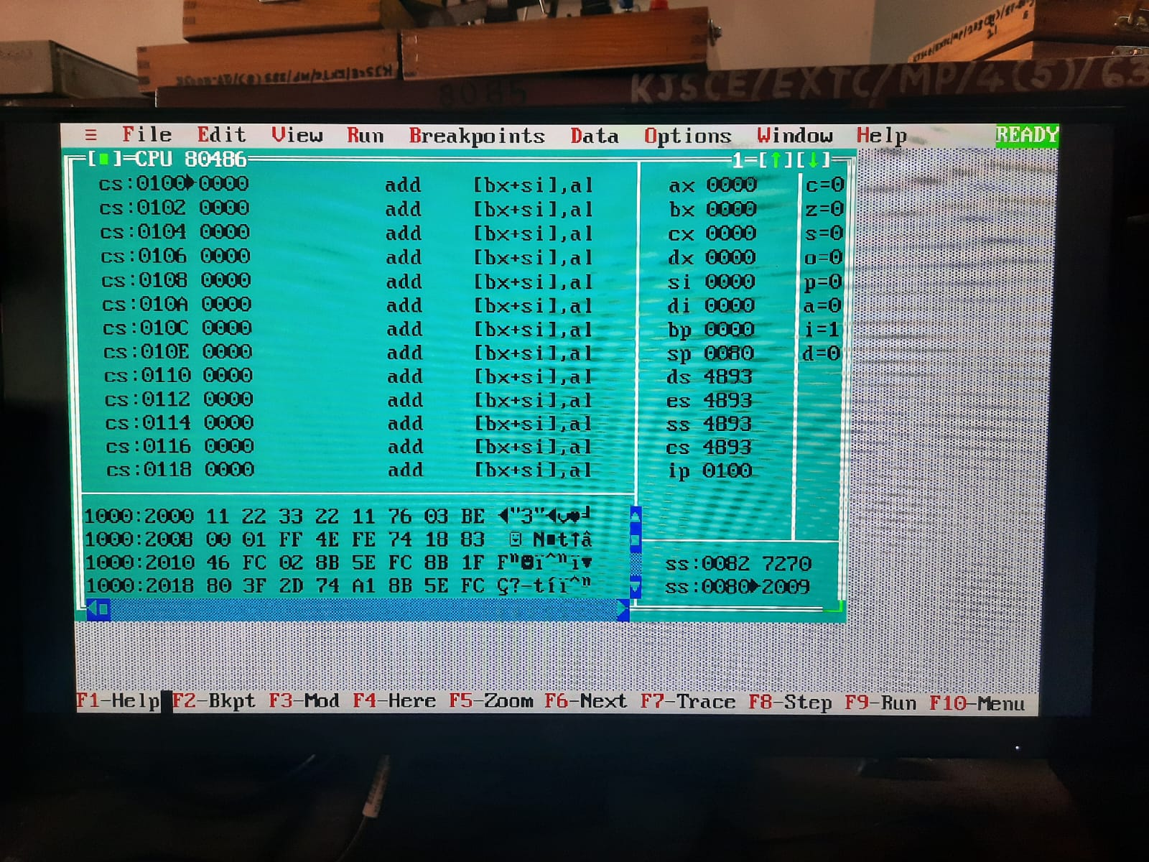

Program:

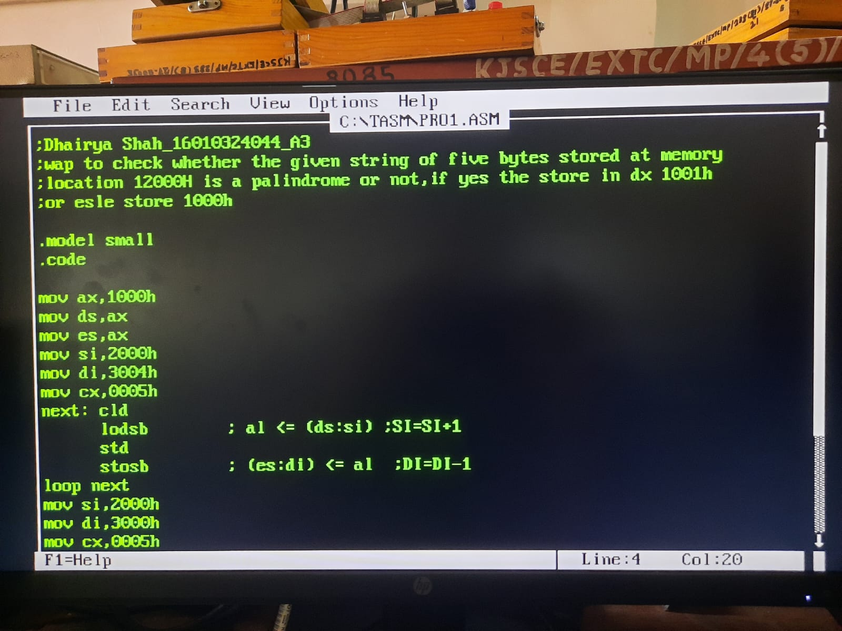
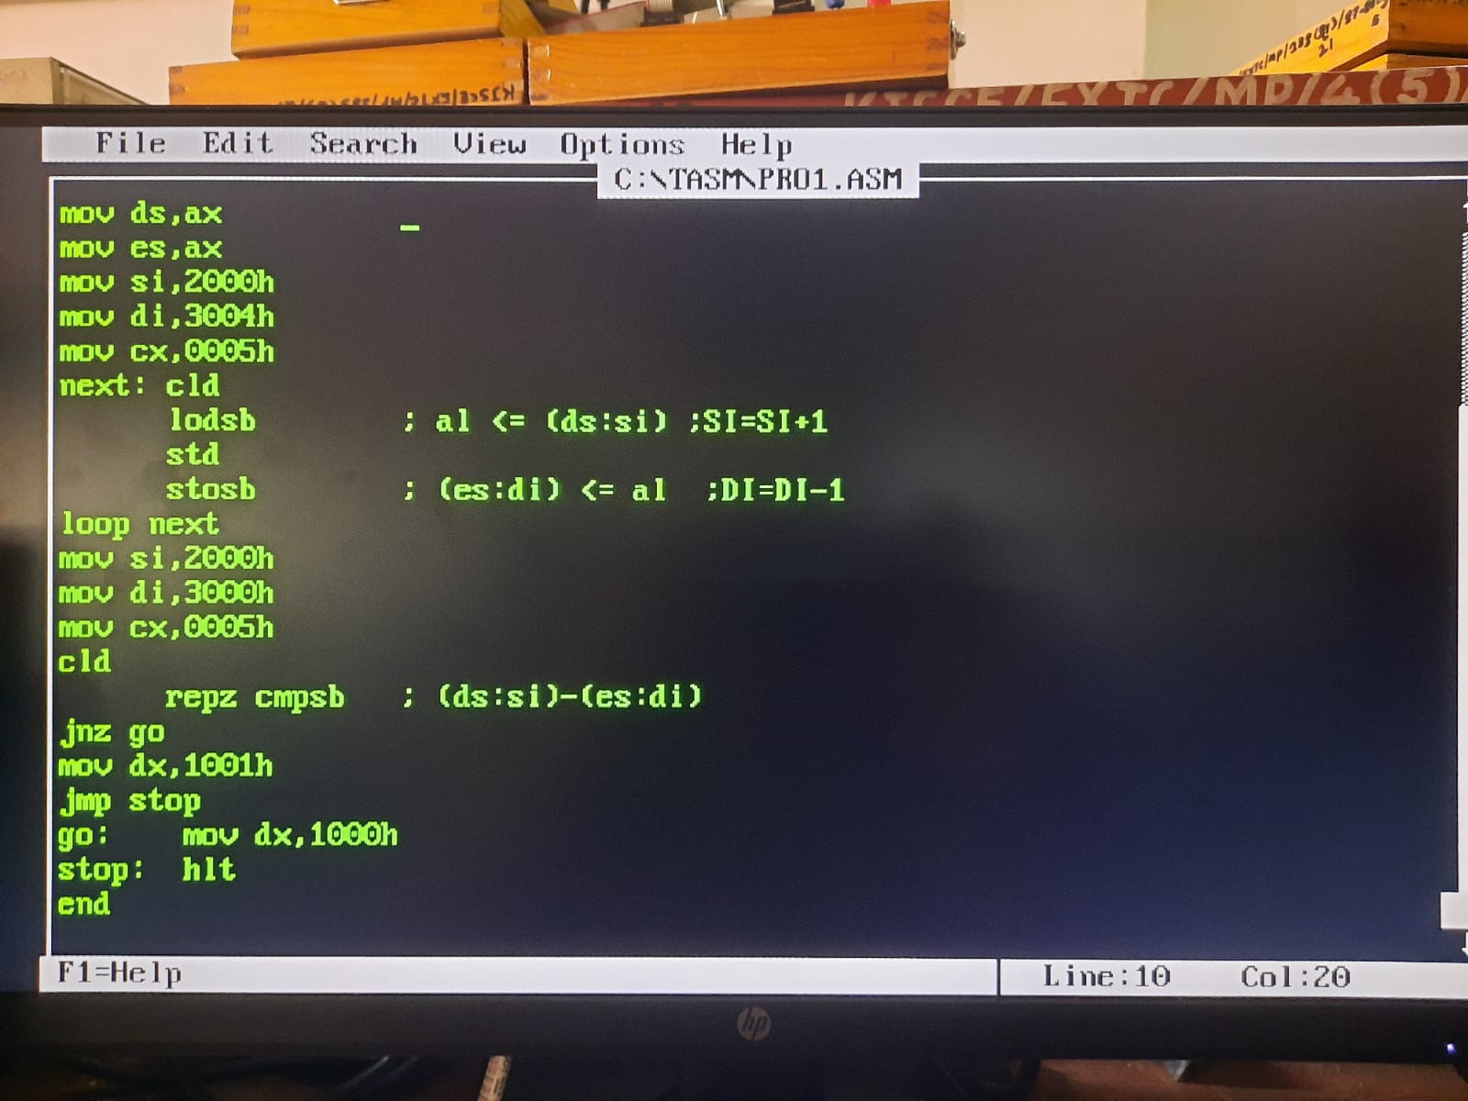

Result:

Memory LocationAddress | Data
1000:3000 | 11
1000:3001 | 22
1000:3002 | 33
1000:3003 | 22
1000:3004 | 11

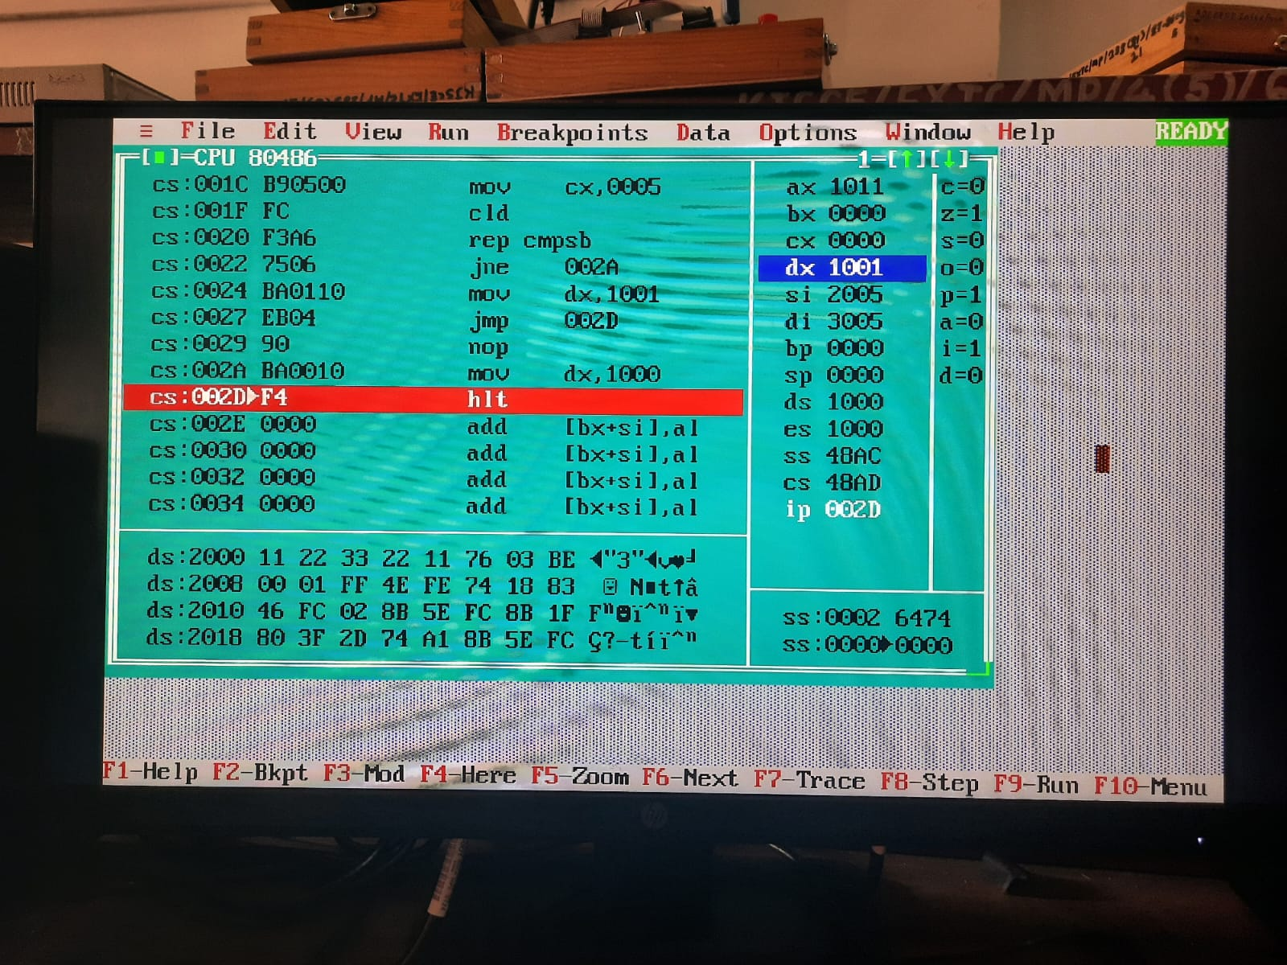
Conclusion: (specify the concepts learnt in this experiment)

In this experiment, I learned how to use loadsb, stosb, loop, jmp and jnz. Also understood the purpose and how to use the direction flag with std and cld.
I learnt string manipulation and logic building in assembly language to check whether a given string is a palindrome or normal string.

Signature of faculty in-charge

