


Batch: A3 Roll No.: 16010324044
Experiment No. 5
Grade: AA / AB / BB / BC / CC / CD /DD


Signature of the Staff In-charge with date

TITLE: Reverse Block Transfer

AIM: Write an Assembly Language Program for 8051 to Reverse the Block of bytes stored in consecutive memory locations and Transfer it to other memory locations.

OUTCOME:
Student will be able to develop programming skills using instruction set of microprocessor 8051

Assumptions about data:
Before Execution

Memory Location Address | Data
D:30h | 01
D:31h | 02
D:32h | 03
D:33h | 04
D:34h | 05
D:35h | 06
D:36h | 07
D:37h | 08
D:38h | 09
D:39h | 10

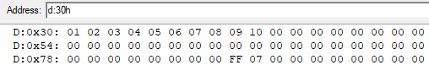
Program:
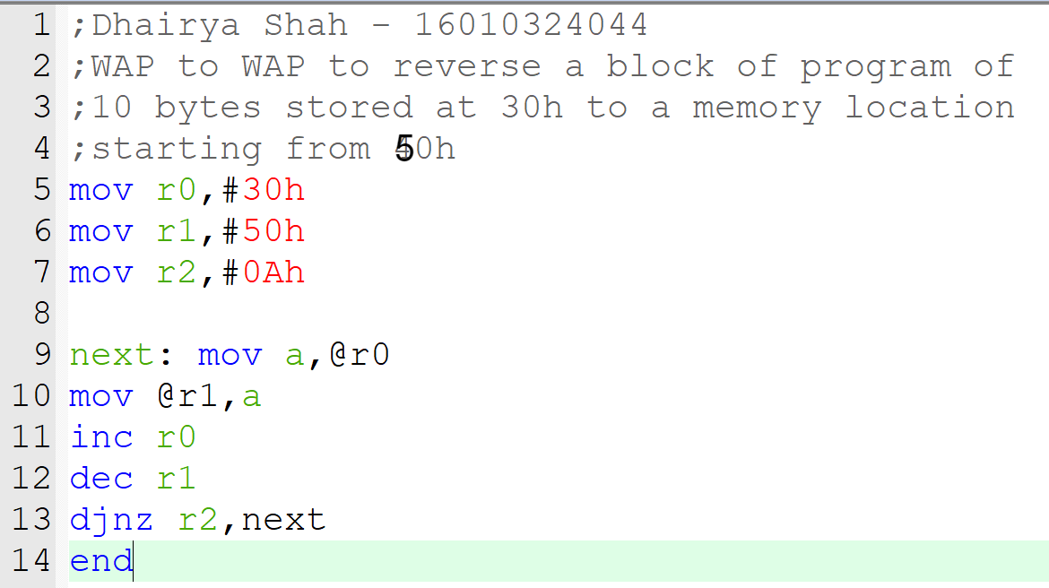

Result:
Before Execution After Execution

Memory Location Address | Data |  | Memory Location Address | Data
D:50h | 00 |  | D:50h | 01
D:49h | 00 |  | D:49h | 02
D:48h | 00 |  | D:48h | 03
D:47h | 00 |  | D:47h | 04
D:46h | 00 |  | D:46h | 05
D:45h | 00 |  | D:45h | 06
D:44h | 00 |  | D:44h | 07
D:43h | 00 |  | D:43h | 08
D:42h | 00 |  | D:42h | 09
D:41h | 00 |  | D:41h | 10

Conclusion: (specify the concepts learnt in this experiment)

In this experiment, I learned how to reverse a block of data, apply data transfer instructions, and understand memory handling for an 8051 microcontroller in assembly programming.

Signature of faculty in-charge

