


Batch: A3 Roll No.: 16010324044
Experiment No. 6
Grade: AA / AB / BB / BC / CC / CD /DD


Signature of the Staff In-charge with date

TITLE: Block Addition

AIM: Write an Assembly Language Program for 8051 to add the block of 5 numbers stored in consecutive memory locations and store the result in the memory.

OUTCOME:
Student will be able to develop programming skills using instruction set of microprocessor 8051

Assumptions about data:
Before Execution

Memory Location Address | Data
30H | 11H
31H | 12H
32H | 13H
33H | 14H
34H | 15H
35H | 16H
36H | 17H

Program:

Instructions/Mnemonics | Comments
MOV R0, #30H | Load starting address of data block
MOV R1, #07H | Load counter with number of data bytes (7)
MOV R2, #00H | Clear high byte of result
CLR A | Clear accumulator (low byte of sum)
GO: ADD A, @R0 | Add data at memory location pointed by R0
JNC NEXT | If no carry, jump to NEXT
INC R2 | If carry, increment high byte
NEXT: INC R0 | Move to next memory location
DJNZ R1, GO | Decrement counter and repeat until zero
MOV 40H, A | Store result low byte at 40H
MOV 41H, R2 | Store result high byte at 41H
END | End of program

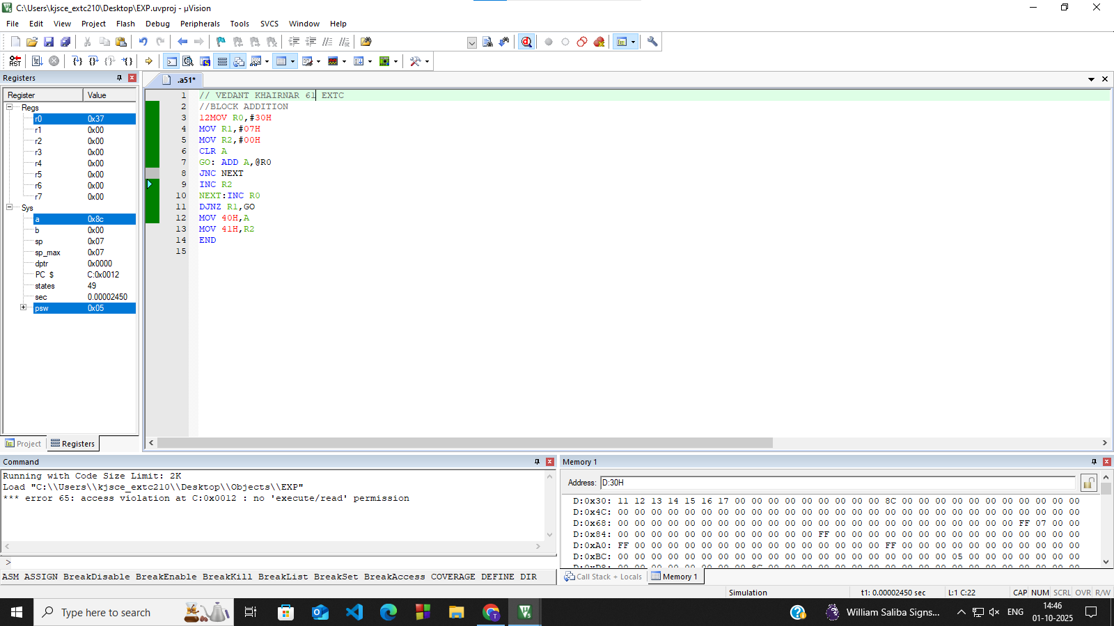

Result:

Memory Location Address | Data
40H | 8CH
41H | 00H

Conclusion: (specify the concepts learnt in this experiment)
In this experiment, I learnt how to do block addition using the 8051 microcontroller. It also gave me a better understanding of indirect addressing (@R0), loop control using DJNZ, and carry management
with JNC.

Signature of faculty in-charge

