Batch: 44 | Roll No.: 16010324044
Experiment No. 7
Grade: AA / AB / BB / BC / CC / CD /DD

Signature of the Staff In-charge with date

TITLE: Generation of Square wave using Timers of 8051
AIM: Write a program of 8051 to generate a square wave using on-chip Timers.

OUTCOME:

Students will be able to develop programming skills using instruction set of microcontroller 8051.

Diagram:

Timer 0 in Mode 1

TMOD: (Draw Control Word Format and Control Word obtained)

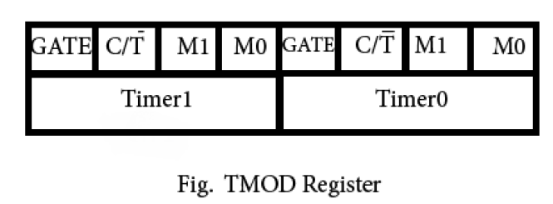

TCON: (Control Word Format and Control Word obtained)

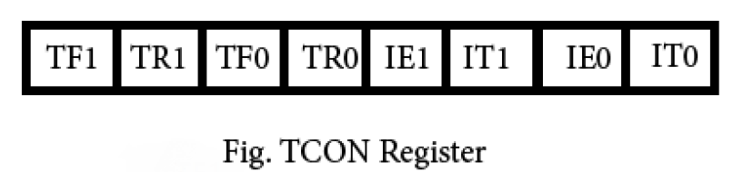

Program:
CLR P1.0 ;
AGAIN:MOV TMOD,#01H ; timer 0 in mode 1
MOV TL0,#0CH ;
MOV TH0,#0FEH ; load the timer with initial count
SETB TR0 ; START TIMER 0
HERE:JNB TF0 ,HERE ;
CPL P1.0 ; COMPLIMENT P1.0
CLR TR0 ; STOP THE TIMER
CLR TF0 ; CLEAR THE TIMER FLAG
SJMP AGAIN

//square wave of 1 KHz,Timer0 in mode 1,Crystal freq=12MHz

Result (Waveform Obtained):
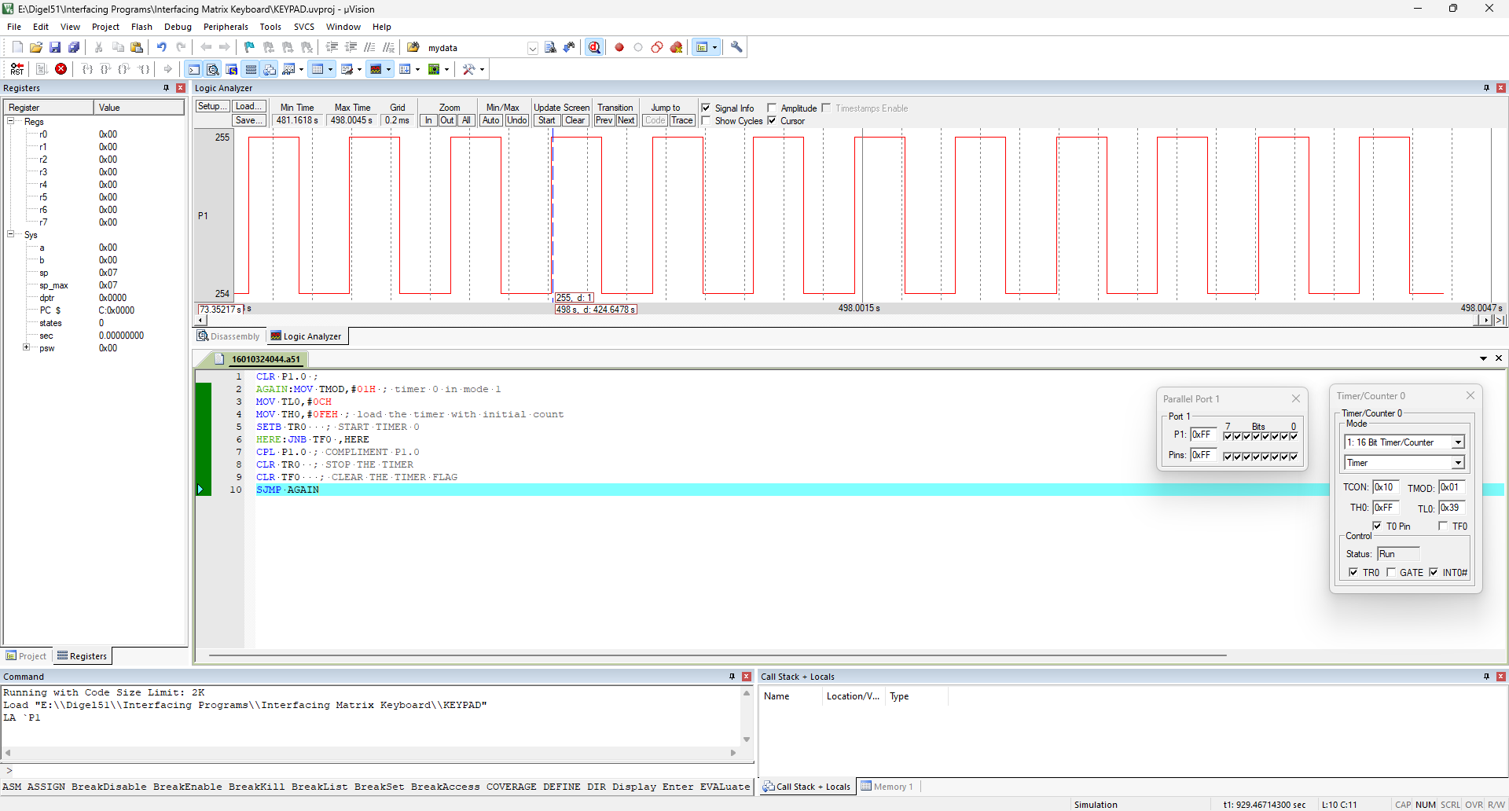

Conclusion: : (specify the concepts learnt in this experiment)

In this experiment, I learned how to use the 8051 timer in mode 1 for generating a square wave. I understood timer registers, control words, and port pin toggling, in assembly language programming.

Signature of faculty in-charge

