
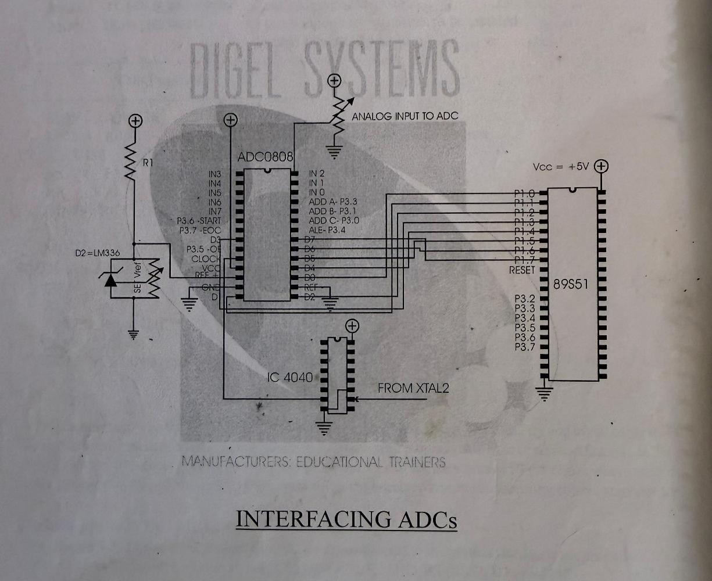



K. J. Somaiya College of Engineering, Mumbai-77
(A Constituent College of Somaiya Vidyavihar University)
Batch: A3 Roll No.: 16010324044
Experiment No. 8
Grade: AA / AB / BB / BC / CC / CD /DD Signature of the Staff In-charge with date
TITLE: Interfacing of ADC with 8051
AIM: Design a ADC interface for 8051 and write a program to convert an analog signal to its equivalent digital value.

OUTCOME:
Students will be able to understand the interfacing of peripheral ICs with 8051 to design various applications.
Diagram of Interfacing of ADC:


K. J. Somaiya College of Engineering, Mumbai-77
(A Constituent College of Somaiya Vidyavihar University)

Explanation of ADC interfacing with 8051 (Communication between ADC and 8051):

- Configure Ports:
  - Set the data port (e.g., P1) as input to read ADC output.
  - Configure control lines (ALE, START, OE, EOC, ADDR_A/B/C for channel selection) on Port 3.
- Select ADC Channel (if applicable):
  - Use ADDR_A, ADDR_B, ADDR_C to select the desired channel for multi-channel ADCs.
- Start Conversion:
  - Set ALE high to latch the address.
  - Apply a START pulse (set START high, then low) to begin conversion.
- Monitor End of Conversion (EOC):
  - Poll the EOC pin; it goes high when conversion completes.
- Read Digital Data:
  - Set OE high to enable ADC output.
  - Read the converted digital data from the data port (P1).
- Reset for Next Conversion:
  - Clear OE and START to reset the ADC.



Program:
K. J. Somaiya College of Engineering, Mumbai-77
((A Constituent College of Somaiya Vidyavihar University)

Mnemonic | Comment
ADDR_C BIT P3.0 | Define ADDR_C as bit P3.0 – used for addressing channel C on ADC
ADDR_B BIT P3.1 | Define ADDR_B as bit P3.1 – used for addressing channel B on ADC
ADDR_A BIT P3.3 | Define ADDR_A as bit P3.3 – used for addressing channel A on ADC
ALE BIT P3.4 | Define ALE as bit P3.4 – used as Address Latch Enable for ADC
OE BIT P3.5 | Define OE as bit P3.5 – used as Output Enable for ADC
START BIT P3.6 | Define START as bit P3.6 – used to start the ADC conversion
EOC BIT P3.7 | Define EOC as bit P3.7 – used to monitor End of Conversion from ADC
ORG 0000H | Set origin (starting address) of the program to 0000H
MOV P1, #0FFH | Make Port 1 an input port by writing all 1s
SETB EOC | Set EOC (End of Conversion) bit high initially
CLR ALE | Clear ALE to prepare for the next ADC operation
CLR START | Clear START to initialize the ADC
CLR OE | Clear OE (Output Enable) to disable ADC output initially
NEXT_SAMPLE: | Label for the start of a new ADC sample sequence
CLR ADDR_C | Clear ADDR_C to select channel 2 on the ADC
SETB ADDR_B | Set ADDR_B to select channel 2 on the ADC
CLR ADDR_A | Clear ADDR_A to select channel 2 on the ADC
NOP | No Operation – short delay for address setup
SETB ALE | Set ALE (Address Latch Enable) to latch the address bits into ADC
NOP | No Operation – short delay after setting ALE
SETB START | Apply a START pulse to initiate ADC conversion
NOP | No Operation – delay after starting ADC conversion



K. J. Somaiya College of Engineering, Mumbai-77
(A Constituent College of Somaiya Vidyavihar University)

CLR ALE | Clear ALE after starting the conversion
CLR START | Clear START to prepare for the next cycle
JB EOC, $ | Wait for EOC to go high (polling EOC) to check if conversion is complete
JNB EOC, $ | Keep waiting until EOC goes low, indicating the conversion is finished
SETB OE | Set OE to enable ADC output (ready to read the converted value)
HERE: SJMP HERE | Infinite loop to hold the program here after conversion
END | End of program

Results:

Analog Input | Digital Output
0 | 00000000
0.5 | 00100000
1 | 00111111
1.5 | 01011100
2 | 01111011
2.5 | 10011010
3 | 10111001
3.5 | 11010010
4 | 11110001
4.27 | 11111111

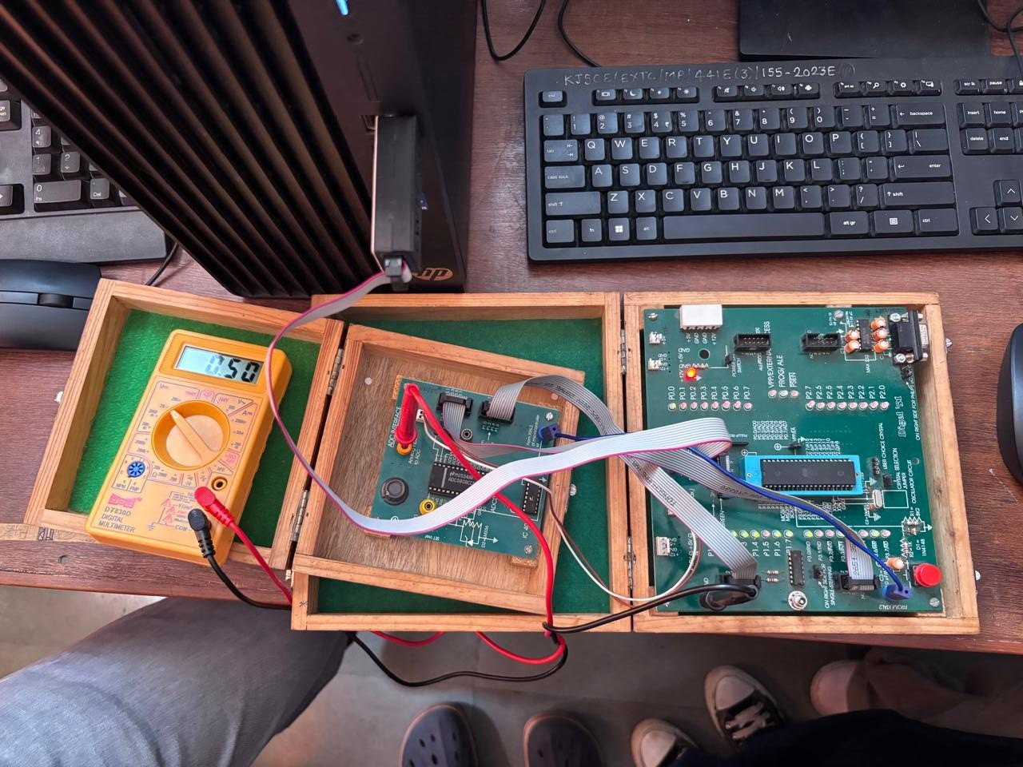



K. J. Somaiya College of Engineering, Mumbai-77
(A Constituent College of Somaiya Vidyavihar University)

Conclusion: (specify the concepts learnt in this experiment)

In this experiment, I learnt ADC interfacing for 8051 and successfully converted analog signals to digital signals. I also learnt concepts like ADC, microcontroller port configuration, digital communication with ADC, timing and polling techniques.

Signature of faculty in-charge

