Batch: A3 | Roll No.: 16010324044
Experiment No. 9
Grade: AA / AB / BB / BC / CC / CD /DD

Signature of the Staff In-charge with date

TITLE: Interfacing LCD with 8051

AIM: Design an LCD interface with 8051 and a program to display a message on the LCD screen.

OUTCOME:

Students will be able to understand the interfacing of peripheral device with 8051 to design various applications.

Diagram-Interfacing of LCD with Microcontroller:

Explanation (in brief): (LCD initialization and steps used to give command and data
to the LCD)
To initialize LCD to 8051 the following instructions and commands are embedded into
the functions.
1. 0X38 is used for 8 bit data initialization
2. 0X0C for making LCD Display on and cursor off
3. 0X01 for clearing the display of LCD
4. 0X80 for positioning the cursor at the first line.
Commands to LCD:
1. E=1, enable pin should be high
2. RS=0, Register select pin should be low for sending commands
3. Setting data on data registers
4. R/W=0, Read/Write pin should be low
Data to LCD:
1. E=1, enable pin should be high
2. RS=1, Register select should be high for writing data
3. Placing the data on data register
4. R/W=0, Read/ Write pin should be low for writing data

Program: (Attach Printout of Program)
; This program displays 'DHAIRYA' on LCD ;
;------------------------------------------------------;
ORG 0000h
LCDISP:
MOV A,#3Ch
ACALL COMMAND
MOV A,#0Eh
ACALL COMMAND
MOV A,#06h
ACALL COMMAND
MOV A,#01h
ACALL COMMAND
MOV A,#87h
ACALL COMMAND
MOV A,#'D'
ACALL DISPLAY
MOV A,#'H'
ACALL DISPLAY
MOV A,#'A’
ACALL DISPLAY
MOV A,#'I'
ACALL DISPLAY
MOV A,#'R'
ACALL DISPLAY
MOV A,#'Y'
ACALL DISPLAY
MOV A,#'A'
ACALL DISPLAY
HERE: SJMP HERE
;LCD strobe subroutine
COMMAND:
ACALL READY
MOV P1,A
CLR P3.3
CLR P3.4
SETB P3.5
CLR P3.5
RET
DISPLAY:
ACALL READY
MOV P1,A
SETB P3.3
CLR P3.4
SETB P3.5
CLR P3.5
RET
READY: CLR P3.5
MOV P1,#0FFh
CLR P3.3

Results:
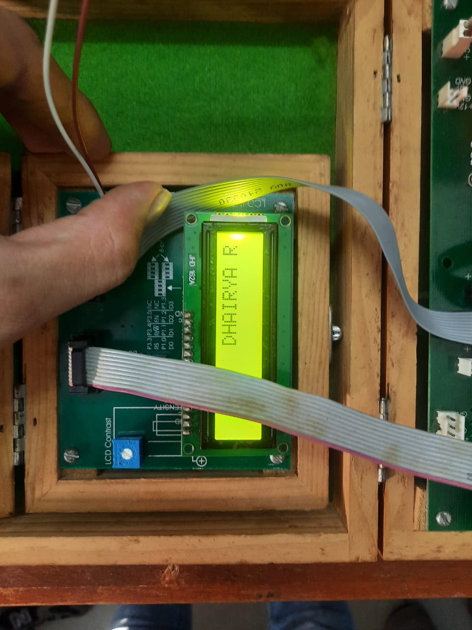

Conclusion: (specify the concepts learnt in this experiment)
From the above experiment we can learn how to design and implement a program to interface the required output on peripheral devices for e.g. LCD interfacing with
89C51 or 8051 by using LCD display.

Signature of faculty in-charge

