Batch: A3
Group No.: 4
Experiment / assignment / tutorial No. 10 Grade: AA / AB / BB / BC / CC / CD /DD
Signature of the Staff In-charge with date
TITLE: Mini project
AIM: To implement an RFID-based authentication system that verifies specific card IDs and displays the validation result on a 16x2 LCD using an MSP430 microcontroller.
OUTCOME: Students will be able to apply programming skills to develop application using MSP430/LPC 2148

- Group Members:
Dhairya M Shah | 16010324044
Dhrumit C Shah | 16010324045

Software requirement:
  - Code Composer and Energia IDE: An open-source electronics prototyping platform used to program TI Microcontrollers.
  - LiquidCrystal Library: Used for interfacing the 16x2 LCD with the MSP430

Hardware tool:
  - MSP430 Launchpad (MSP-EXP430G2): The main microcontroller development board.
  - EM-18 RFID Reader Module: A 125 KHz reader that outputs serial data.
  - 16x2 LCD Display: To display the RFID card ID.
  - RFID Tags/Cards: Unique ID carriers for testing.
  - Potentiometer (10k): For adjusting the LCD contrast.
  - Breadboard and Jumper Wires: For circuit connections.
  - Power Source: 5V (for EM-18) and USB cable (for MSP430).
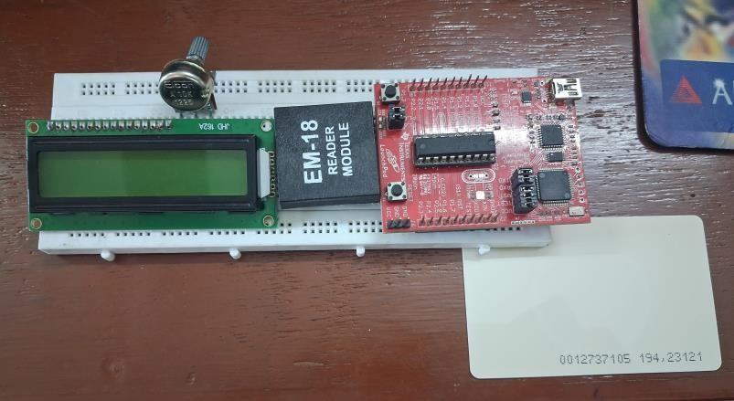

Abstract:
Radio Frequency Identification (RFID) technology is widely used for wireless identification and authentication. This project demonstrates how to interface an EM-18 RFID reader with a TI MSP430 Launchpad.
When an RFID tag is brought near the reader, the EM-18 reads its unique 12-digit ASCII ID and transmits it to the MSP430 via UART serial communication. The microcontroller then processes this data and displays the specific card number on a 16x2 LCD. This system serves as a foundation for security systems, attendance trackers, and inventory management
This project implements an automated RFID-based Attendance Tracking System using the MSP430 Launchpad. Traditional manual attendance is prone to errors and "proxy" entries; this system mitigates those issues by assigned a unique RFID tag to each user. When a tag is scanned by the EM- 18 reader, the MSP430 verifies the ID against a local database or logs the entry with a timestamp.
This provides a contactless, fast, and secure method for monitoring presence in schools or workplaces

Block diagram:
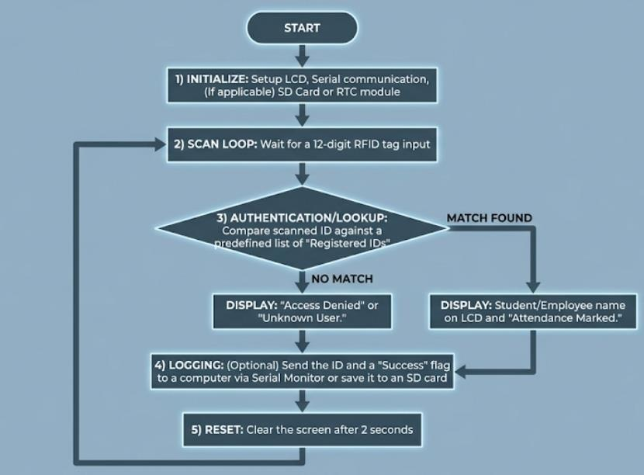

- Algorithm:

- Initialize: Setup LCD, Serial communication, and (if applicable) an SD Card or RTC (Real-Time Clock) module.
- Scan Loop: Wait for a 12-digit RFID tag input.
- Authentication/Lookup: Compare the scanned ID against a predefined list of "Registered IDs" in the code.
  - If match found: Display the student/employee name on the LCD and "Attendance Marked."
  - If no match: Display "Access Denied" or "Unknown User."

- Logging: (Optional) Send the ID and a "Success" flag to a computer via Serial Monitor or save it to an SD card.
- Reset: Clear the screen after 2 seconds and wait for the next person

- Circuit Schematic:
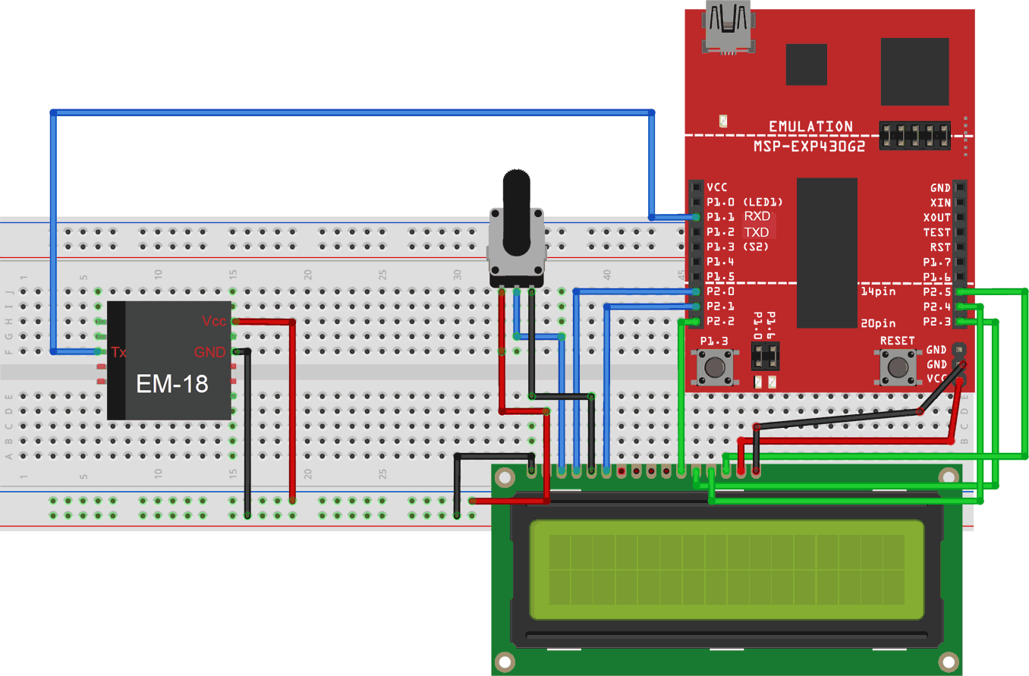
- Source code
- Code Composer Program:

#include <msp430.h> #include <string.h>

#define RS BIT0
#define EN BIT3 // Moved to P1.3 to free P1.1 for UART RX #define LCD_DATA (BIT4 | BIT5 | BIT6 | BIT7)

char rfid_buffer[12]; int count = 0;
int card_ready = 0;

void pulse_en() { P1OUT |= EN;
delay_cycles(200); P1OUT &= ~EN;
delay_cycles(200);
}

void lcd_cmd(unsigned char cmd) {
delay_cycles(1000);
P1OUT = (P1OUT & ~LCD_DATA) | (cmd & 0xF0); P1OUT &= ~RS;
pulse_en();
P1OUT = (P1OUT & ~LCD_DATA) | ((cmd << 4) & 0xF0);
pulse_en();
}

void lcd_data(unsigned char data) {
delay_cycles(1000);
P1OUT = (P1OUT & ~LCD_DATA) | (data & 0xF0); P1OUT |= RS;
pulse_en();
P1OUT = (P1OUT & ~LCD_DATA) | ((cmd << 4) & 0xF0); // Error fix: data << 4
P1OUT = (P1OUT & ~LCD_DATA) | ((data << 4) & 0xF0);
pulse_en();
}
void lcd_print(char *str) { while(*str) lcd_data(*str++);
}

void lcd_init() {
P1DIR |= (RS | EN | LCD_DATA);
delay_cycles(20000); lcd_cmd(0x33); lcd_cmd(0x32); lcd_cmd(0x28); lcd_cmd(0x0C); lcd_cmd(0x01);
delay_cycles(2000);
}
void uart_init() {
P1SEL |= BIT1 | BIT2; // P1.1 = RXD, P1.2 = TXD P1SEL2 |= BIT1 | BIT2;
UCA0CTL1 |= UCSWRST;
UCA0CTL1 |= UCSSEL_2; // SMCLK UCA0BR0 = 104; // 9600 Baud at 1MHz UCA0BR1 = 0;
UCA0MCTL = UCBRS0; UCA0CTL1 &= ~UCSWRST;
IE2 |= UCA0RXIE; // Enable RX interrupt
}

void main(void) {
WDTCTL = WDTPW | WDTHOLD;
BCSCTL1 = CALBC1_1MHZ; // Set DCO to 1MHz DCOCTL = CALDCO_1MHZ;

lcd_init(); uart_init();
enable_interrupt();

while(1) {
lcd_cmd(0x01); // Clear lcd_cmd(0x80); lcd_print("Welcome and"); lcd_cmd(0xC0); lcd_print("please scan card");

chars
while(!card_ready); // Wait for UART interrupt to collect 12

// Check if the scanned card matches your ID
// EM-18 sends 10 chars + 2 checksum. We check first 10. if (strncmp(rfid_buffer, "0012737105", 10) == 0) {
delay_cycles(100000); // Small debounce lcd_cmd(0x01);
lcd_cmd(0x80); lcd_print("Welcome NP"); lcd_cmd(0xC0);
lcd_print("00127281158");

delay_cycles(4000000); // 4 Second Delay
} else {
lcd_cmd(0x01); lcd_cmd(0x80); lcd_print("Unknown Card");
delay_cycles(2000000);
}

card_ready = 0;
count = 0;
}
}
#pragma vector=USCIAB0RX_VECTOR
interrupt void USCI0RX_ISR(void) { rfid_buffer[count++] = UCA0RXBUF; if (count == 12) {
card_ready = 1;
}
}

Energia Code:
#include <LiquidCrystal.h>
// Initialize LCD: RS, EN, D4, D5, D6, D7 LiquidCrystal lcd(P1_0, P1_3, P1_4, P1_5, P1_6, P1_7);

char input[13]; // Buffer to store RFID tag ID (12 chars + null) int count = 0;

void setup() {
// EM-18 default baud rate is 9600 Serial.begin(9600);

lcd.begin(16, 2); showStandbyMessage();
}

void loop() {
// Check if data is available from EM-18 if(Serial.available()) {
while(Serial.available() && count < 12) { input[count] = Serial.read(); // Read the character count++;
delay(5); // Small delay for serial stability
}
// Once 12 characters are received if(count == 12) {
input[count] = '\0'; // Terminate string

lcd.clear(); lcd.setCursor(0, 0); lcd.print("Welcome NP"); lcd.setCursor(0, 1); lcd.print("0012728158");

delay(4000); // 4 second delay

// Reset for next scan count = 0; showStandbyMessage();
}
}
}

void showStandbyMessage() { lcd.clear(); lcd.setCursor(0, 0); lcd.print("Welcome and"); lcd.setCursor(0, 1);
lcd.print("please scan card");
}

SFRs configured in the source code:

  - Port 1 Control Registers (GPIO & Peripheral Selection)

    - P1DIR: Configures the direction of Port 1 pins. Specifically, bits BIT0 (RS), BIT3 (EN), and BIT4-BIT7 (Data lines) are set as outputs.
    - P1OUT: Used to drive the logic levels (High/Low) for the LCD's RS, EN, and 4-bit data bus.
    - P1SEL & P1SEL2: These are critical for the UART. They are configured to bypass standard GPIO and enable the USCI_A0 hardware peripheral on pins P1.1 (RXD) and P1.2 (TXD).

  - USCI_A0 UART Control Registers

    - UCA0CTL1:
      - Set to UCSWRST (Software Reset) during configuration.
      - Set to UCSSEL_2 to select SMCLK (Sub-Main Systems Clock) as the frequency source for the baud rate generator.
    - UCA0BR0 & UCA0BR1: The Baud Rate Control registers. UCA0BR0 = 104 (with BR= 0) sets the clock prescaler to achieve 9600 Baud from a 1MHz clock source.
    - UCA0MCTL: The Modulation Control Register. UCBRS0 is used to fine-tune the baud rate clock transitions to minimize errors.

  - Interrupt & System Registers

    - IE2: The Interrupt Enable register. UCA0RXIE is set to allow the CPU to jump to the Interrupt Service Routine (ISR) whenever a new byte is received from the RFID reader.
    - IFG2: (Accessed implicitly) The Interrupt Flag register where UCA0RXIFG is cleared automatically when you read UCA0RXBUF.
    - UCA0RXBUF: The Receive Buffer register where the incoming RFID character is stored until the code moves it to rfid_buffer.
    - WDTCTL: The Watchdog Timer Control register, set to WDTPW | WDTHOLD to stop the watchdog timer and prevent the MCU from resetting.
    - BCSCTL1 & DCOCTL: Basic Clock System registers used to calibrate the internal oscillator to a stable 1MHz frequency.

Procedure:

- Wiring:

  - LCD (Port 1): Connect RS → P1.0, EN → P1.3, and Data (D4–D7) → P1.4 to P1.7.
  - RFID: Connect EM-18 TX → P1.1 (RXD).
  - Power: Provide 5V to EM-18; connect all grounds (GND) together.
- Jumpers: Set MSP430 Launchpad RXD/TXD jumpers to HW UART mode.
- Software: Use Code Composer Studio (CCS) to compile and flash the C code to the MSP430.
- Testing: Power on and scan an RFID tag near the EM-18 antenna.

Verification:

  - Match: LCD shows "Welcome NP" for ID: 0012728158.
  - No Match: LCD shows "Unknown Card".

Observation: (Copy the screen shot for each program)

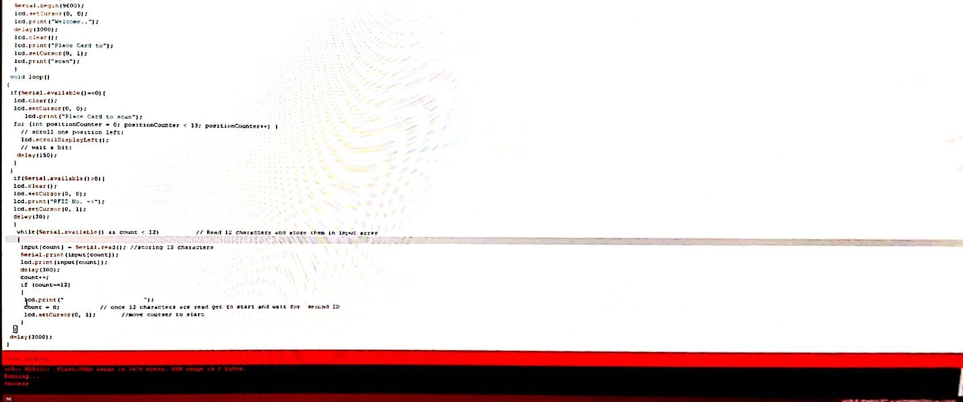
Energia IDE Interface showing successful upload of the program into MSP430

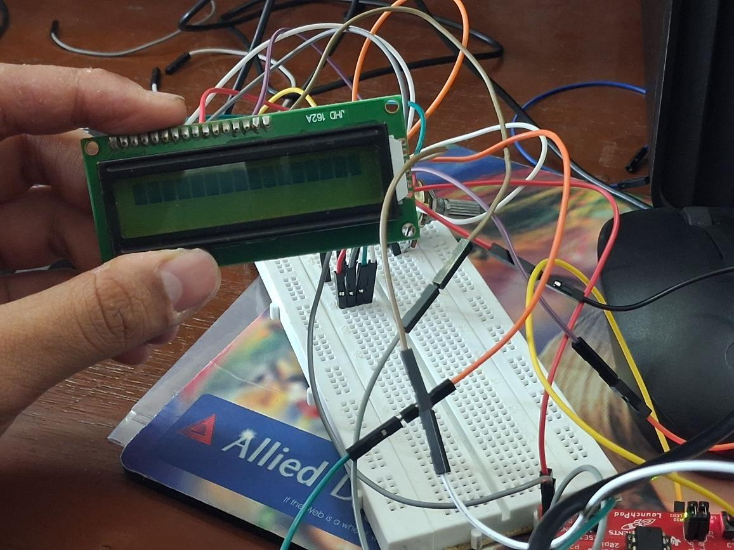
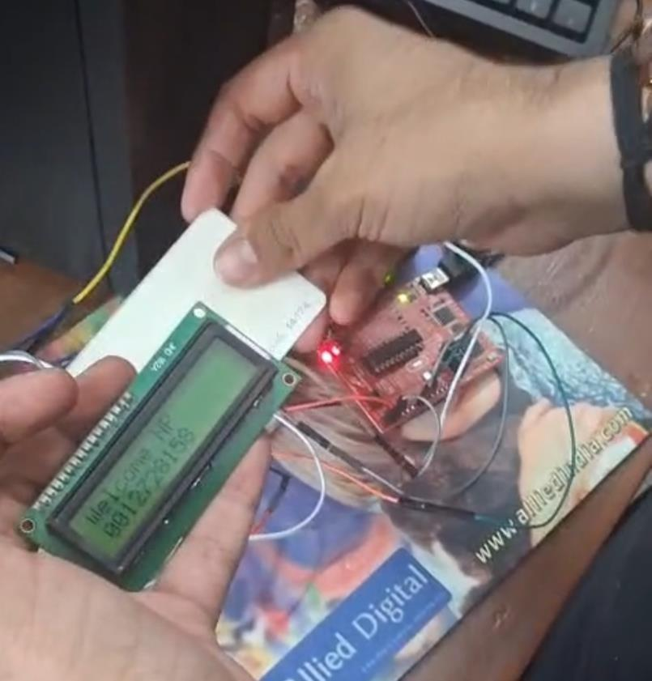

Conclusion:
The project successfully demonstrates the interfacing of an RFID module with the MSP430 Launchpad. By utilizing the Hardware UART of the MSP430, the system reliably captures data from the EM-18 reader. This setup provides a low-cost, efficient solution for identifying unique tags, which can be further integrated into IoT-based security systems or database- driven attendance logs.
This project successfully demonstrates a low-cost RFID security system using the MSP430’s Hardware UART to interface with the EM-18 reader. By leveraging hardware-level registers, the system ensures reliable data capture and real-time identification. The modular design serves as a robust foundation for more complex IoT security or automated attendance applications.

Signature of faculty in-charge with date

