Batch: A3 Roll No.: 16010324044
Experiment - 1
Grade: AA / AB / BB / BC / CC / CD /DD

Signature of the Staff In-charge with date

TITLE: Overview on MSP430G2 Launchpad & IDE
AIM: 1) To understand features and on chip peripherals MSP430 G2LP
2) Understand tools of Code composer IDE

OUTCOME: Students will be able to understand the features of MSP 430 family and usage of IDE tools for programming

MSP 430G2 LP overview:
Features:

• USB debugging and programming interface featuring a driverless installation and application UART serial communication with up to 9600 Baud
• Supports MSP430G2xx2, MSP430G2xx3, and MSP430F20xx devices in PDIP14 or PDIP20 packages
• Two general-purpose digital I/O pins connected to green and red LEDs for visual feedback
• Two push button for user feedback and device reset
• Easily accessible device pins for debugging purposes or as socket for adding customized extension boards
• High-quality 20-pin DIP socket for an easy plug-in or removal of the target device

Sr. No | Features | Comment
1 | No of pins | 20 pins
2 | No of bits can be accessed | 16-bit RISC architecture
3 | Flash memory | Up to 16 KB
4 | RAM | 512 Bytes
5 | CPU speed | Up to 16 MHz
6 | ADC bits | 10-bit ADC (MSP430G2553)

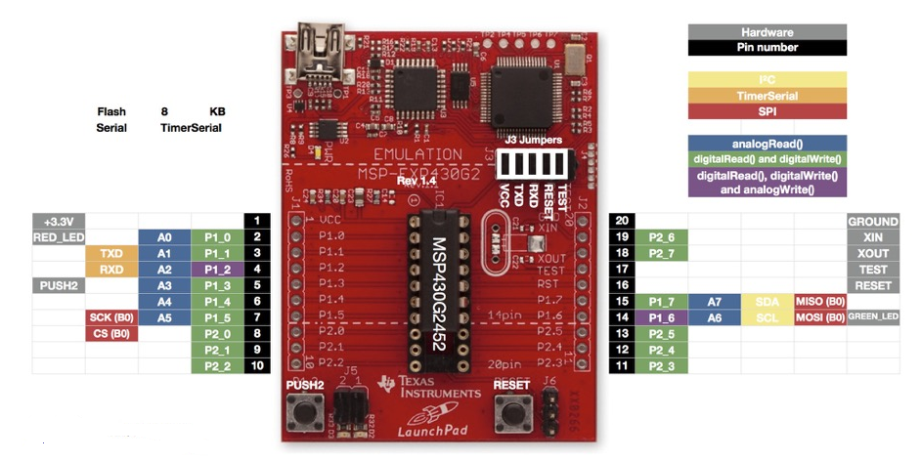

Figure 1: MSP430 board overview

Installation:
Installation of the MSP-EXP430G2 Launch Pad development kit consists of three easy steps:
1. Download the required software.
2. Install the selected IDE.
3. Connect the Launch Pad to the PC.
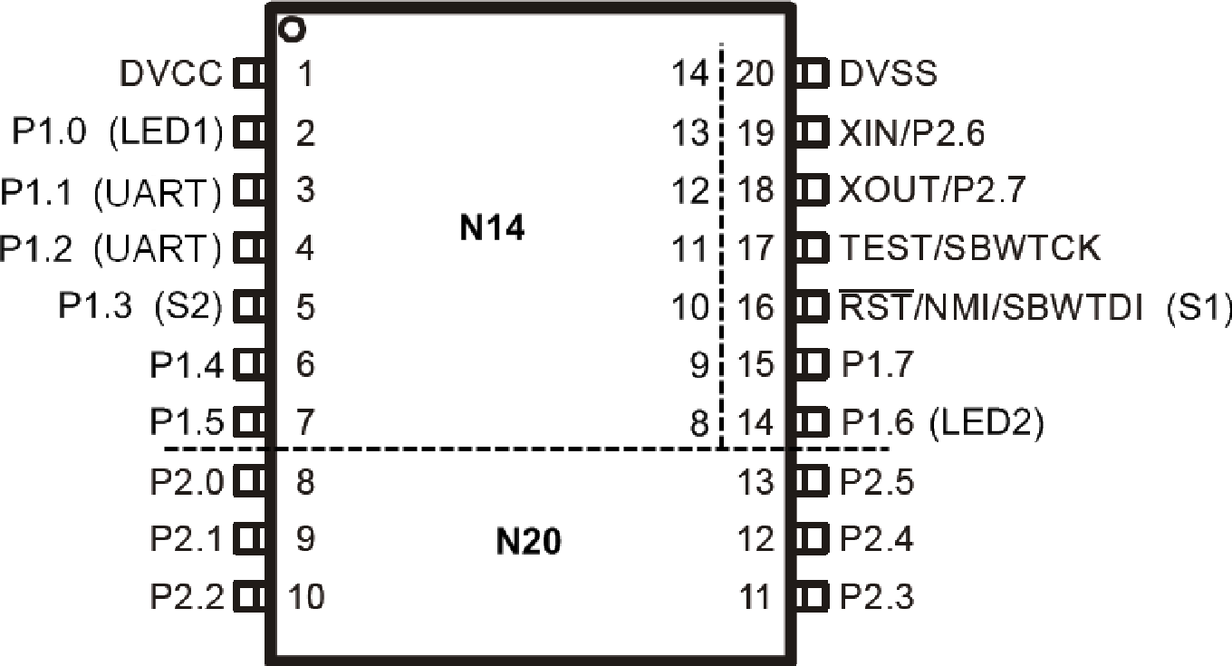

Figure2: Device pinout

2) IDE overview for debugging and downloading code
Code Composer Studio is an integrated development environment used for writing, compiling, debugging, and downloading programs into the MSP430 microcontroller. It provides tools like editor, compiler, debugger and register view.

1. CCS
(Students are expected to copy the screenshots of necessary procedure)
Download and install Code Composer Studio.
Connect the MSP430G2 LaunchPad to the PC using a USB cable.
Open CCS and create a new MSP430 project.
Write or load the sample program.
Build and debug the program.

Conclusion:
This experiment helped in understanding the MSP430G2 LaunchPad and its basic features. The use of Code Composer Studio for program development and debugging was also learned. This forms a base for further microcontroller programming experiments.

Signature of faculty in-charge with date

