Batch: A3 Roll No.: 16010324044
Experiment / assignment / tutorial No. 2
Grade: AA / AB / BB / BC / CC / CD /DD

Signature of the Staff In-charge with date

TITLE: MSP430 GPIO programming
AIM: 1) To understand registers of GPIO
2) To blink an LED with GPIO
OUTCOME: Students will be able to understand the features of MSP 430 family and usage of IDE to get proficiency in assembly and embedded C programming language and its usage for applications

Software requirement:
Code Composer Studio 8.0.0

Digital I/O
MSP430G2553 devices have up to eight digital I/O ports (P1 to P8). Each port has up to eight I/O pins that are configured with user software. Every I/O pin is individually configurable as input or output, and can be individually read or written to

The features of the digital I/O are:

• Independently programmable individual I/Os
• Any combination of input or output
• Individually configurable P1 and P2 interrupts
• Independent input and output data registers
• Individually configurable pull-up or pull-down resistors
• Individually configurable pin-oscillator function in some MSP430 devices
The MSP430G2553 has two general-purpose digital I/O pins connected to green LED (P1.6) and red LED (P1.0) on the MSP-EXP430G2 Launch Pad for visual feedback

Functional Block diagram:
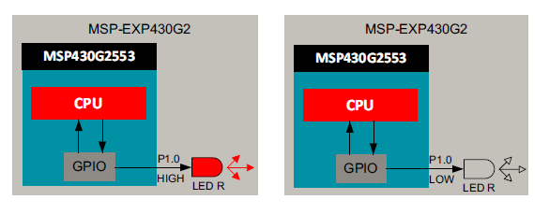
Figure: 1 Functional block diagram

Algorithm/Flowchart:
1. Start the program.
2. Stop the Watchdog Timer to prevent system reset.
3. Configure Port P1.0 (LED pin) as output by setting the corresponding bit in P1DIR. 4. Enter an infinite loop.
5. Set P1.0 HIGH to turn the LED ON.
6. Provide a delay for visible blinking.
7. Set P1.0 LOW to turn the LED OFF.
8. Provide another delay.

Source code: ( Embedded C program)
1.
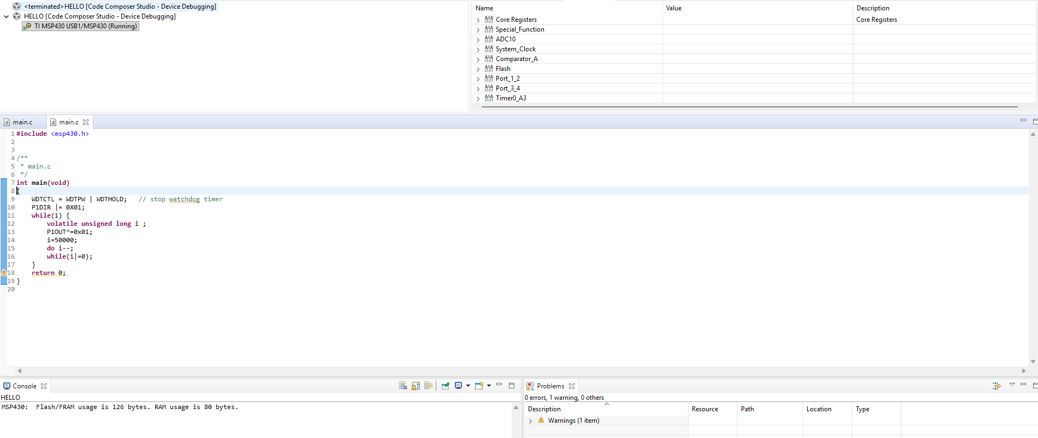
2.
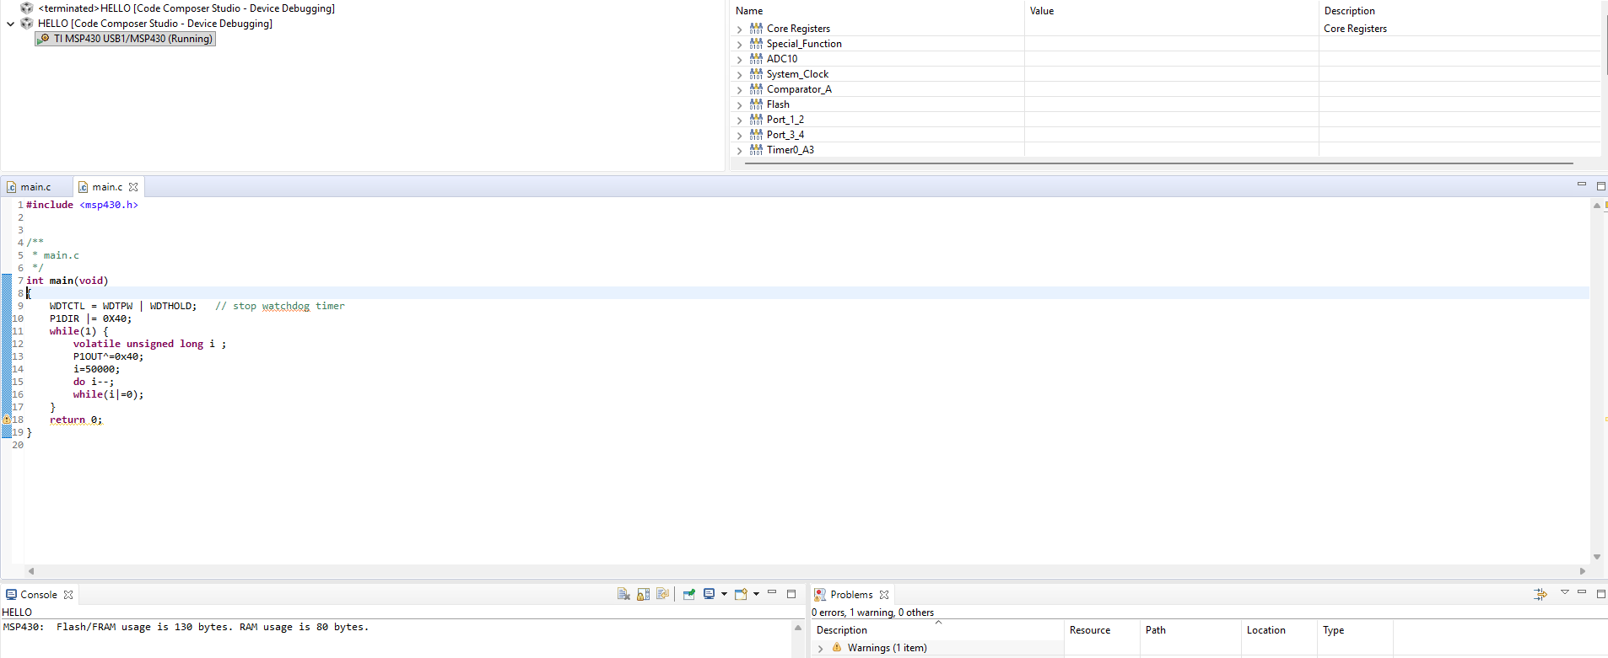
3.
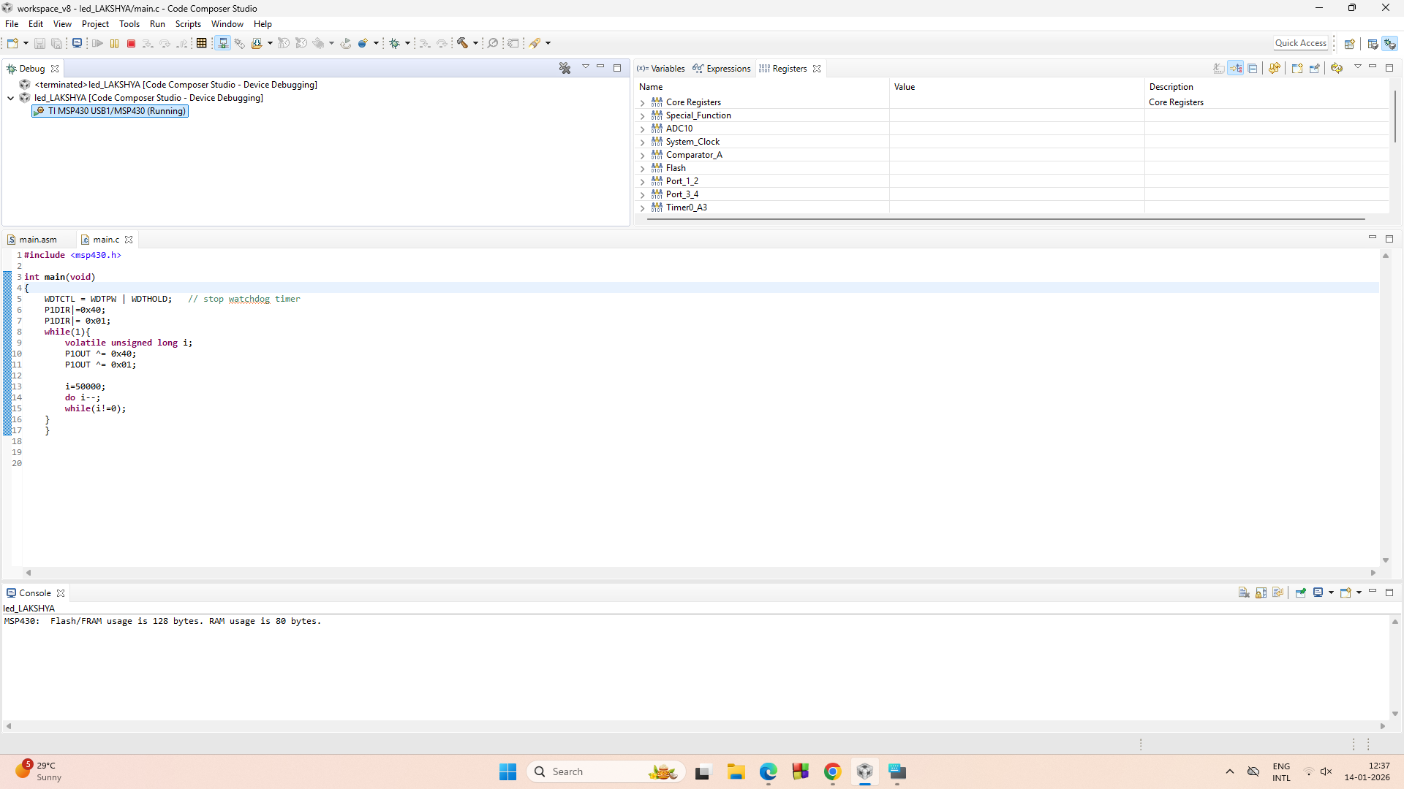
SFR Used:
- WDTCTL: 16-bit Watchdog Timer Control Register - The Watchdog Timer (WDT) is typically used to trigger a system reset after a certain amount of time. In most examples, the timer is stopped during the first line of code to prevent a continuous restart loop and for ease of debugging. In our program, the instruction WDTCTL = WDTPW | WDTHOLD sets the password (WDTPW) and WDTHOLD bit to stop the timer.

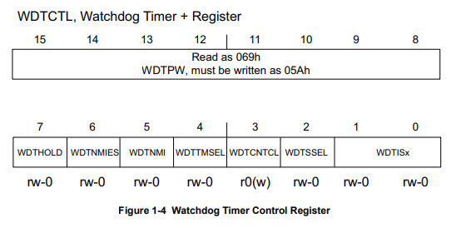

- P1DIR: 8-bit Direction Register: Each bit in the direction register selects the direction of the corresponding pin as an input or an output. Here, bit 0 is set to "1" directing the Port Pin 1.0 as an output.

- P1OUT: 8-bit Output Register: Each bit in the output register is the value to be output on the corresponding I/O pin when the pin is configured as an output. A bit 1 sets the pin HIGH, while a 0 resets the pin to LOW.
Procedure:
- Connect the MSP-EXP430G2 LaunchPad to the PC using the USB cable supplied.
- 2. Build, program and debug the code into the LaunchPad using CCS to view the status of the red LED.
- 3. In the CCS debug perspective, select View Registers
Observation: (Students are expected to copy the register value in ON/OFF mode)
While the code is running, pause it. In the Registers tab of IDE, expand and view the registers P1OUT, P1DIR and WDTCTL. Compare the values with your code.
When the program is executed, the red LED connected to P1.0 blinks ON and OFF at a fixed time interval.
The register P1DIR shows bit 0 set to 1, confirming that P1.0 is configured as an output pin. The register P1OUT alternates between 1 and 0, corresponding to LED ON and OFF states.
The Watchdog Timer (WDTCTL) is disabled, allowing the program to run continuously without reset.

Exercise: (Copy the source code)
1. Alter the delay with which the LED blinks.
2. Alter the code to make the green LED blink.
3. Alter the code to make the green and red LEDs blink:
i. Together
ii. Alternately

Conclusion:
The experiment demonstrated how GPIO pins of MSP430 can be configured and controlled. LED blinking verified proper use of direction and output registers. This helped in understanding basic microcontroller I/O operations in a simple way.

Signature of faculty in-charge with date

