Batch: A3 Roll No.: 16010324044
Experiment / assignment / tutorial No. 3
Grade: AA / AB / BB / BC / CC / CD /DD

Signature of the Staff In-charge with date

TITLE: Pulse Width Modulator
AIM: 1) Generate PWM signal
2) Understand basics of on chip Timer
OUTCOME: Students will be able to understand the features of MSP 430 family and usage of IDE to get proficiency embedded C programming language and its usage for applications

Software requirement:

Code Composer Studio 8.0.0

Introduction:

PWM:
Pulse Width Modulation (PWM) is a method of digitally encoding analog signal levels. High-resolution digital counters are used to generate a square wave of a given frequency, and the duty cycle of the square wave is modulated to encode the analog signal. The duty cycle determines the time during which the signal pulse is HIGH. The Timer A and Timer B of the MSP430G2553 are capable of PWM outputs in compare mode.

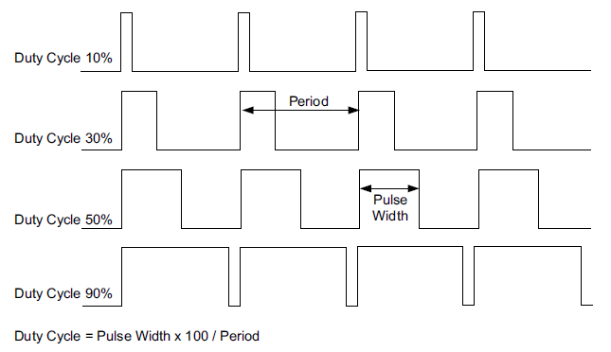
Figure: 1 PWM signal for varying duty cycle
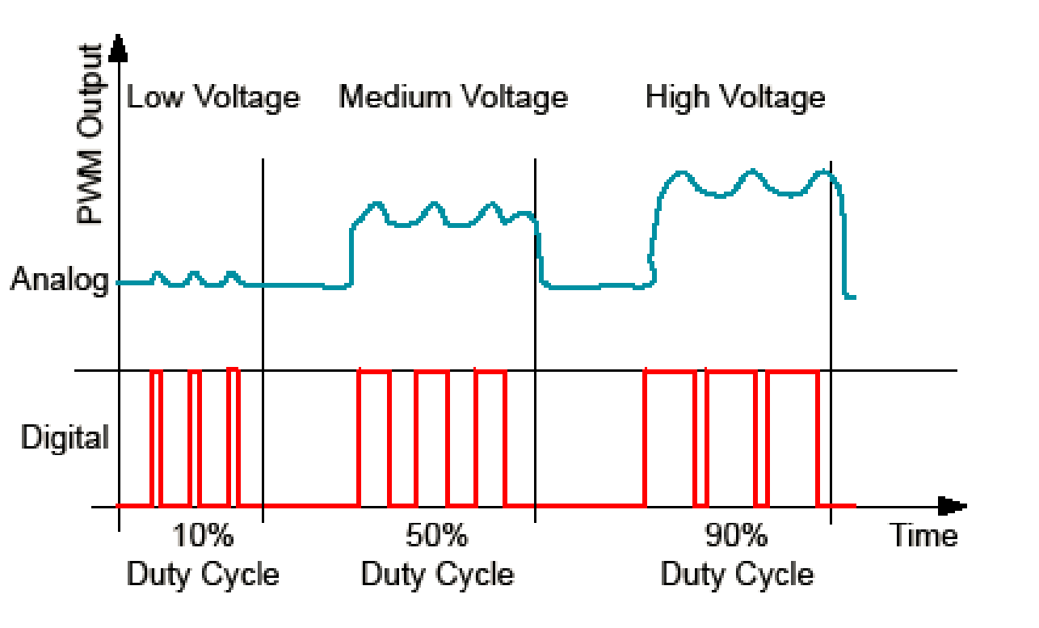
Figure 2: PWM Output for Analog Signal

Algorithm/Flowchart:
- Stop the watchdog timer
Disable the watchdog to prevent unwanted resets.
- Configure PWM output pin
Select the timer function for the output pin
Set the pin direction as output.
- Set PWM period
Load TA0CCR0 with a hexadecimal value to define the PWM period.
- Set duty cycle
Load TA0CCR1 with a hexadecimal value.
Duty cycle is calculated as:
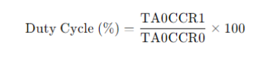
- Configure compare mode
Set TA0CCTL1 to reset/set mode for PWM output.
- Configure Timer_A
Select clock source (e.g., SMCLK).
Set the timer to Up mode.
Clear the timer.
- Start the timer
PWM signal is generated continuously at the output pin.

Source code: ( C program)
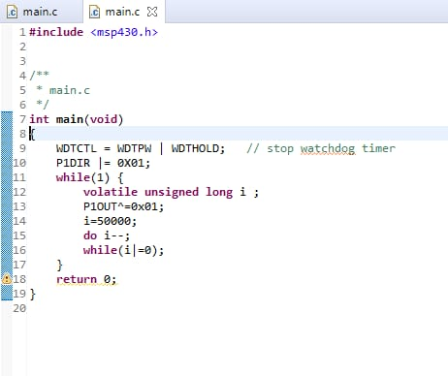
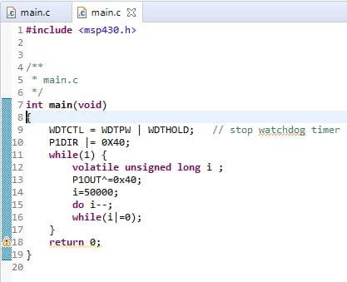
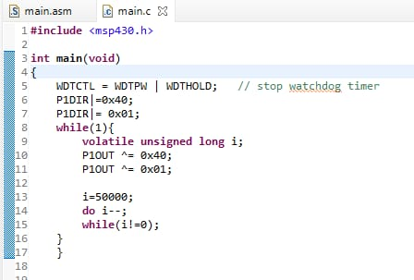
Registers Used:
- WDTCTL: The Watchdog Timer (WDT) is typically used to trigger a system reset after a certain amount of time. The register is set to WDT_MDLY_32 for 32ms interval interrupt.

- IE1: Interrupt Enable Register 1 : This register enables the NMI interrupts and WDT interrupts. Here, the Watchdog timer interrupt is enabled.

- P1DIR: 8-bit Direction Register: Each bit in the direction register selects the direction of the corresponding pin as an input or an output. Here, bit 6 is set to 1 directing the Port Pin 1.6 as an output.

- P1SEL: Function Select Register: Each bit in the function select register is used to select the pin function - I/O port or peripheral module function. Here, the pin used as PWM output (P1.6) is specified.

- TA0CTL: Timer A Control Register: Each bit in this register configures Timer A operation. Here, SMCLK is used as a clock source and the count up mode (MC_1) is selected for timer configuration.

- TA0CCR0: Timer A Capture/Compare Register: It holds the data for comparison to the timer value in compare mode. Here, the PWM period is set using this register.

- TA0CCR1: Timer A Capture/Compare Register: It holds the data for comparison to the timer value in compare mode. Here, this register set is used to the PWM duty cycle. This value will be equal to the reading taken from the potentiometer at any instant and will alter the LED’s brightness.

- TA0CCTL1: Timer A Capture/Compare Control Register: The Timer capture/compare register configures the capture/compare modes of the timer. Here, the PWM output mode is set to PWM Reset/Set mode (OUTMODE_7).

Procedure:
  - Connect the MSP-EXP430G2 LaunchPad to the PC using the USB cable supplied.
  - Build, program and debug the code into the LaunchPad using CCS.
Observation:
TA0CCR1 | TA0CCR0 | Duty Cycle =  (TA0CCR1/TA0CCR0) *100
0x0200 | 0x0100 | 50%
0x0200 | 0x0180 | 75%
0x0200 | 0x0200 | 100%

Conclusion:
In this experiment, PWM was generated using Timer A by changing the duty cycle values.
This helped in understanding how timers work in MSP430 and how PWM controls output
levels.

Signature of faculty in-charge with date

