Batch: A3 Roll No.: 16010324044
Experiment / assignment / tutorial No. 4
Grade: AA / AB / BB / BC / CC / CD /DD

Signature of the Staff In-charge with date

TITLE: Serial communication
AIM: To use UART of the MSP430G2553 to communicate with the computer
OUTCOME: Students will be able to understand the features of MSP 430 family and usage of IDE to get proficiency in embedded C programming language and its usage for applications

Software requirement:

Code Composer Studio 8.0.0

Introduction:
Serial communication can be divided into two categories:
• Synchronous serial communication
• Asynchronous serial communication
Synchronous serial communication uses a dedicated communication channel to send a clock signal which provides the timing between the transmitter and receiver. While in asynchronous communication, the timing is encoded within the signal. There are several versions of both synchronous and asynchronous serial communication. The MSP430G2553 supports 3 different types of communications using its USCI peripheral: Serial Peripheral Interface (SPI), Inter-Integrated Circuit Interface (I2C) and UART.
The MSP430G2553 is an ultra-low power device and has one active mode and five software
Selectable low-power modes of operation. An interrupt event can wake up the device from any of the low-power modes, service the request, and restore back to the low-power mode on return from the interrupt program.
In UART mode, the USCI transmits and receives characters at a bit rate asynchronous to the
Paired device. Timing for the transmission of each character is based on the selected baud rate of the USCI. The transmit and receive functions use the same baud rate frequency.

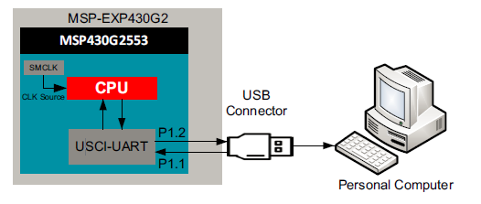
Figure:1 Functional diagram

Algorithm/Flowchart:
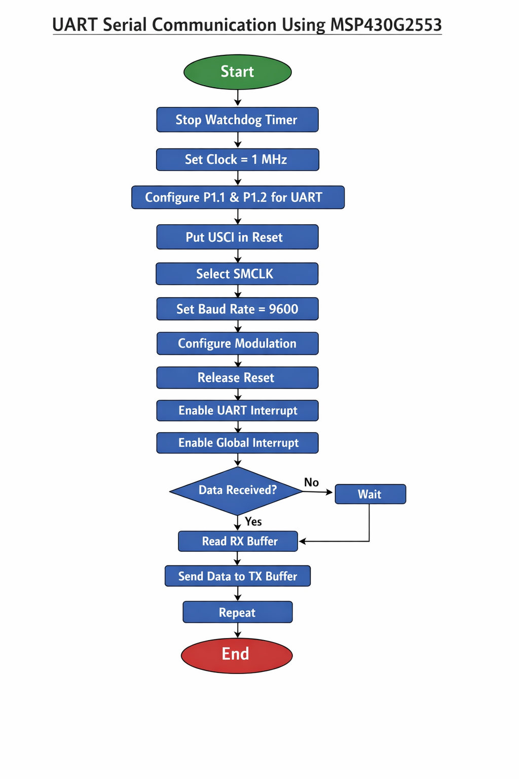
Source code: ( C program)
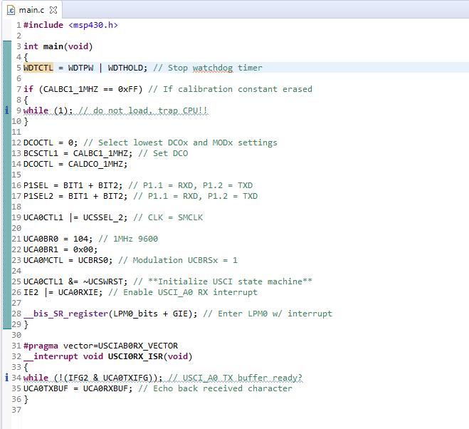
Registers Used:
- WDTCTL: The Watchdog Timer (WDT) is typically used to trigger a system reset after a certain amount of time. The register is set to WDT_MDLY_32 for 32ms interval interrupt

- IE2: Interrupt Enable Register 2: This register enables the USCI transmit and receive interrupts. Here, the USCI interrupts are enabled.

- P1SEL1 and P1SEL2: Function Select Register: Each bit in the function select register is used to select the pin function - I/O port or peripheral module function. Here, the UART function on Pins P1.1 and P1.2 are enabled.

- UCA0CTL0: USCI_A0 Control Register 0 – This register configures the USCI module. Here the configuration is: No parity, LSB first, 8-bit data, 1 stop bit, UART, Asynchronous.

- UCA0CTL1: USCI_A0 Control Register 1-- This register is used to configure clock source and enable software interrupts. Here, SMCLK is used as clock source.

- UCA0BR0 & UCA0BR1: USCI_A0 Baud Rate Control Register 0 and 1 – These 16-bit registers are configured the clock prescaler setting of the baud rate generator. Here, the registers are configured to have 1MHz frequency and 9600 baud rate.

- UCA0MCTL: USCI_A0 Modulation Control Register – This register selects the modulation stages which determine the modulation pattern for BITCLK. Here, the 2nd Stage modulation = 1, and oversampling is turned off.

- IFG2: Interrupt Flag Register 2 - This register consists of the transmit and receive interrupt flags. Here, the flags are cleared.

Procedure:
- Create MSP430G2553 project in Code Composer Studio.
- Write and compile the UART program.
- Configure UART pins, clock, and baud rate (9600).
- Load code to MSP430 and run it.
- Open serial terminal and verify data transmission.

Observation: (Copy the screen shot)
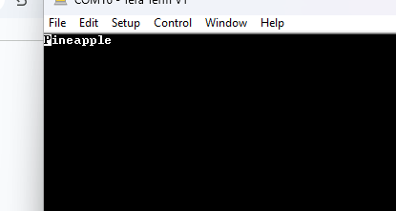
Conclusion:
In this experiment, I learnt UART serial communication using MSP430G2553 was successfully performed. The UART module was configured using USCI registers and serial data transmission and reception were verified through the computer terminal. This experiment helped in understanding asynchronous serial communication, baud rate configuration, and usage of MSP430 UART registers using embedded C programming.
Signature of faculty in-charge with date

