Batch: A3 Roll No.: 16010324044
Experiment / assignment / tutorial No. 5
Grade: AA / AB / BB / BC / CC / CD /DD

Signature of the Staff In-charge with date

TITLE: ADC programming
AIM: Interface potentiometer MSP430G2553 LP
OUTCOME: Students will be able to understand the features of MSP 430 family and usage of IDE to get proficiency in embedded C programming language and its usage for applications

Software requirement:

Code Composer Studio 8.0.0

Introduction:
The MSP430G2553 consists of ADC10, 10-bit analog-to-digital converter which converts the analog input into a maximum of 1024 discrete levels. The ADC10 module is capable of 8 external inputs and 4 internal analog sources. The ADC10 can be configured to convert a single channel or a block of contiguous channels and can optionally repeat its conversions automatically. Each conversion takes multiple cycles. The timing is controlled by an ADC clock. While a conversion is in progress, the busy flag set. After conversion, the result is stored in the ADC10MEM register. There is a possible interrupt signaled when a conversion is complete. There is also a data transfer controller that can steal cycles from the CPU and store a block of conversion results directly in memory.

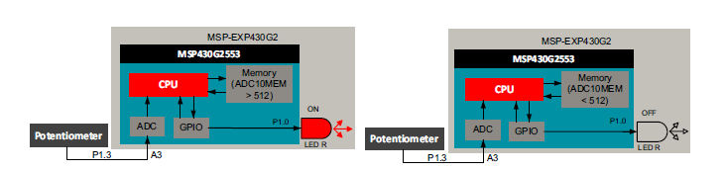
Figure:1 Functional diagram

Algorithm/Flowchart:
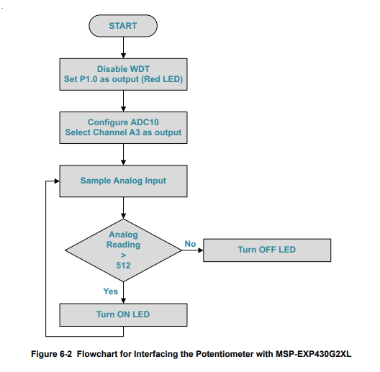
Source code: ( C program)
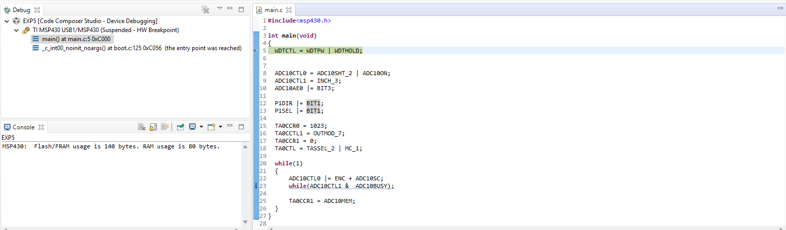

Registers Used:
- WDTCTL: The Watchdog Timer (WDT) is typically used to trigger a system reset after a certain amount of time. The register is set to WDT_MDLY_32 for 32ms interval interrupt.

- ADC10CTL0:ADC10 Control Register 0: The ADC10 core is configured by the ADC10CTL0 and ADC10CTL1 registers.

- ADC10CTL1:ADC10 Control Register 1: The ADC10 core is configured by the ADC10CTL0 and ADC10CTL1 registers.

- ADC10AE: Analog (Input) Enable Control Register 0 : The bits of this register enable the corresponding pin for analog input.

- P1DIR: 8-bit Direction Register : Each bit in the direction register selects the direction of the corresponding pin as an input or an output. Here, bit 0 is set to 1 directing the Port Pin 1.0 as an output.

- ADC10MEM: Conversion Memory Register: The 10-bit conversion results are stored in this register.

Observation: (Copy the screen shot)
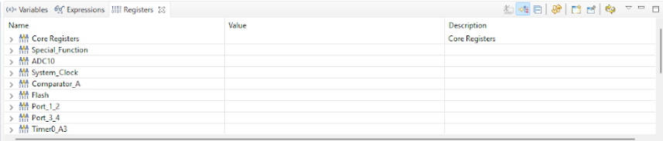
Procedure:
1. Connect the MSP-EXP430G2 LaunchPad to the PC using the USB cable supplied.
2. Connect the positive lead of the potentiometer to the Vcc pin on the MSP-EXP430G2 LaunchPad and the negative lead of the potentiometer to the GND pin.
3. Connect the output lead of the potentiometer to pin P1.3 or Analog Channel A3.
4. Connect the jumpers on the MSP-EXP430G2 LaunchPad for RXD and TXD horizontally
Conclusion:
In this experiment, I learnt how the ADC readings changed with change(rotation) in potentiometer. As the input analog voltage was varied, the digital output value stored in the ADC10MEM register varied from low to high within the 10-bit range (0–1023). Resulting in the brightness or dullness of the built-in LED.

Signature of faculty in-charge with date

