Batch: A3 Roll No.: 16010324044
Experiment / assignment / tutorial No. 6
Grade: AA / AB / BB / BC / CC / CD /DD

Signature of the Staff In-charge with date

TITLE: GPIO programming of LPC 2148
AIM: Write an embedded C program for LED interfacing
OUTCOME: Students will be able to understand the architecture and data processing of ARM and apply programming skills to develop application

Software requirement:

Hardware tool:

- Features of LPC 2148 Microcontroller(Students are expected to refer the data sheet and answer )
LPC2148 is a 32-bit ARM7TDMI based microcontroller.

- It operates up to 60 MHz clock speed.
- It has 512 KB Flash memory and 40 KB SRAM.
- It has up to 45 GPIO pins for input/output operations.
- It contains ADC and DAC modules.
- It supports UART, I2C, SPI, SSP and USB communication.
- It has timers, PWM and watchdog timer.
- It has low power modes like idle and power-down.
- Pin functions are selected using PINSEL registers.

- Flowchart/algorithm:
- Start the program.
- Select GPIO function using PINSEL register.
- Set LED pin as output using IOxDIR.
- Turn LED ON using IOxSET.
- Give delay.
- Turn LED OFF using IOxCLR.
- Give delay.
- Repeat continuously.
- Stop.

- Source code:
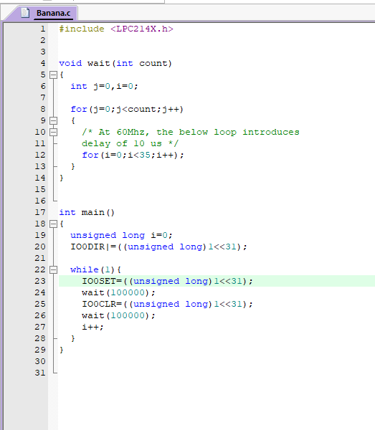
- Procedure:
- Open Keil software and create LPC2148 project.
- Write Embedded C program for LED interfacing.
- Configure PINSEL for GPIO mode.
- Set LED pin direction as output using IOxDIR.
- Use IOxSET and IOxCLR to blink LED.
- Compile and build the program.
- Dump the code into LPC2148 board.
- Run the program and observe LED output.
- Take SFR screenshots for observation.

GPIO programming SFRs:
IOxDIR:
IOxSET:
IOxCLR:
PINSEL register:
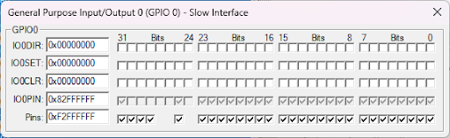
Observation: (Copy the screen shots SFR’s)
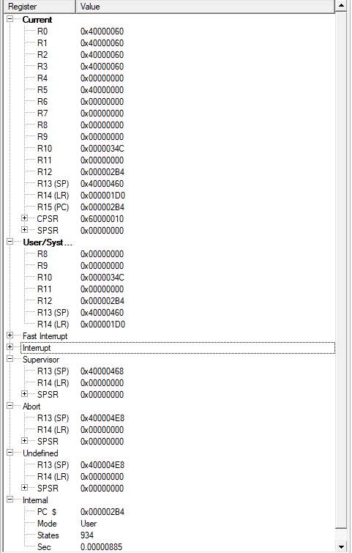
Conclusion:
In this experiment, GPIO programming of LPC2148 was performed successfully. LED interfacing was done using Embedded C and GPIO registers. This helped in understanding GPIO control and basic ARM microcontroller programming.

Signature of faculty in-charge with date

