Batch: A3 Roll No.: 16010324044
Experiment / assignment / tutorial No. 7
Grade: AA / AB / BB / BC / CC / CD /DD

Signature of the Staff In-charge with date

TITLE: Serial communication using UART0 module of LPC 2148
AIM: Write an embedded C program for “YOUR NAME” on serial monitor
OUTCOME: Students will be able to understand the architecture and data processing of ARM and apply programming skills to develop application

Software requirement:
Keil uVision 5

Hardware tool:
LPC2148

UART0: (Explain in brief)
UART (Universal Asynchronous Receiver Transmitter) is a serial communication protocol used for transmitting and receiving data without a clock signal. In LPC2148, UART0 is used for serial communication with external devices like a PC. It converts parallel data from the microcontroller into serial form for transmission and vice versa. Communication is asynchronous and uses start bit, data bits, parity bit (optional), and stop bit.
Source code:
- main.c
#include <LPC214X.h>
#include "Serial.h"
void wait(int count)
{
int j=0,i=0;
for(j=0;j<count;j++)
{
/* At 60Mhz, the below loop introduces
delay of 10 us */
for(i=0;i<35;i++);
}
}
int main()
{
uart0_init();
// IO0DIR|=((unsigned long)1<<31);
while(1){
uart0_puts("\n\rdhairya!!!");
wait(1000);
}
}
- serial.c
#include <LPC214x.H> /* LPC21xx definitions */
#include <stdio.h>
#include "Serial.h"
#define CR 0x0D
/* implementation of putchar (also used by printf function to output data) */
int sendchar (int ch) { /* Write character to Serial Port */
if (ch == '\n') {
while (!(U1LSR & 0x20));
U1THR = CR; /* output CR */
}
while (!(U1LSR & 0x20));
return (U1THR = ch);
}
int uart0_getkey (void) { /* Read character from Serial Port */
while (!(U0LSR & 0x01));
return (U0RBR);
}
int uart1_getkey (void) { /* Read character from Serial Port */
while (!(U1LSR & 0x01));
return (U1RBR);
}
void uart1_init()
{
/* initialize the serial interface
Baud= Pclk * mulVal
-----------------
16*(256*U0BLM+U0DLL)*(mulVal+divVal)
*/

PINSEL0 |= 0x00050000; /* Enable RxD1 and TxD1 */
U1LCR = 0x83; /* 8 bits, no Parity, 1 Stop bit */
U1DLL = 71; /* 9600 Baud Rate @ 15MHz VPB Clock */
U1FDR=0x00000083; //MulVal=8 DivVal=3
U1LCR = 0x03; /* DLAB = 0 */
U1FCR=0x01;
}

//------------------------------------------------------------------------------------------------//
//---------------------------- Function for send character 1 time via UART1-----------------------//
//------------------------------------------------------------------------------------------------//
void uart1_putc(char c)
{
while(!(U1LSR & 0x20)); // Wait until UART1 ready to send character
U1THR = c; // Send character
}
//------------------------------------------------------------------------------------------------//
//---------------------------- Function for send string via UART1---------------------------------//
//------------------------------------------------------------------------------------------------//
void uart1_puts(char *p)
{
while(*p) // Point to character
{
uart1_putc(*p++); // Send character then point to next character
}
}
//------------------------------------------------------------------------------------------------//
//---------------------------- Function for Initial UART0 ----------------------------------------//
//------------------------------------------------------------------------------------------------//
void uart0_init()
{
/* initialize the serial interface
Baud= Pclk * mulVal
-----------------
16*(256*U0BLM+U0DLL)*(mulVal+divVal)
*/

PINSEL0 |= 0x00000005; /* Enable RxD0 and TxD0 */
U0LCR = 0x83; /* 8 bits, no Parity, 1 Stop bit DLAB = 1 */
//U0DLL = 71; /* 9600 Baud Rate @ 15MHz VPB Clock */
//U0FDR=0x00000083; /*MulVal=8 Divide Val=3 */
U0DLL=97;
U0LCR = 0x03; /* DLAB = 0 */
}
//------------------------------------------------------------------------------------------------//
//---------------------------- Function for send character 1 time via UART0-----------------------//
//------------------------------------------------------------------------------------------------//
void uart0_putc(char c)
{
while(!(U0LSR & 0x20)); // Wait until UART0 ready to send character Transmitter Holding Register Empty
U0THR = c; // Send character
}
//------------------------------------------------------------------------------------------------//
//---------------------------- Function for send string via UART1---------------------------------//
//------------------------------------------------------------------------------------------------//
void uart0_puts(char *p)
{
while(*p) // Point to character
{
uart0_putc(*p++); // Send character then point to next character
}
}

void uart0_dump(char *p,unsigned short len,unsigned char mod)
{
unsigned char temp[3];
unsigned short i=0;
for(;i<len;i++){
if(i%mod==0)
uart0_puts("\n\r");
sprintf((char *)temp,"%02x ",p[i]);
uart0_puts((char *)temp);
}
}

- serial.h
int uart0_getkey(void);
int uart1_getkey(void);
void uart1_init (void);
void uart0_init (void);
void uart1_putc (char);
void uart0_putc (char);
void uart1_puts (char *);
void uart0_puts (char *);

SFRs: PINSEL0: Pin function select register 0.

Bit | Symbol | Value | Description
1:0 | P0.0 | 01 | TXD0 (Transmit Data)
3:2 | P0.1 | 01 | RXD0 (Receive Data)

UART0 Line Control Register (U0LCR):

Enable Divisor Latch access, set 8 bit word length,1 stop bit, no parity.

Bit | Symbol | Value | Description
1:0 | WLS | 11 | 8-bit word length
2 | SBS | 0 | 1 Stop bit
3 | PE | 0 | Parity disabled
5:4 | PS | 00 | No parity
6 | BC | 0 | Break disabled
7 | DLAB | 1/0 | Enable divisor latch

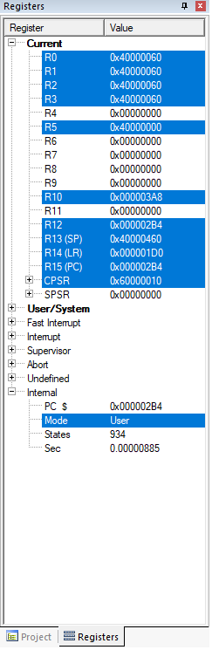
Divisor Latch Register (UDLL & UDLM)
- The UART0 /1Divisor Latch Register is part of the UART0 fractional baud rate generator and holds the value used to divide the clock supplied by the fractional prescalar in order to produce the baud rate clock, which must be 16x the desired baud rate.
- Divisor=PCLK/(16* Desired Baud Rate)
- The U0DLL and U0DLM registers together form 1 16 bit divisor where U0DLL contains the lower 8 bits of divisor and U0DLM contains the higher 8 bits of the divisor. A 0X0000 value will be treated like a 0x0001 values as division by Zero is not allowed.

UART FIFO control register (U0FCR):

Bit | Symbol | Value | Description
0 | FIFOEN | 1 | Enable FIFO
1 | RXRST | 1 | Reset RX FIFO
2 | TXRST | 1 | Reset TX FIFO
7:3 | - | - | Reserved

UART Line Status Register( ULSR): It is read only register that provides status information on UART TX and RX blocks.

Bit | Symbol | Value | Description
0 | RDR | 1 | Data ready
5 | THRE | 1 | Transmitter holding register empty

UART0THR:
- Used to send data.
- Writing a byte to U0THR transmits it serially.

UART0RBR:
- Used to receive data.
- Stores received byte from serial input.

Baud rate calculation:
Baud Rate=16×DivisorPCLK​
Where:
- Divisor = (256 × U0DLM) + U0DLL
- PCLK = Peripheral Clock Frequency
Example (from your code):
- Assume PCLK = 15 MHz
- Desired Baud Rate = 9600
Divisor=15×10616×9600≈97\text{Divisor} = \frac{15 \times 10^6}{16 \times 9600} \approx 97
Divisor=16×960015×106​≈97
So:
- U0DLL = 97
- U0DLM = 0

Procedure:
- Open Keil uVision 5 and create a new project for LPC2148.
- Add source files: main.c, serial.c, and serial.h.
- Configure UART0 pins using PINSEL0 register.
- Set baud rate using U0DLL and U0DLM registers.
- Configure U0LCR for 8-bit data, no parity, 1 stop bit.
- Write code to initialize UART using uart0_init().
- Use uart0_puts() to send string data to serial terminal.
- Compile and debug the program.
- Connect LPC2148 board and open serial monitor (9600 baud).
- Observe output string continuously on terminal.

Observation: (Copy the screen shot for each program)
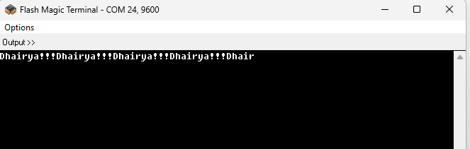
Conclusion:
In this experiment, I learnt how to successfully interface the UART0 module of LPC2148 was and program using Embedded C. Serial communication was established, and data was transmitted to the serial monitor correctly. This experiment helped in understanding UART architecture, baud rate calculation, and serial data transmission in ARM microcontrollers.

Signature of faculty in-charge with date

