Batch: A3 Roll No.: 16010324044
Experiment / assignment / tutorial No. 8
Grade: AA / AB / BB / BC / CC / CD /DD

Signature of the Staff In-charge with date

TITLE: Timer programming
AIM: Write an Embedded C program to generate delay using timer 0 of LPC 2148
OUTCOME: Students will be able to understand the architecture and data processing of ARM and apply programming skills to develop application

Software requirement:
Keil uVision 5

Hardware tool:
LPC2148

About time (in brief):
Time is a fundamental parameter in embedded systems used to control events, generate delays, and synchronize operations. In microcontrollers like LPC2148, time is managed using hardware timers. These timers count clock pulses and help create accurate delays without wasting CPU resources. By configuring timer registers, we can generate precise time intervals required for tasks such as LED blinking, communication timing, and signal generation.

Registers Used:

Timer Control Register (T0TCR ):-
Bit | Symbol | Value | Description
0 | CEN | 1 | Enables Timer Counter
0 | CEN | 0 | Disables Timer Counter

Count Control Register (T0CTCR ):-

Bit | Symbol | Value | Description
1:0 | MODE | 00 | Timer Mode (increments on every clock cycle)
1:0 | MODE | 01 | Counter Mode (rising edge)

Prescale Register (T0PR):-

The 32-bit Prescale Register specifies the maximum value for the Prescale Counter.

Delay calculations:
Given:
- CPU Clock = 15 MHz
- Time period of one clock cycle =
115×106=66.67 ns\frac{1}{15 \times 10^6} = 66.67 \text{ ns}15×1061​=66.67 ns
To generate 1 ms delay:
1 ms=1000 µs=15000 clock cycles1 \text{ ms} = 1000 \text{ µs} = 15000 \text{ clock cycles}1 ms=1000 µs=15000 clock cycles
So,
T0PR=15000−1=14999T0PR = 15000 - 1 = 14999T0PR=15000−1=14999
Thus:
- Timer Counter increments every 1 ms
- For delay:
Delay=counts×1 ms\text{Delay} = \text{counts} \times 1 \text{ ms}Delay=counts×1 ms
Example:
- delay_ms(1000) → 1000 ms = 1 second delay

Algorithm:
#include <lpc214x.h>

void initTimer0(void); // Setup and Initialize Timer0
void delay_ms(unsigned int counts); // Generate delay

int main(void)
{
initTimer0(); // Initialize Timer0

IO0DIR = ((unsigned long)1 << 31); // Configure Pin P0.31 as Output

while (1)
{
IO0SET = ((unsigned long)1 << 31); // Turn ON LED
delay_ms(1000);

IO0CLR = ((unsigned long)1 << 31); // Turn LED OFF
delay_ms(1000);
}

// return 0;
}

void initTimer0(void)
{
T0CTCR = 0x0; // Set Timer0 into Timer Mode
T0PR = 14999; // Increment TC every 15000 clock cycles
// Count begins from zero hence subtracting 1
// 15000 clock cycles @15MHz = 1 ms
//T0TCR = 0x02; // Reset Timer
}

void delay_ms(unsigned int counts) // Using Timer0
{
T0TCR = 0x02; // Reset Timer
T0TCR = 0x01; // Enable timer
while (T0TC < counts); // wait until TC reaches desired delay
T0TCR = 0x00; // Disable timer
}

Result:
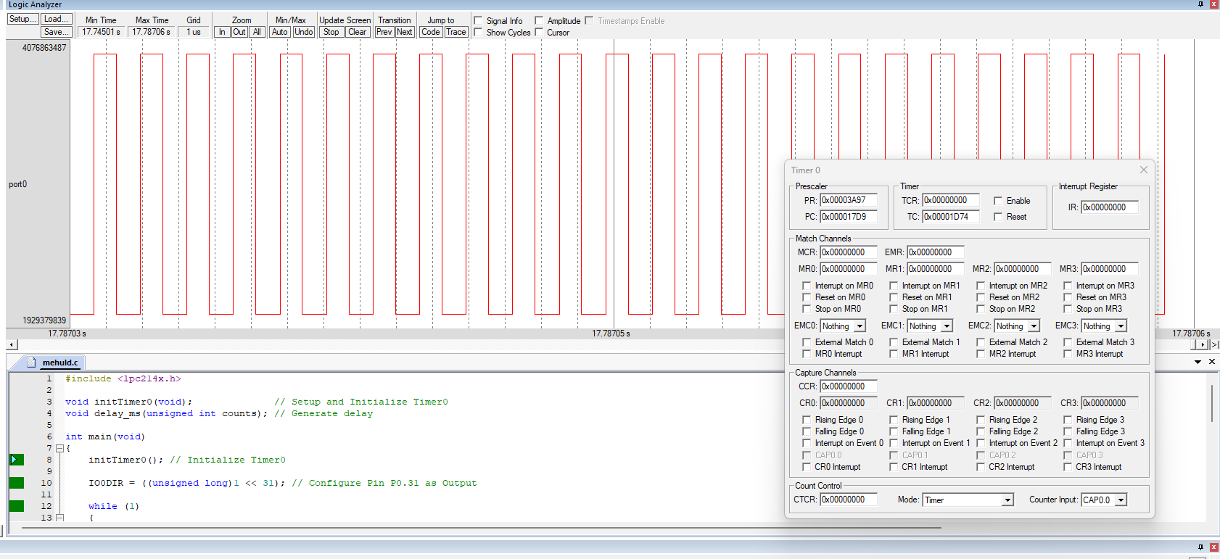
Conclusions:
In this experiment, I learnt how to successfully generate precise delays using Timer0 of LPC2148. The experiment demonstrated how timer registers and prescaler values control time intervals efficiently. This method not only provides more accurate and reliable delays compared to software loops but also frees up the microcontroller to switch to power saving or do other tasks.
Signature of faculty in-charge with date

