Batch: A3 Roll No.: 16010324044
Experiment / assignment / tutorial No. 9
Grade: AA / AB / BB / BC / CC / CD /DD

Signature of the Staff In-charge with date

TITLE: DAC module of LPC 2148
AIM: Write an embedded C program for waveform generation using DAC
OUTCOME: Students will be able to understand the architecture and data processing of ARM and apply programming skills to develop application

Software requirement:
- Keil μVision IDE

Hardware tool:
- LPC2148 Microcontroller

DAC: (Explain in brief)
DAC (Digital to Analog Converter) converts digital values into analog voltage.
- LPC2148 has 10-bit DAC
- Output pin: P0.25
- Output range: 0V to Vref (3.3V)
Source code:
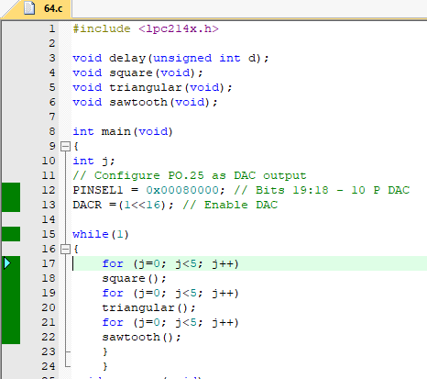
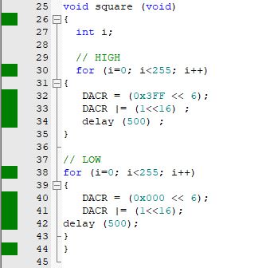
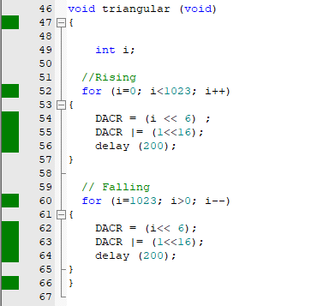
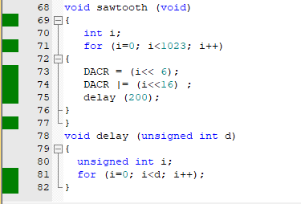
SFRs: DACR

Bit | Symbol | Value | Description
31 : 17 | - | 0 | Reserved bits (must be written as 0)
16 | BIAS | 0 / 1 | Bias control (0 = fast mode, 1 = low power mode)
15 : 6 | VALUE | 0 - 1023 | 10-bit digital value for DAC output
5 : 0 | - | 0 | Reserved bits (must be written as 0)

Procedure:
- Configure DAC pin (P0.25)
- Initialize DAC register
- Write code for square, triangular, sawtooth waves
- Add delay
- Compile and run
- Observe output on CRO/Logic Analyzer

Observation: (Copy the screen shot for each program)
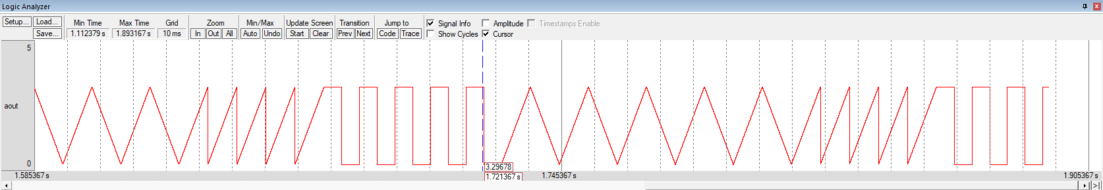
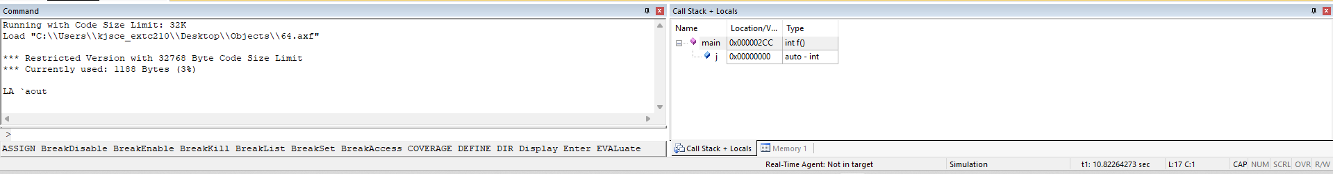
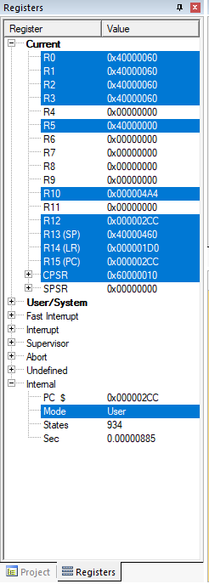
Conclusion:
In this experiment, I learnt how to successfully generate square, triangular, and sawtooth waveforms using the DAC module of LPC2148. The digital values written into the DAC register were converted into corresponding analog voltages. Different waveforms were obtained by varying the pattern of digital input values in the program. This experiment demonstrates the practical use of DAC for signal generation in embedded systems.

Signature of faculty in-charge with date

