Batch: A3 Roll No.: 16010324044
Experiment / assignment / tutorial No. 8
Grade: AA / AB / BB / BC / CC / CD /DD

Signature of the Staff In-charge with date

TITLE: Schmitt Trigger
AIM: To implement and study Schmitt Trigger using OPAMP
OUTCOME: Students will be able to understand the basics of analog Integrated circuits.

PROCEDURE:
- Assemble OPAMP Schmitt trigger circuit as shown in diagram.
- Take sinusoidal input signal of fixed amplitude and apply it to the Schmitt
trigger circuit.
- Observe the output square waveform corresponding to input sinusoidal signal.
- Overlap both the input and output waves and note down voltages at positions on
sine wave where output changes its state. These voltages denote the Upper
threshold voltage and the Lower threshold voltage.
- Verify that these practical threshold voltages are almost same as the theoretical
threshold voltages calculated using formula.
- Repeat the same for triangular input and comment on the observed output
waveform.

Circuit Diagram 1:
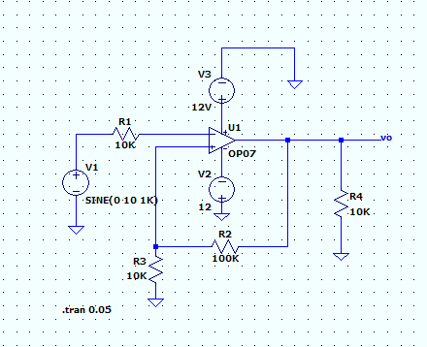

Observation Table I :
V_{CC} = V, Vee = V Input Signal Voltage (Vs) = V
 |  |  | Theoretical value |  | Practical value
Sr.  No. | R1 | R2 | Vut= +Vsat* [R1/ (R1+R2)] | Vlt= -Vsat* [R1/ (R1+R2)] | Vut | Vlt
 | 10k | 100k | 0.9818V | -0.9819V | 3 | -3.03
 | 100k | 10k | 9.818V | -9.818V | 9.98 | -9.956

Signature of faculty in-charge
Theoretical Calculations:
When R1 = 10k and R2 = 100k
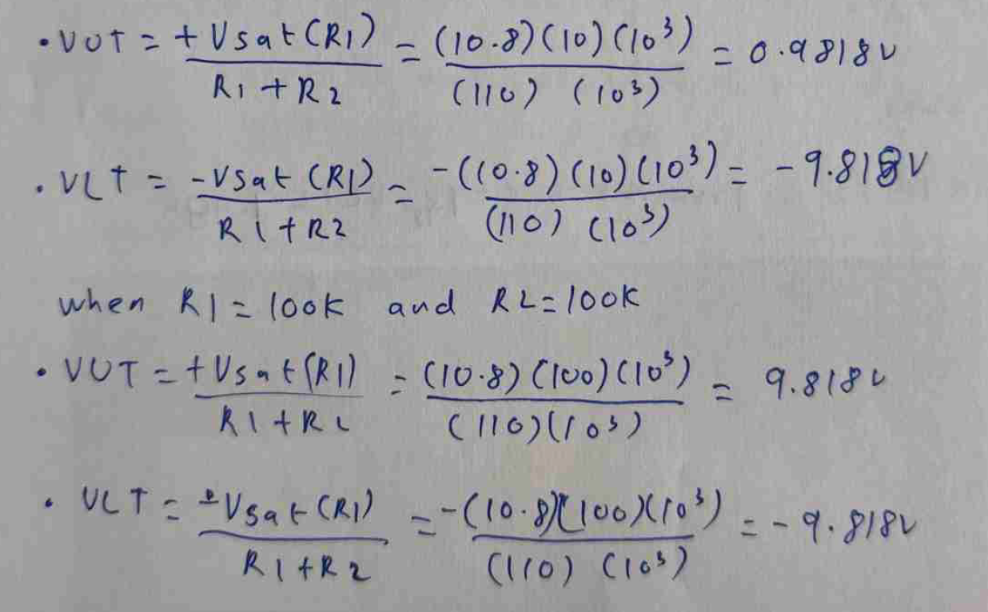

Conclusion:
The Schmitt Trigger experiment was successfully demonstrated, highlighting the hysteresis effect achieved through positive feedback, which creates two distinct switching thresholds. A 20 V peak-to-peak sine wave input was effectively converted into a stable square wave output, confirming the circuit’s reliability. The results show that the operational amplifier is well-suited for precise signal conditioning and comparator applications. Additionally, the observed threshold values closely matched the theoretical expectations, especially for R₁ = 100 kΩ and R₂ = 10 kΩ, indicating high accuracy of the circuit.

