Name: Dhairya Shah

Roll no.: 16010324044

Batch: A3

Communication toolbox:

Documentation:
- Modulation/demodulation (PSK, QAM, FSK)
- Channel coding and BER analysis
- Channel models (AWGN, Rayleigh, Rician)
- RF impairment modeling
- AI/ML for wireless systems
- End-to-end system simulation
- Support for standards (LTE, 5G, WLAN)
- Signal analysis & measurement tools
- Code generation & hardware deployment (SDR support)

Wireless waveform generator app:

1:
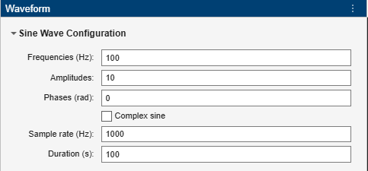
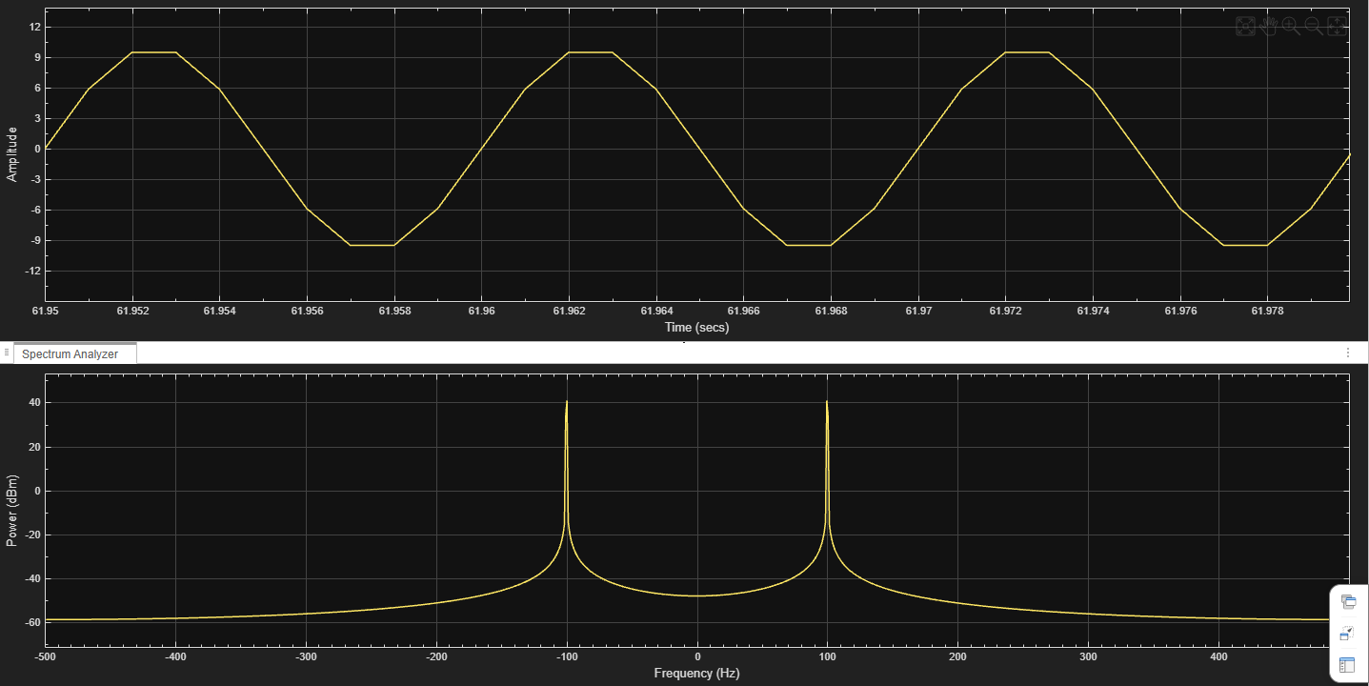

2:
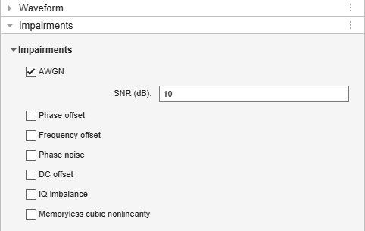
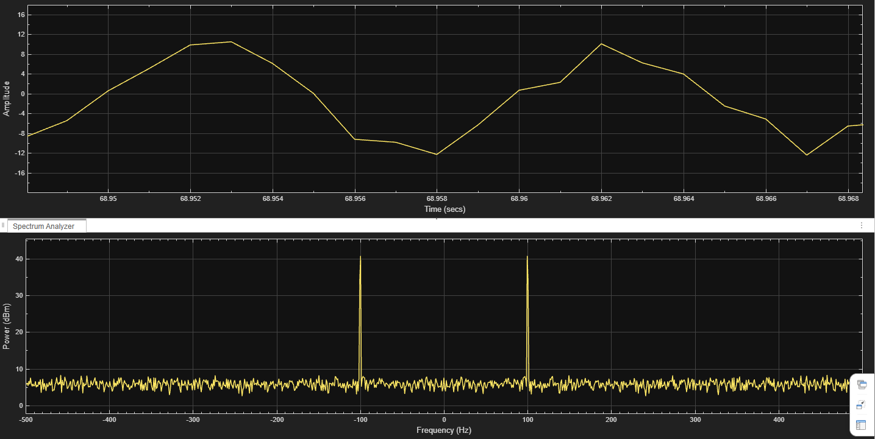

Conclusion:
In this experiment, I learnt about Communication Toolbox and its capabilities in simulating and analyzing digital communication systems. Key concepts such as modulation techniques, channel effects, and signal analysis were explored effectively. The toolbox simplifies complex processes like BER evaluation and waveform generation, making it a powerful tool for practical learning and system design in modern wireless communication.

POST Lab Activity:

1) Importance of Spectrum Analysis in Communication Systems:
Spectrum analysis is important because it helps in understanding how a signal’s power is distributed over different frequencies. It allows us to identify bandwidth, detect noise and interference, and verify whether the signal is within the desired frequency range. From spectrum analysis, we can obtain information such as signal frequency components, power levels, presence of distortion, and unwanted signals. This is essential for ensuring efficient transmission and proper system performance.

2) Impairments in MATLAB Wireless Waveform Generator App & Observations:
Common impairments available include Additive White Gaussian Noise (AWGN), frequency offset, phase noise, DC offset, IQ imbalance, and timing offset. When these impairments are added to the generated signal, the following observations can be made:
- AWGN: Introduces random noise, making the signal distorted and reducing clarity.
- Frequency Offset: Shifts the signal spectrum, causing mismatch at the receiver.
- Phase Noise: Causes phase variations, leading to signal instability.
- DC Offset: Shifts the signal baseline from zero.
- IQ Imbalance: Distorts the constellation and reduces accuracy in demodulation.
- Timing Offset: Affects synchronization and may cause symbol errors.

