Part 1:

Case 1:-
Amplitude: 8
Frequency: 1kHz
Volt(V) / div: 1
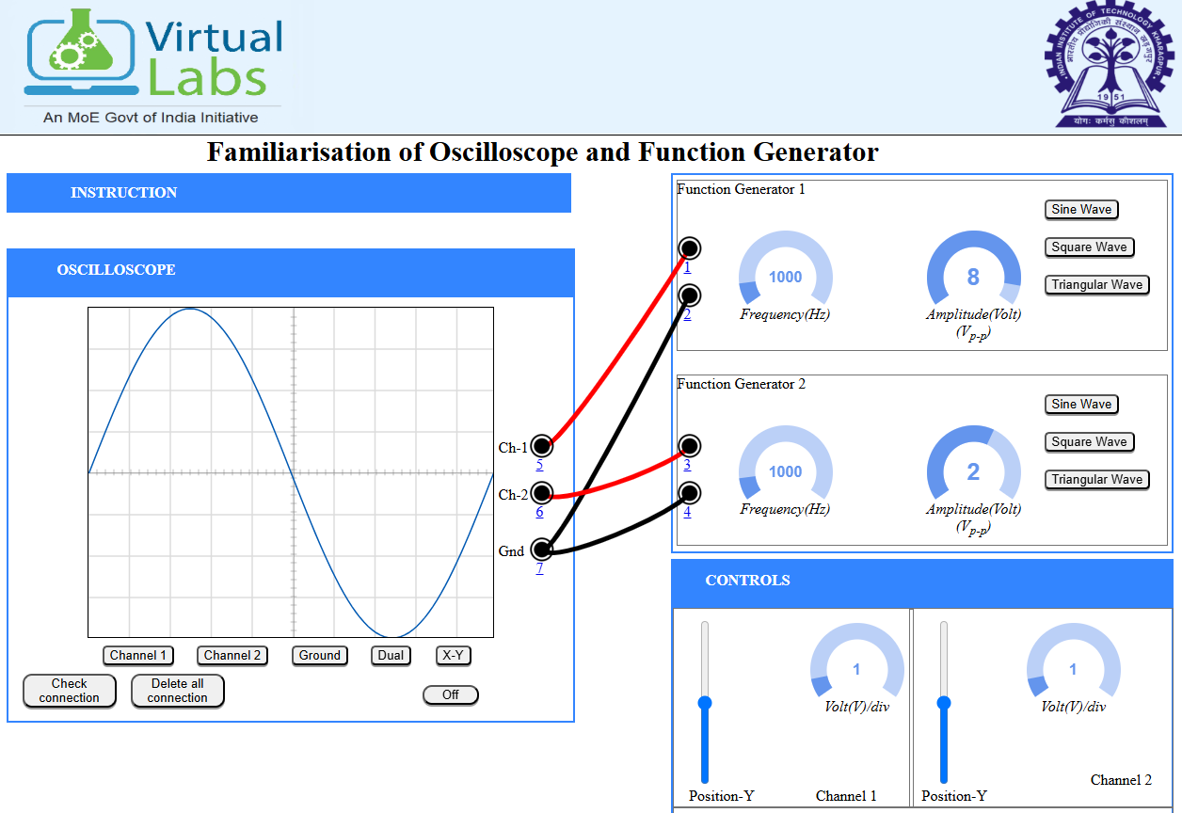

Case 2:-
Amplitude: 8
Frequency: 1kHz
Volt(V) / div: 2
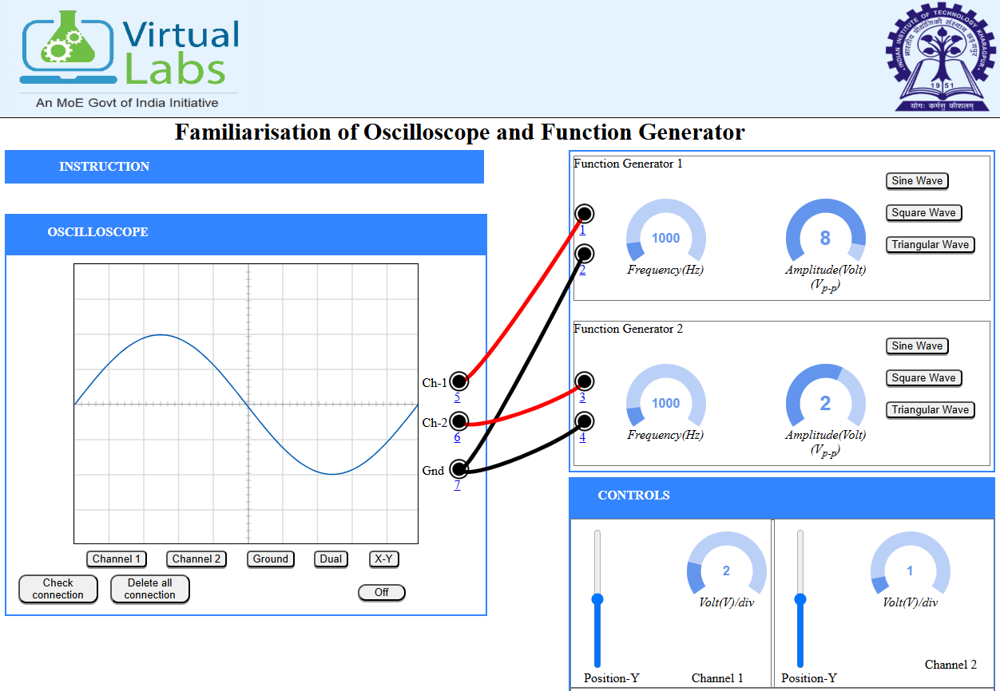

Case 3:-
Amplitude: 4
Frequency: 1kHz
Volt(V) / div: 2

Part 2:
Programme:

clc; clear; close all;

%% 1. Signal Generation
fs = 1000; % Sampling frequency (Hz)
t = 0:1/fs:1-1/fs; % Time vector (1 second duration)
f_m = 5; % Message signal frequency (5 Hz)
A_m = 2; % Message signal amplitude
message = A_m*sin(2*pi*f_m*t); % Generating the sine wave

%% 2. Adding AWGN (Noise)
target_snr_db = 10;
noisy_signal = awgn(message, target_snr_db, 'measured');

%% 3. SNR Calculation & Verification
% Calculate signal power and noise power
sig_power = mean(message.^2);
noise_added = noisy_signal - message;
noise_power = mean(noise_added.^2);

% Calculate SNR in dB
calculated_snr = 10 * log10(sig_power / noise_power);

%% 4. Visualization
figure('Name', 'SNR Analysis in Analog Communication');

subplot(3,1,1);
plot(t, message, 'LineWidth', 1.5);
title('Original Message Signal (Clean)');
grid on; ylabel('Amplitude');

subplot(3,1,2);
plot(t, noise_added, 'r');
title('Additive White Gaussian Noise (AWGN)');
grid on; ylabel('Amplitude');

subplot(3,1,3);
plot(t, noisy_signal, 'k');
hold on;
plot(t, message, 'g--', 'LineWidth', 1); % Overlay original for comparison
title(['Noisy Signal (Measured SNR: ', num2str(calculated_snr, '%.2f'), ' dB)']);
grid on; ylabel('Amplitude'); xlabel('Time (s)');
legend('Noisy Signal', 'Original Signal');

Expected Output:
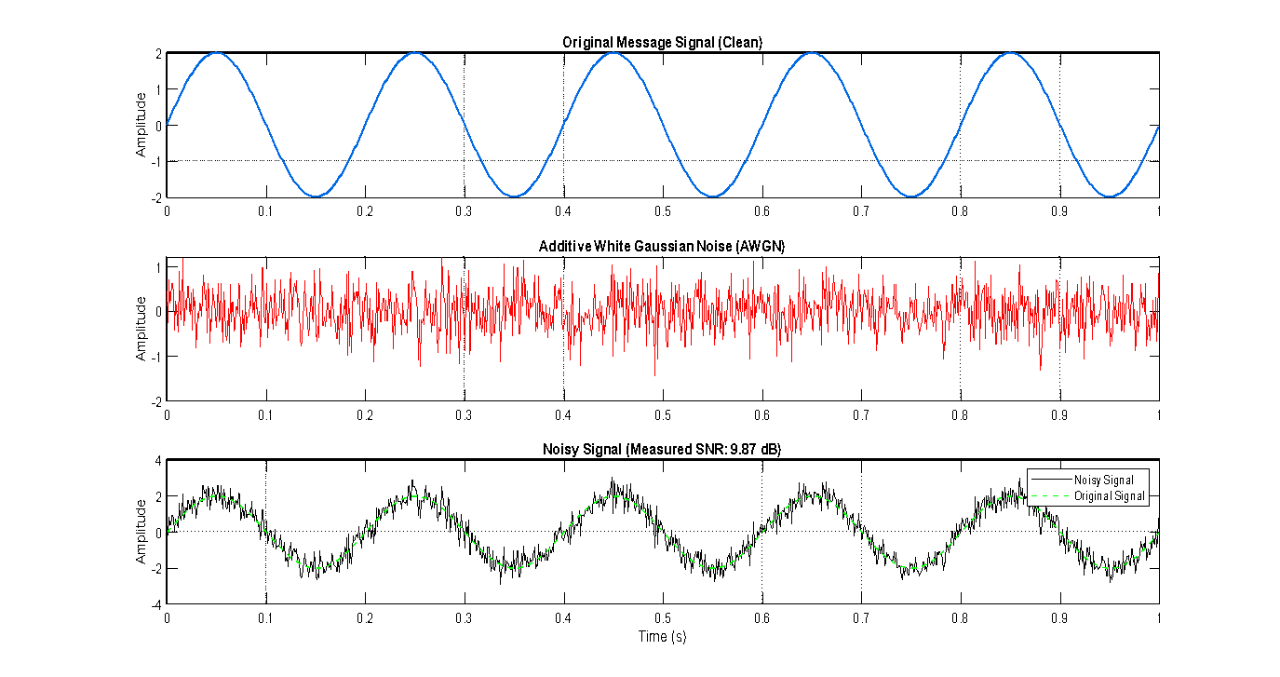
Sample

Output:
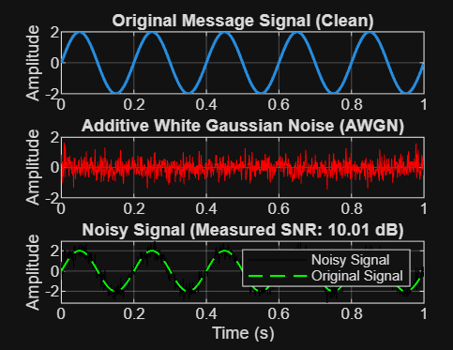

Post Lab Activity:
