Name: Dhairya Shah

Rollno.: 16010324044

Batch: A3

Code 1: tau = 75 microsecond
clc; %clear command window
clear all; %clear all variables
close all; %close all open windows

fs = 44100; %defining value of sampling frequency
tau = 75e-6; %defining value of time constant

fc = 1 /(2*pi*tau); %defining formula of cutoff frequency

num_pre = [1 + 2*fs*tau, 1 - 2*fs*tau]; %defining numerator of pre-emphasis
den_pre = [1,0]; %defining denominator of pre-emphasis

f = 0:10:fs/2; %(start, step, end), x-axis plot value

H_pre = 1 + j*(f/fc); %defining formula of pre-emphasis of network
H_de = 1 ./ (1 + j*(f/fc)); %defining formula of de-emphasis of network

figure; %to plot graph
subplot(2,1,1); %location of plot within the plot, (row, column, nth plot)

semilogx(f, 20*log10(abs(H_pre)), 'b', 'LineWidth',2)
%semilog graph (x-axis, y-axis: log of absolute of pre-emphasis, blue colour, line size = 2)

grid on; %grids in the graph will be visible
hold on; %first plot window will remain open even after second

%plotting graph
title('Magnitude Response of Pre-empasis Network'); %heading of graph
xlabel('Frequency (Hz)'); %x-axis name
ylabel('Gain (dB)'); %y-axis name
axis([100 fs/2 0 25]); %(max, min, frequency range)

figure; %to plot graph
subplot(2,1,2); %location of plot within the plot, (row, column, nth plot)

semilogx(f, 20*log10(abs(H_de)), 'r', 'LineWidth',2)
%semilog graph (x-axis, y-axis: log of absolute of de-emphasis, blue colour, line size = 2)

grid on; %grids in the graph will be visible
hold on; %first plot window will remain open even after second

%plotting graph
title('Magnitude Response of De-empasis Network'); %heading of graph
xlabel('Frequency (Hz)'); %x-axis name
ylabel('Gain (dB)'); %y-axis name
axis([100 fs/2 -25 0]); %(max, min, frequency range)

Output 1:
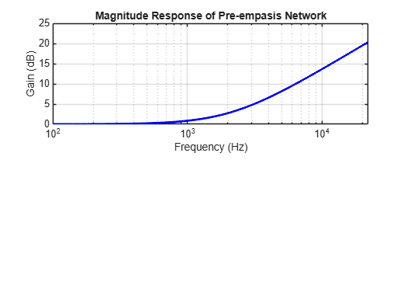
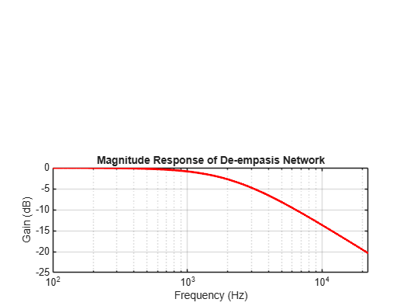

Code 2: tau = 50 microsecond
clc; %clear command window
clear all; %clear all variables
close all; %close all open windows

fs = 44100; %defining value of sampling frequency
tau = 50e-6; %defining value of time constant

fc = 1 /(2*pi*tau); %defining formula of cutoff frequency

num_pre = [1 + 2*fs*tau, 1 - 2*fs*tau]; %defining numerator of pre-emphasis
den_pre = [1,0]; %defining denominator of pre-emphasis

f = 0:10:fs/2; %(start, step, end), x-axis plot value

H_pre = 1 + j*(f/fc); %defining formula of pre-emphasis of network
H_de = 1 ./ (1 + j*(f/fc)); %defining formula of de-emphasis of network

figure; %to plot graph
subplot(2,1,1); %location of plot within the plot, (row, column, nth plot)

semilogx(f, 20*log10(abs(H_pre)), 'b', 'LineWidth',2)
%semilog graph (x-axis, y-axis: log of absolute of pre-emphasis, blue colour, line size = 2)

grid on; %grids in the graph will be visible
hold on; %first plot window will remain open even after second

%plotting graph
title('Magnitude Response of Pre-empasis Network'); %heading of graph
xlabel('Frequency (Hz)'); %x-axis name
ylabel('Gain (dB)'); %y-axis name
axis([100 fs/2 0 25]); %(max, min, frequency range)

figure; %to plot graph
subplot(2,1,2); %location of plot within the plot, (row, column, nth plot)

semilogx(f, 20*log10(abs(H_de)), 'r', 'LineWidth',2)
%semilog graph (x-axis, y-axis: log of absolute of de-emphasis, blue colour, line size = 2)

grid on; %grids in the graph will be visible
hold on; %first plot window will remain open even after second

%plotting graph
title('Magnitude Response of De-empasis Network'); %heading of graph
xlabel('Frequency (Hz)'); %x-axis name
ylabel('Gain (dB)'); %y-axis name
axis([100 fs/2 -25 0]); %(max, min, frequency range)

Output 2:
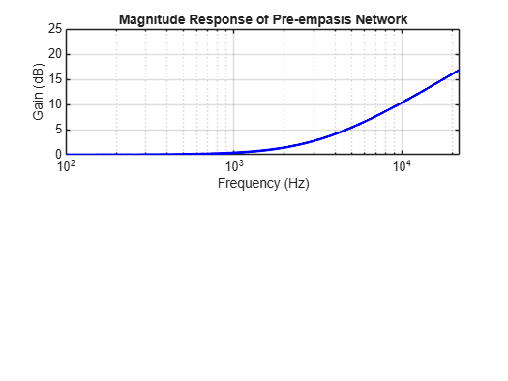

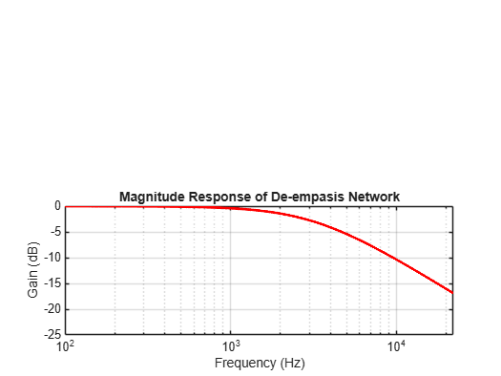

Post Lab 1:
In Frequency Modulation (FM), noise affects the signal by causing unwanted variations in the frequency of the carrier during transmission. The noise power increases with frequency, hence the distortion is mostly seen in the high-frequency region of audio signal received. To reduce this effect, pre-emphasis - to boost high frequency before transmission and de-emphasis - to attenuate after reception thereby improving the overall signal-to-noise ratio.

Post Lab 2:
We can conclude that:
- Noise power increases linearly with frequency.
- The triangular shape shows that noise is minimum at low frequencies and maximum at high frequencies.
- Because of this behavior, FM systems use pre-emphasis and de-emphasis filters to improve high-frequency SNR.

Post Lab 3:
FM is generally more advantageous than AM for most applications because it is less susceptible to interference as information is carried in frequency variations rather than amplitude (amplitude noise can be removed using limiters). It also offers better sound quality and higher signal-to-noise ratio, especially when pre-emphasis and de-emphasis are used. FM has better audio quality and is less prone to interference (than AM), but it needs more bandwidth and circuit complexity.

Conclusion
In this experiment, I learnt how the effect of noise increases with frequency in FM, forming a triangular noise spectrum. The high frequency portions are more susceptible to distortion but it could be reduced with pre-emphasis and de-emphasis networks. It improves the signal-to-noise ratio by boosting high frequencies at the transmitter and then attenuating noise at the receiver, making it suitable for high quality audio broadcasting.

