Tab 1

EXPT: 8

Name: Dhairya Shah
Roll no: 16010324044
Subject: Communication systems laboratory

Part 1:
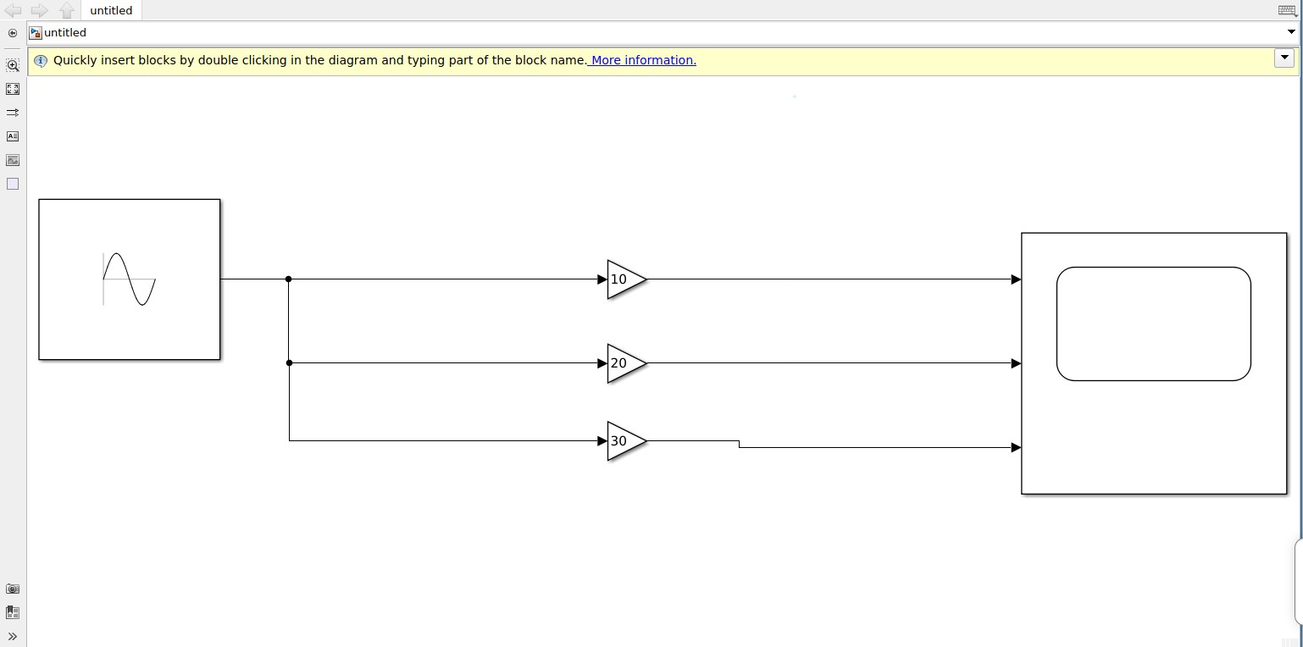
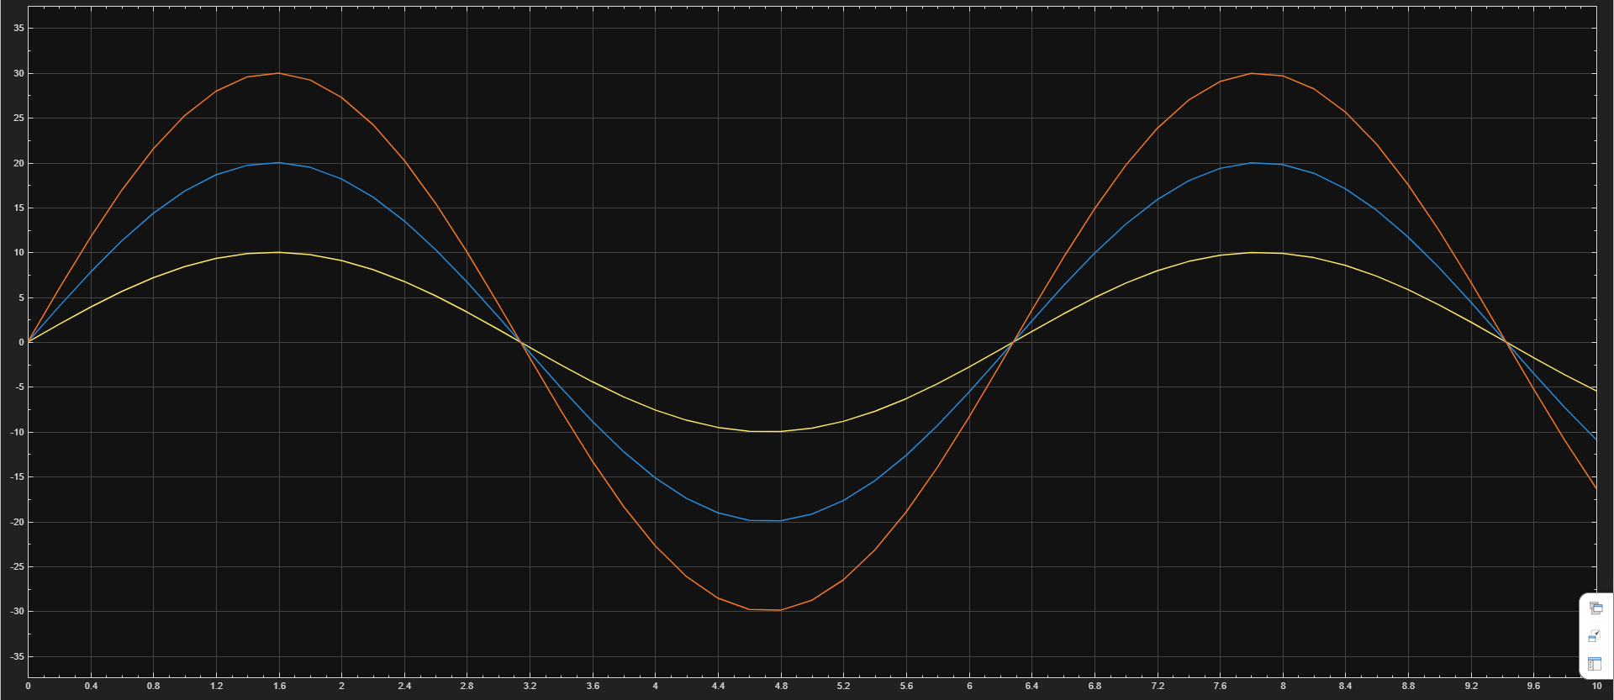
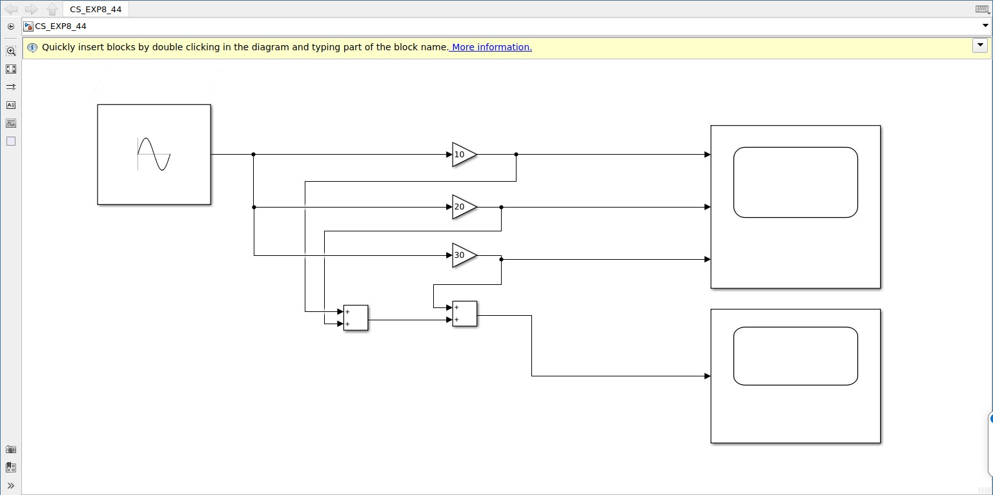
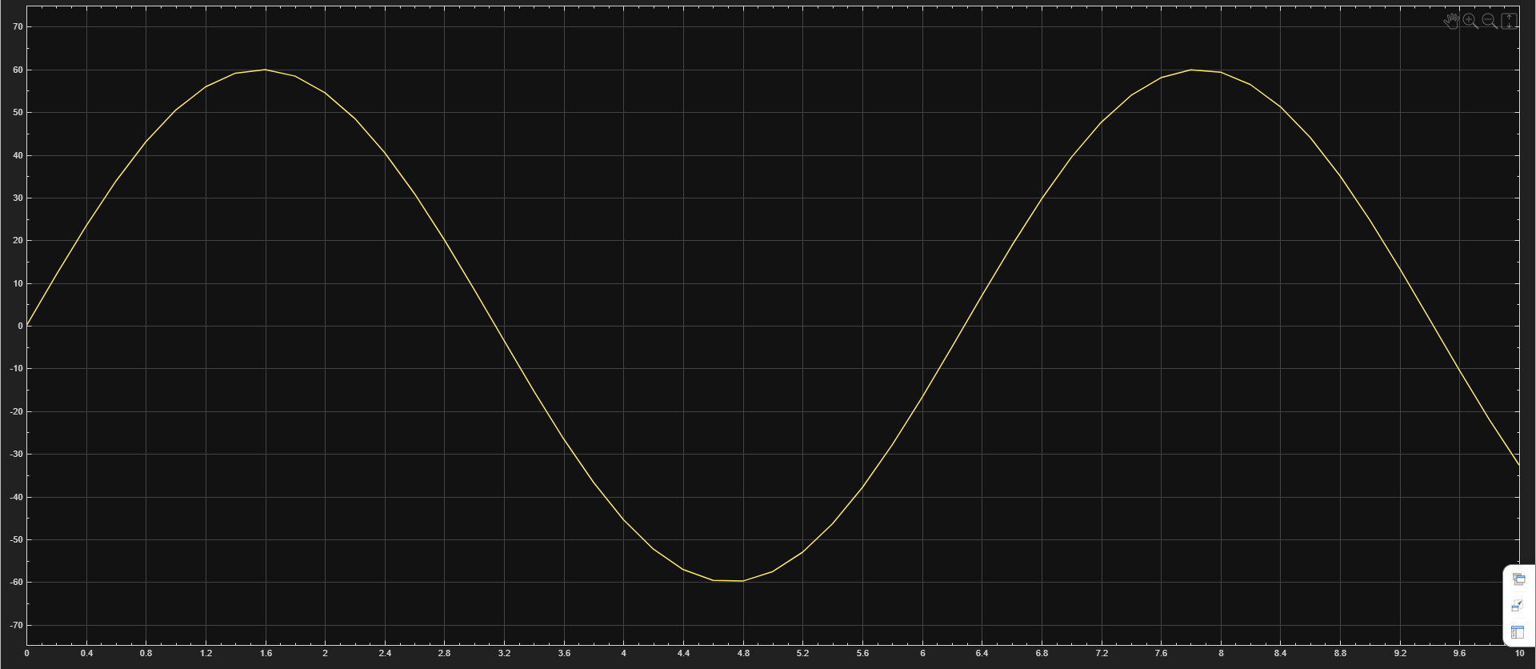

Part 2:

Model:
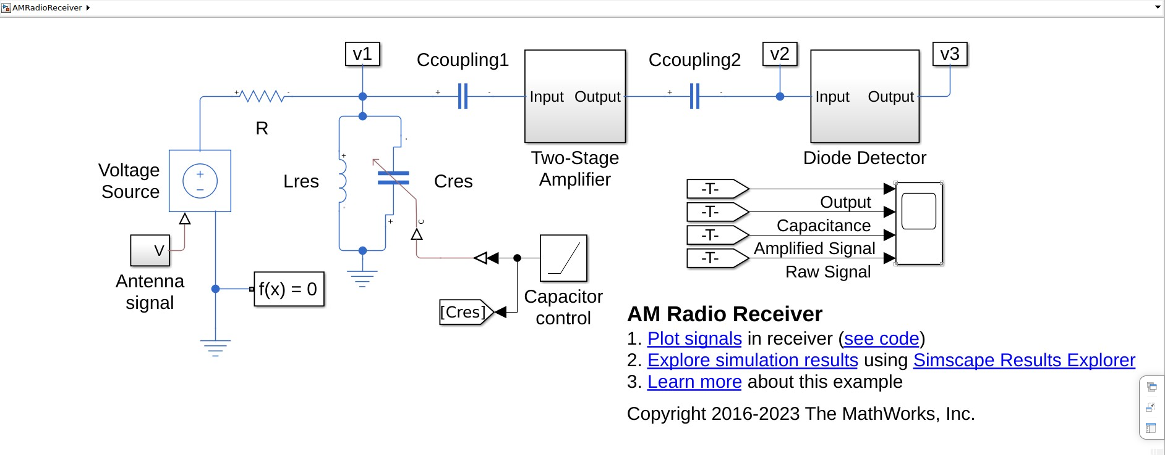
The antenna signal receives the input signal (AM).
The voltage source maintains voltage level when no input exists.
The resistor limits current and stabilizes the circuit.
The LC tank circuit selects the desired frequency while capacitor control allows tuning of stations.
The coupling capacitors allow the AC signals to pass and block DC between stages.
The two-stage amplifier boosts weak signals and the diode detector extracts the original audio signal.
Output points (V1, V2, V3) help observe signal changes and the scope is used to visualize and verify performance.

Antenna signal:
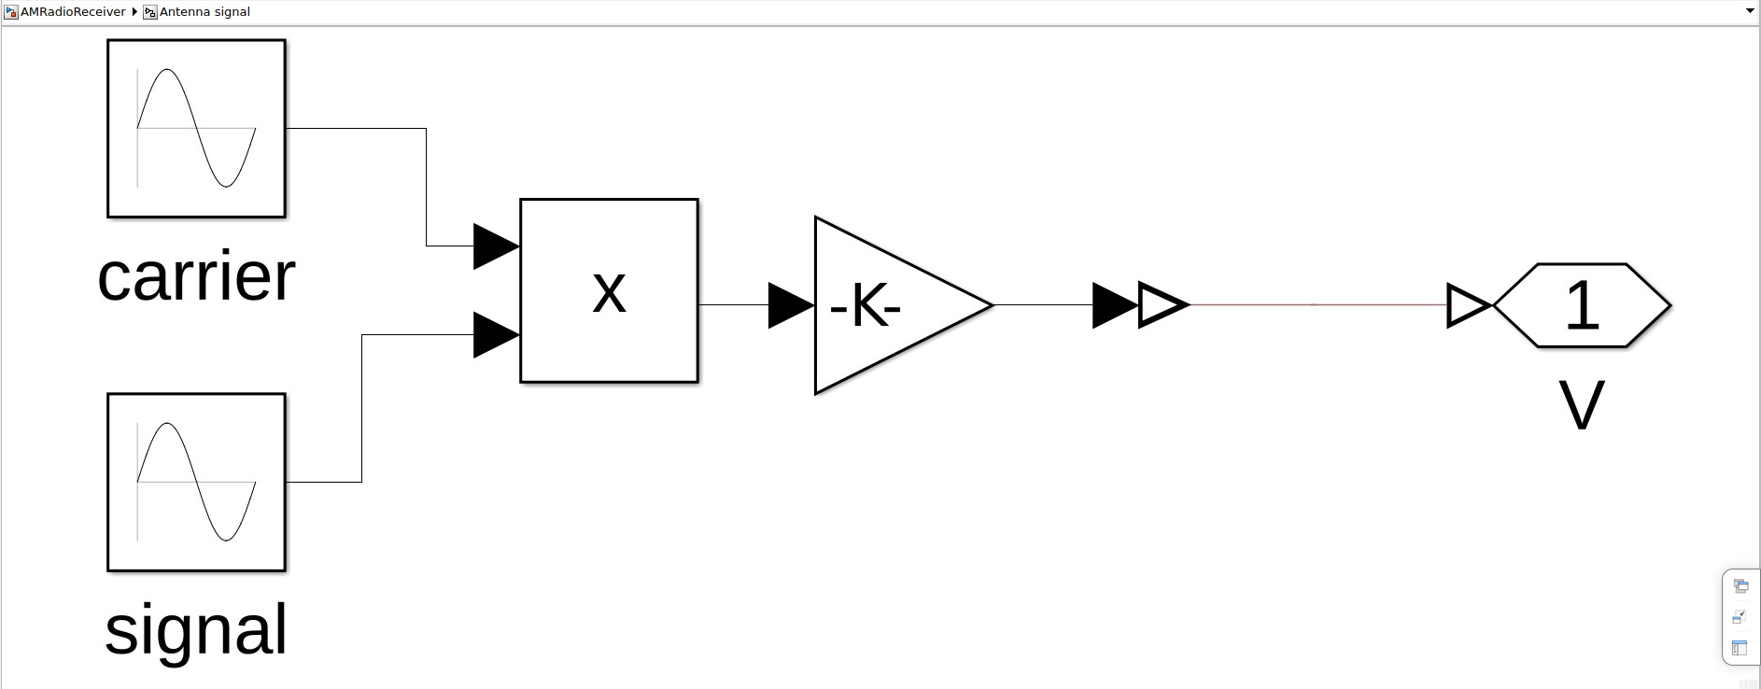
Carrier input: car2*pi*600e3
Signal input: 2*pi*2e3

The antenna signal block generates an AM wave by combining the carrier and message signals using multiplication.

Two stage amplifier:
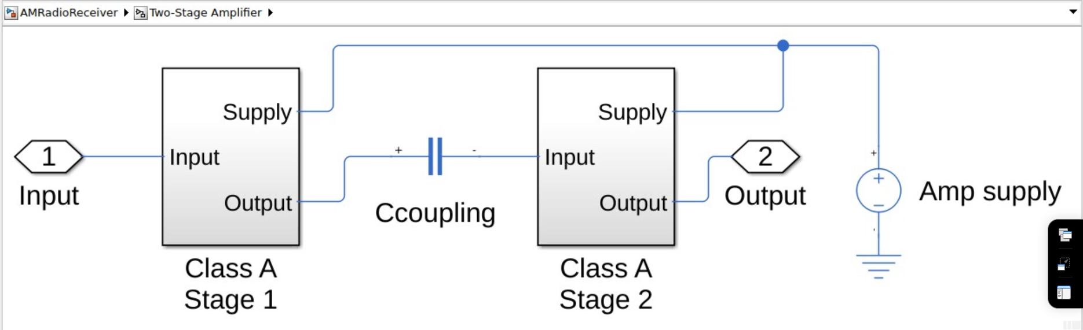

The diode detector rectifies the AM signal and the RC circuit extracts the envelope to recover the original message signal.

Diode Detector:
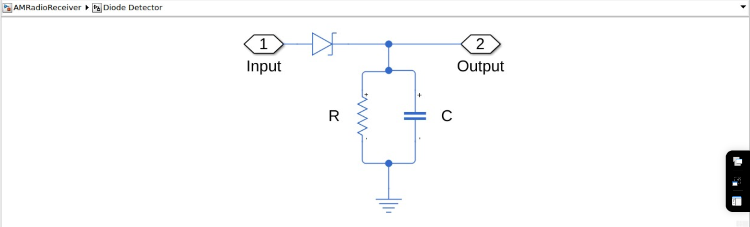

The two-stage Class A amplifier increases signal strength in steps while maintaining low distortion for accurate demodulation.

Output:
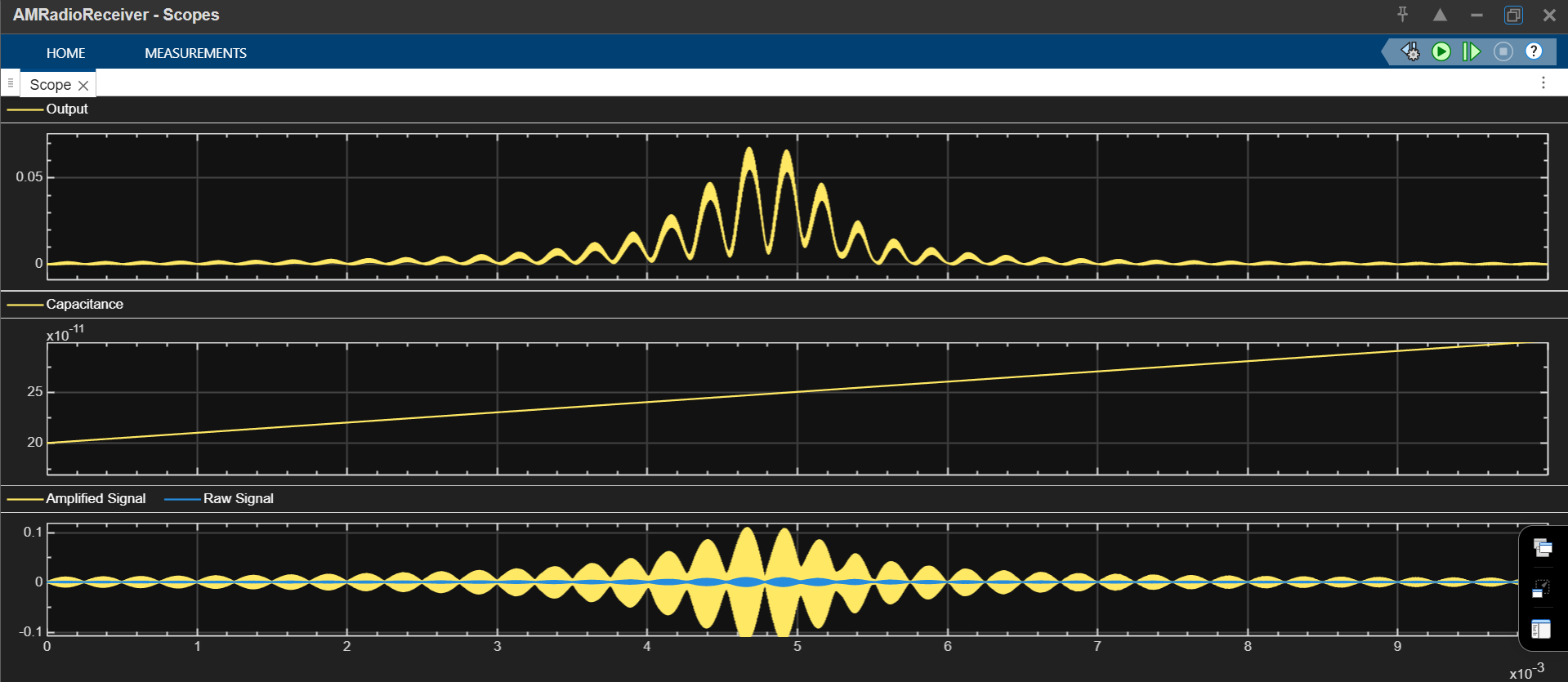

Conclusion:
In this experiment, I learnt how to successfully implement AM receiver in Simulink. The signal was amplified and demodulated correctly, and the output waveform confirms successful recovery of the original message signal. The experiment demonstrates the working of an AM receiver and the role of each stage.

Post Lab Questions
- To facilitate easier and more selective filtering
Reason:
The IF stage converts all received signals to a fixed intermediate frequency, which allows the receiver to use highly selective and stable filters. This improves the ability to separate the desired signal from nearby unwanted signals (noise and interference), making the receiver more efficient and accurate.
- 2100 kHz
IF = 450 kHz
RF = 1200 kHz
Image frequency = RF + 2 × IF
= 1200 + (2 × 450)
= 1200 + 900
= 2100 kHz
- Selectivity: It helps the receiver to pick the desired signal and reject all other unwanted signals.
Sensitivity: It helps the receiver to give output even when the input signal strength is very low.

