Name: Dhairya Shah

Roll no.: 16010324044

Batch: A3

Time Division Multiplexing (TDM):

Theory:
Time Division Multiplexing (TDM) is a technique in which multiple signals share a single communication channel by transmitting them in different time slots. Each signal occupies the channel for a short duration in a cyclic manner. At the receiver, synchronization is used to separate and reconstruct the original signals. TDM is widely used in digital communication systems.

Code:
clc; %clear command window
clear all; %clear variables
close all; %close all open variables

t = 0:0.001:1; %time interval

% Original signals
x1 = sin(2*pi*5*t); %sine wave
x2 = square(2*pi*3*t); %square wave

% TDM Multiplexing
tdm_signal = zeros(1, length(t)*2); %initialize

tdm_signal(1:2:end) = x1; %time slot 1
tdm_signal(2:2:end) = x2; %time slot 2

% Plot original signals
figure;
subplot(2,1,1);
plot(t,x1); title('Original Signal 1 (Sine Wave)');

subplot(2,1,2);
plot(t,x2); title('Original Signal 2 (Square Wave)');

% Plot multiplexed signal
figure;
stem(tdm_signal(1:1000)); %discrete representation of 'plot'
title('TDM Signal');

% DEMULTIPLEXING
y1 = tdm_signal(1:2:end); %recover x1
y2 = tdm_signal(2:2:end); %recover x2

% Plot recovered signals
figure;
subplot(2,1,1);
plot(t,y1); title('Recovered Signal 1');

subplot(2,1,2);
plot(t,y2); title('Recovered Signal 2');

Output:
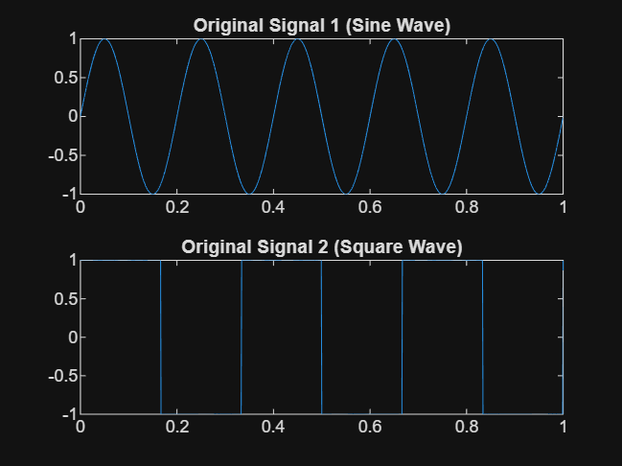
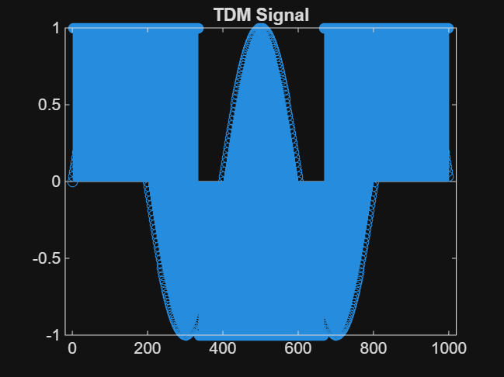
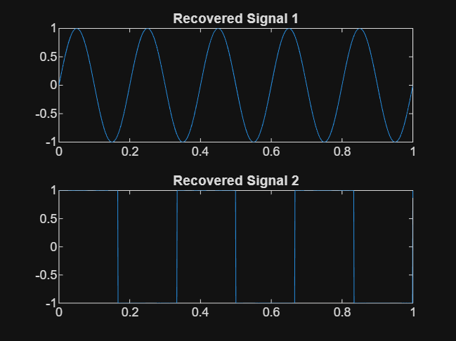

Frequency Division Multiplexing (FDM):

Theory:
Frequency Division Multiplexing (FDM) is a technique where multiple signals are transmitted simultaneously by assigning different frequency bands to each signal. Each signal modulates a different carrier frequency, and all signals are combined for transmission. At the receiver, filters and demodulation are used to recover the original signals.

Code:
clc;
clear all;
close all;

t = 0:0.001:1; %time

% Original signals
m1 = sin(2*pi*5*t); %signal 1
m2 = square(2*pi*3*t); %signal 2

% Carrier signals
c1 = cos(2*pi*50*t);
c2 = cos(2*pi*100*t);

% FDM Multiplexing
s1 = m1 .* c1;
s2 = m2 .* c2;

fdm_signal = s1 + s2;

% Plot original signals
figure;
subplot(2,1,1);
plot(t,m1); title('Original Signal 1');

subplot(2,1,2);
plot(t,m2); title('Original Signal 2');

% Plot multiplexed signal
figure;
plot(t,fdm_signal);
title('FDM Signal');

% DEMODULATION
d1 = fdm_signal .* c1;
d2 = fdm_signal .* c2;

% LOW PASS FILTER
y1 = lowpass(d1,10,1000);
y2 = lowpass(d2,10,1000);

% Plot recovered signals
figure;
subplot(2,1,1);
plot(t,y1); title('Recovered Signal 1');

subplot(2,1,2);
plot(t,y2); title('Recovered Signal 2');

Output:
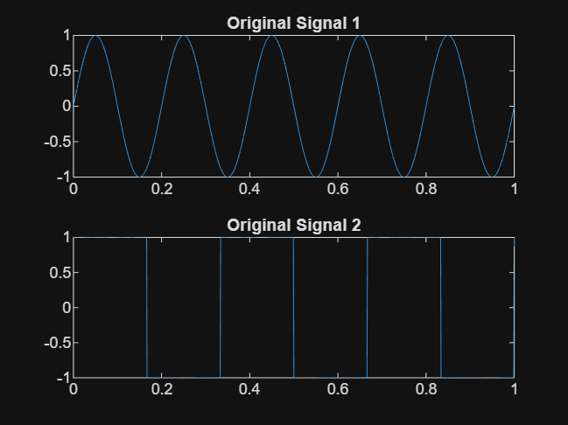
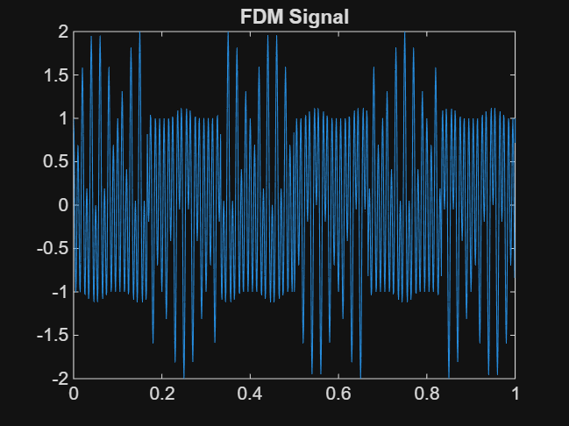
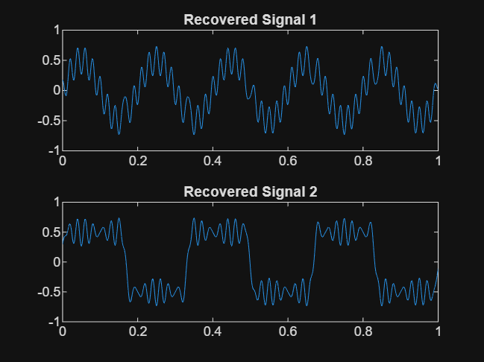

Post Lab Activity:

Code:
clc;
clear all;
close all;

t = 0:0.001:1;

x1 = sin(2*pi*5*t);
x2 = sin(2*pi*10*t);
x3 = sin(2*pi*15*t);

tdm_signal = zeros(1,length(t)*3);

tdm_signal(1:3:end) = x1;
tdm_signal(2:3:end) = x2;
tdm_signal(3:3:end) = x3;

% Plot multiplexed
figure;
stem(tdm_signal(1:1500));
title('TDM with 3 Signals');

% DEMULTIPLEXING
y1 = tdm_signal(1:3:end);
y2 = tdm_signal(2:3:end);
y3 = tdm_signal(3:3:end);

% Plot recovered
figure;
subplot(3,1,1); plot(t,y1); title('Recovered Signal 1');
subplot(3,1,2); plot(t,y2); title('Recovered Signal 2');
subplot(3,1,3); plot(t,y3); title('Recovered Signal 3');

Output:
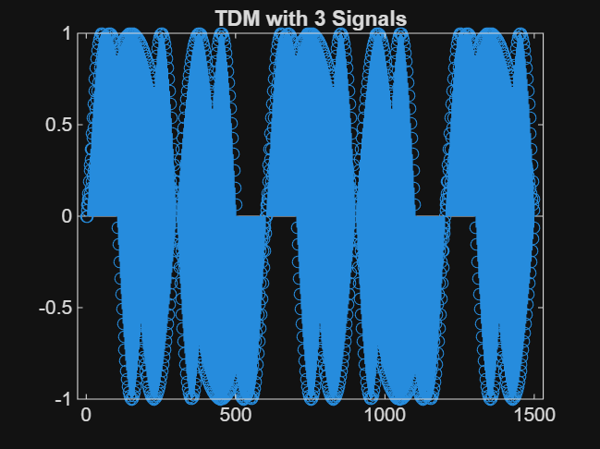
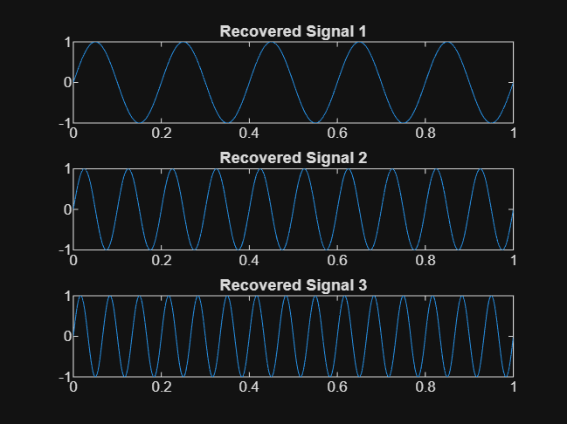

Code:
clc;
clear all;
close all;

t = 0:0.001:1;

m1 = sin(2*pi*5*t);
m2 = sin(2*pi*10*t);
m3 = sin(2*pi*15*t);

c1 = cos(2*pi*50*t);
c2 = cos(2*pi*100*t);
c3 = cos(2*pi*150*t);

s1 = m1 .* c1;
s2 = m2 .* c2;
s3 = m3 .* c3;

fdm_signal = s1 + s2 + s3;

% Plot multiplexed
figure;
plot(t,fdm_signal);
title('FDM with 3 Signals');

% DEMODULATION
d1 = fdm_signal .* c1;
d2 = fdm_signal .* c2;
d3 = fdm_signal .* c3;

% LOW PASS FILTER
y1 = lowpass(d1,10,1000);
y2 = lowpass(d2,10,1000);
y3 = lowpass(d3,10,1000);

% Plot recovered
figure;
subplot(3,1,1); plot(t,y1); title('Recovered Signal 1');
subplot(3,1,2); plot(t,y2); title('Recovered Signal 2');
subplot(3,1,3); plot(t,y3); title('Recovered Signal 3');

Output:
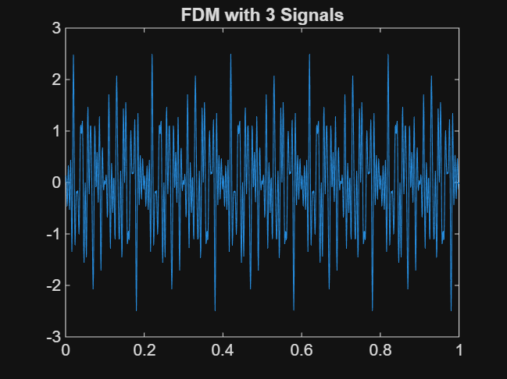
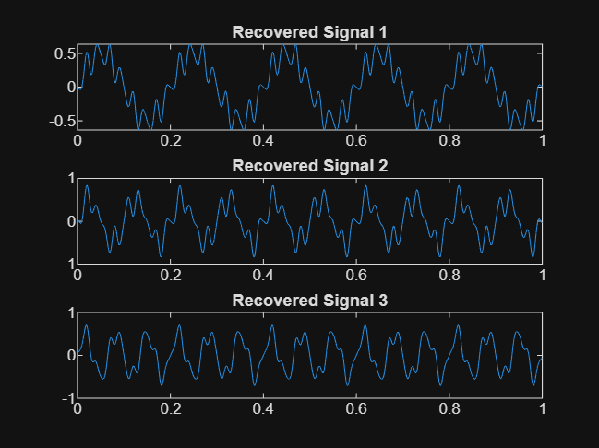

Applications:
TDM:
- Digital telephony
- Data communication systems
- Satellite communication

FDM:
- Radio broadcasting
- Television transmission
- Cable TV

Conclusion:
In this experiment, I learnt how to implement TDM and FDM using MATLAB. TDM multiplexes signals in different time slots, while FDM uses different carrier frequencies. The original signals were successfully recovered using demultiplexing techniques.

