Practice Problems
Module-1

1. Suppose that the number of accidents in non-rainy days is modeled by a Poisson distribution with (unknown) parameter λ.
The number of accidents in 10 randomly chosen non-rainy days is as follows:
4, 0, 6, 5, 2, 1, 2, 0, 4, 3. Find λ, mean, SD and P(x<=2)

2. The total number of hours, measured in units of 1 hour, that a family runs a vacuum cleaner over a period of one year is a continuous random variable X
that has the density function
f(x)=
Find the probability that over a period of one year, a family runs their vacuum cleaner
(a) less than 1.2 hours;
(b) between 0.5 and 1 hour

3
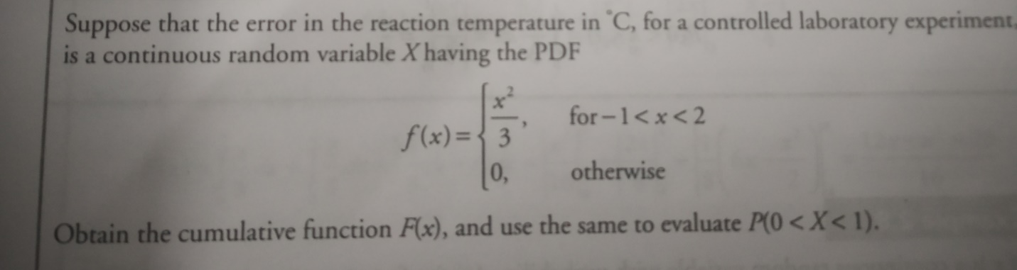

4

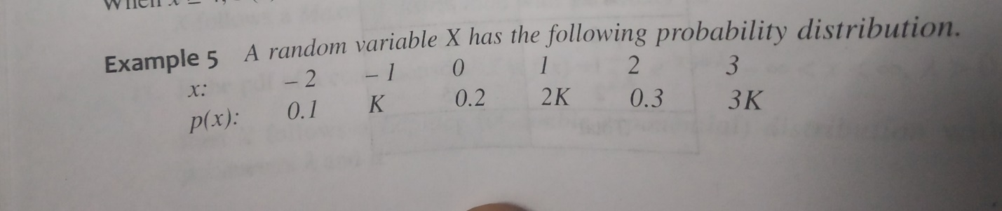
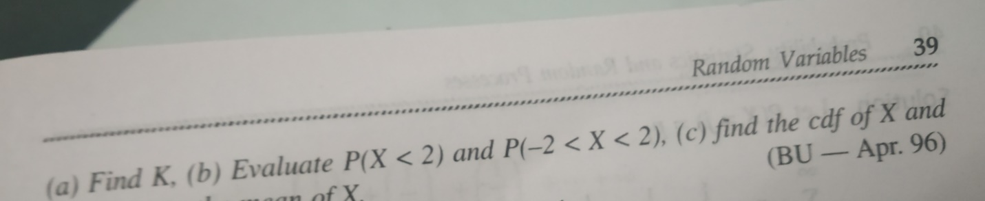

5
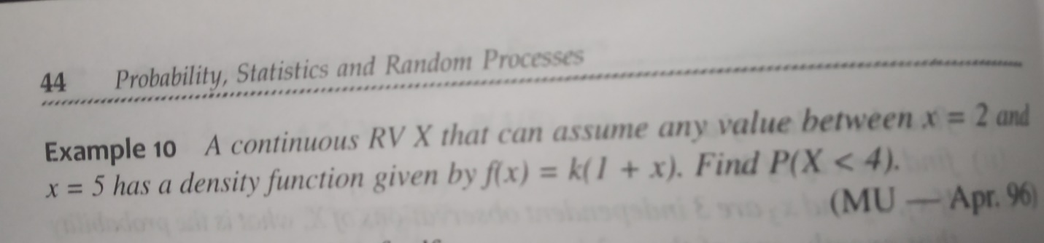

6. If X is N(2, 9), determine Pr(X ≤ 5).
7. Suppose that women’s heights are normally distributed with mean 64 inches & standard deviation 3 inches. What is the probability that a randomly selected woman is under five feet tall?
8. The time till failure of an electronic component has an Exponential distribution and it is known that 10% of components have failed by 1000 hours.
(a) What is the probability that a component is still working after 5000 hours?
(b) Find the mean and standard deviation of the time till failure.
9. A component has a 20% chance of being a faulty follow Binomial distribution. If five are selected from a large batch, what is the probability that more than one is a faulty?
10. A basketball player makes a successful free throw 80% of the time. What is the probability that her first successful shot occurs on the third attempt? Find the mean and the standard deviation of this geometric distribution.
11. A spam filter uses Bayes' theorem to classify emails as spam or not spam. Given:
40% of all received emails are spam.
5% of spam emails contain the word "lottery".
1% of non-spam emails also contain the word "lottery".
If an email contains the word "lottery," what is the probability that it is spam?

12. A medical test for a rare disease has the following properties:
The disease affects 0.1% of the population.
If a person has the disease, the test correctly identifies it 99% of the time (true positive rate).
If a person does NOT have the disease, the test falsely identifies them as having it 5% of the time (false positive rate).
If a randomly chosen person tests positive, what is the probability that they actually have the disease?

