Practice Problems
Module-2
1. A manufacturer of electronic components is interested in determining the lifetime of a certain type of battery. A sample, in hours of life, is as follows:

123, 116, 122, 110, 175, 120, 125, 111, 118, 117.

Represent the data using box plot. From the box plot find the values of range of data, inter-quartile range of data and comment on skewness of a data set

2. Find the coefficient of correlation and Covariance between X and Y
X : 22 26 29 30 31 31 34 35
Y : 20 20 21 29 27 24 27 31

3. The following data give the resting pulse rates and the year of schooling of 10 individuals. are the heights and starting salaries of 12 law school classmates whose law school examination scores
were roughly the same
Year of school: 12, 16, 13, 18, 19, 12, 18, 12, 14, 17
Pulse Rate: 73, 67, 74, 63, 73, 84, 60, 62, 76, 71
i)Represent this data in a scatter diagram
ii) Find the sample correlation coefficient. Comment on the results.

4.A researcher is studying the heights (in cm) and genders (male, female) of students in a class over a semester.

- Define the population and sample for this study.

- Classify the variables height and gender into the appropriate data variable types: qualitative (nominal, ordinal, binary) and quantitative (continuous, discrete).

- Is the dataset described a cross-sectional or time series dataset?

- Determine whether the data is uni-variate, bi-variate, or multi-variate.

- Suppose the researcher records the height and gender of 50 students, calculate the average height if the total height recorded is 8100 cm.

5 A class of 20 students took a math test, and their scores are as follows:
55,67,58,72,90,88,76,64,95,82,73,69,84,91,75,60,85,78,66,70
- Construct a stem and leaf for the test scores
- Draw a histogram and Pie chart

6. Calculate the sample correlation coefficient for two variables,
X = [3, 6, 9, 12, 15] and Y = [8, 10, 12, 14, 16], and interpret the result.

7. For a dataset [20, 22, 24, 26, 28, 30], calculate the five-number summary (minimum, Q1, median, Q3, maximum) and draw a box plot.
8.Calculate the mean, median, mode, sample variance, and standard deviation for the data: [12, 15, 14, 19, 15, 20, 18, 16]. Summarize what these measures tell about the data distribution.

9. Suppose an IT company has two stores that sell computers. The company recorded the number of sales each store made each month. In the past 12 months, we have the following numbers of sold computers:
Store 1:
350, 460, 20, 160, 580, 250, 210, 120, 200, 510, 290, 380.
Store 2:
520, 180, 260, 380, 80, 500, 630, 420, 210, 70, 440, 140.
Draw the box plot for both the companies. Using Box plot find which store performs better. Also write the interpretations, outliers and skewness drawn from the plots.
10. The following stem and leaf plot gives the scores on a statistics exam taken by industrial engineering students.
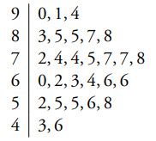
Find
- the Geometric,Harmonic,and Arithmetic mean
- the sample median
- the sample mode

11. Refer to the following graph and answer the question given below:
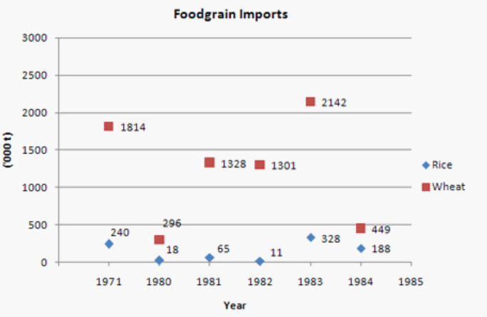
Note: Considering the import values in above graph: in 1971, 240,000 tonnes of rice was imported and 1814,000 tonnes of wheat.

The total values of food grains (rice and wheat) imported during 1983 is Rs. 587 crore.
If the import price of wheat was Rs. 2,400 per tonne in 1983, then what was the import price of rice per tonne during that year?

