Practice Problems
Module-2
1. A manufacturer of electronic components is interested in determining the lifetime of a certain type of battery. A sample, in hours of life, is as follows:

123, 116, 122, 110, 175, 120, 125, 111, 118, 117.

Represent the data using box plot. From the box plot find the values of range of data, inter-quartile range of data and comment on skewness of a data set

Solution:
stem and leaf
11 | 0 1 6 7 8
12 | 0 2 3 5
17 | 5

Box Plot Analysis:
- Range of Data: 65 (175 - 110)
- Inter-Quartile Range (IQR): 6.5 (Q3 - Q1)
  - Q1 (25th percentile): 116.25
  - Median (Q2, 50th percentile): 119.0
  - Q3 (75th percentile): 122.75
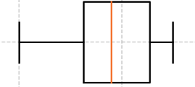

Skewness:
The data set shows right skewness (positive skewness). This is indicated by a longer tail on the right side of the box plot, meaning that there are some higher values (like 175) pulling the mean to the right. The median is closer to Q1 than Q3, further suggesting right skewness.

2. The following data give the resting pulse rates (in beats per minute) and the years of schooling of 5 individuals

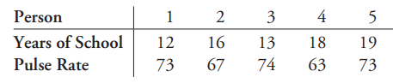

Calculate the sample correlation coefficient for these data. Comment on the correlation between the two variables. Draw Scatter plot between year of school and Pulse rate

Solution:

sample correlation coefficient= -0.4957, Negative correlation
Scatter plot: x-axis: year of school and y-axis: Pulse rate

4.A researcher is studying the heights (in cm) and genders (male, female) of students in a class over a semester.

- Define the population and sample for this study.

- Classify the variables height and gender into the appropriate data variable types: qualitative (nominal, ordinal, binary) and quantitative (continuous, discrete).

- Is the dataset described a cross-sectional or time series dataset?

- Determine whether the data is uni-variate, bi-variate, or multi-variate.

- Suppose the researcher records the height and gender of 50 students, calculate the average height if the total height recorded is 8100 cm.

Solution

1. Define the population and sample for this study.
• Population: All students in the class being studied over the semester.
• Sample: The subset of students whose height and gender are recorded by the researcher.

2. Classify the variables height and gender into the appropriate data variable types: qualitative (nominal, ordinal, binary) and quantitative (continuous, discrete).
• Height: Quantitative (continuous) -
• Gender: Qualitative (nominal) -

3. Is the dataset described a cross-sectional or time series dataset? cross-sectional dataset,

4. Determine whether the data is uni-variate, bi-variate, or multi-variate. bi-variate

5. Suppose the researcher records the height and gender of 50 students, calculate the average height if the total height recorded is 8100 cm. Average height = 162 cm.

5 A class of 20 students took a math test, and their scores are as follows:
55,67,58,72,90,88,76,64,95,82,73,69,84,91,75,60,85,78,66,70
- Construct a stem and leaf for the test scores
- Draw a histogram and Pie chart

Solution:
2.
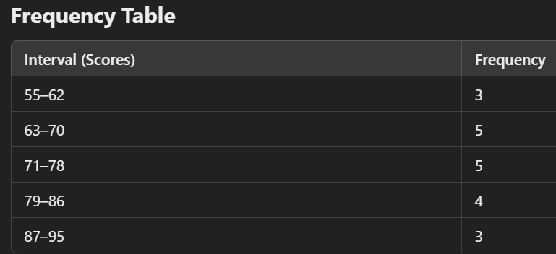
Histogram is BarPlot of class interval Vs frequency
Pie chart is plot of class interval Vs relative frequency

6. Calculate the sample correlation coefficient for two variables,
X = [3, 6, 9, 12, 15] and Y = [8, 10, 12, 14, 16], and interpret the result.
Solution:
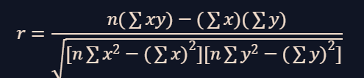
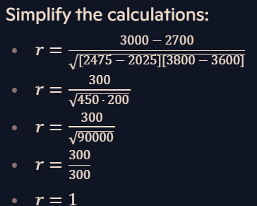

7. For a dataset [20, 22, 24, 26, 28, 30], calculate the five-number summary (minimum, Q1, median, Q3, maximum) and draw a box plot.
Solution:
Min: 20, Q1:22, Q2: 25, Q3:28, Max:30
8.Calculate the mean, median, mode, sample variance, and standard deviation for the data: [12, 15, 14, 19, 15, 20, 18, 16]. Summarize what these measures tell about the data distribution.
Solution:
mean: 16.125, median:15.5, mode:15, Variance: 7.268, standard deviation: 2.695
Overall, the mean and median are quite close, indicating a roughly symmetric distribution.

9. Suppose an IT company has two stores that sell computers. The company recorded the number of sales each store made each month. In the past 12 months, we have the following numbers of sold computers:
Store 1:
350, 460, 20, 160, 580, 250, 210, 120, 200, 510, 290, 380.
Store 2:
520, 180, 260, 380, 80, 500, 630, 420, 210, 70, 440, 140.
Draw the box plot for both the companies. Using Box plot find which store performs better. Also write the interpretations, outliers and skewness drawn from the plots.
Solution:
The five-number summary for Store 1’s sales is (Min20, Q1-180,Q2- 270, Q3-420, Max580.)
Using the same calculations, we can find that the five-number summary for Store 2 is 70, 160, 320, 470, 630
Now, we are ready to draw our comparative double box and whisker plot
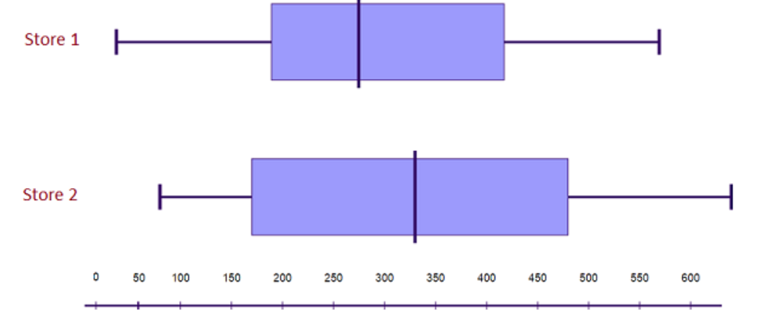
Interpreting the results:
Store 2’s highest and lowest sales are both higher than Store 1’s relevant sales.
In addition, Store 2’s median sales value is higher than Store 1’s. Also, Store 2’s interquartile range is larger. These results tell us that Store 2 consistently sells more computers than Store 1.

10. The following stem and leaf plot gives the scores on a statistics exam taken by industrial engineering students.
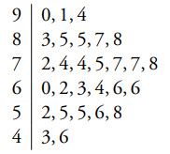
Find
- the Geometric,Harmonic,and Arithmetic mean
- the sample median
- the sample mode
Solution:
- the Arithmatic mean ---70.57. Formula for Geometric,Harmonic mean is given in ppt
- the sample median---73
- the sample mode---no mode

11. Refer to the following graph and answer the question given below:
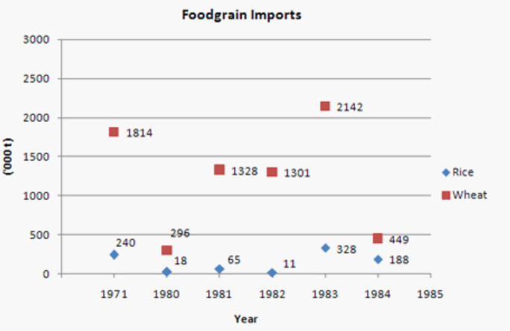
Note: Considering the import values in above graph: in 1971, 240,000 tonnes of rice was imported and 1814,000 tonnes of wheat.

The total values of food grains (rice and wheat) imported during 1983 is Rs. 587 crore.
If the import price of wheat was Rs. 2,400 per tonne in 1983, then what was the import price of rice per tonne during that year?

Solution:
