Practice Problems
Module-4
Hypothesis testing for normal population mean µ when population variance σ² is known: Use Z test

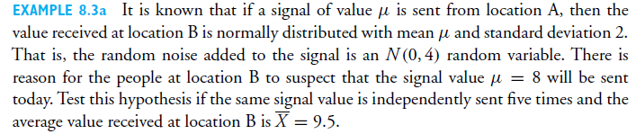
1.

2. Repeat above problem for 1% level of significance. And comment on results

3. 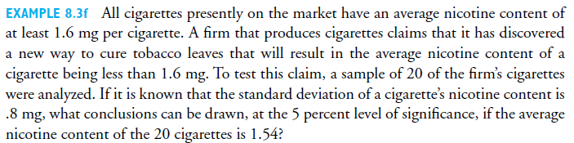

4.


5.


