Batch: A3 Roll No.: 16010324044
Experiment - 1
Grade: AA / AB / BB / BC / CC / CD /DD

Signature of the Staff In-charge with date

TITLE: To read Data from various file formats
AIM: To learn Python commands to read data from various file formats in a dataframe

OUTCOME: Students will be able to effectively read data and save in appropriate format for effective analysis.

Procedure:
Open given Python notebook using Anaconda or Colab. Execute the instructions and fill following observation table

Observation Table:
Procedure Step | Data set : Raisin.csv
 | Variable name\Value\graph | Interpretation\remark
Assignment 1 | 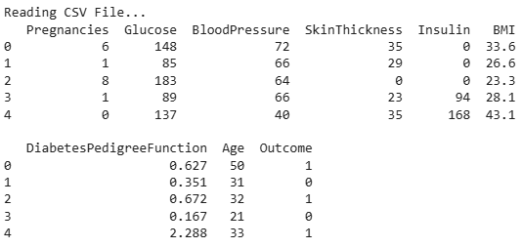 | The output displays the first five rows of the CSV dataset, which helps in understanding the structure of the data, column names, and type of values present. This step is useful for getting a quick overview before performing any further analysis.
Assignment 2 | 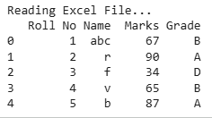 | The displayed records confirm that the Excel file has been read successfully. It verifies that the data is properly loaded into the dataframe and ready for processing or analysis.
Assignment 3 | 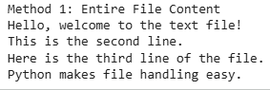 | The complete content of the text file is shown, indicating that the file was read correctly in one go. This confirms proper file access and successful execution of the read operation.
Assignment 4 | 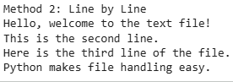 | Here, the text file is read line by line, and each line is printed separately. This demonstrates how files can be processed sequentially, which is useful for large files or when line-wise operations are required.
Assignment 5 | Method 3: File Content as a List  ['Hello, welcome to the text file!\n', 'This is the second line.\n', 'Here is the third line of the file.\n', 'Python makes file handling easy.'] | The output shows the file content stored as a list, where each element corresponds to one line of the text file. This method allows easier manipulation of individual lines using list operations.
Assignment 6 | 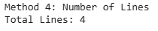 | The program correctly counts the total number of lines in the text file. This confirms that the file traversal logic works properly and the content size is accurately determined.
Assignment 7 | JSON Data:  {'store': 'SuperMart', 'location': 'Mumbai', 'sales': [{'date': '2025-01-01', 'item': 'Laptop', 'units_sold': 5, 'unit_price': 50000, 'total_sales': 250000}, {'date': '2025-01-02', 'item': 'Mobile', 'units_sold': 10, 'unit_price': 15000, 'total_sales': 150000}, {'date': '2025-01-03', 'item': 'Tablet', 'units_sold': 8, 'unit_price': 20000, 'total_sales': 160000}]} | The JSON data is read and displayed in a structured dictionary format. It shows that nested data such as store details and sales records are handled correctly using Python’s JSON handling capabilities.
Assignment 8 | 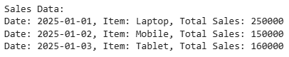 | The processed output presents sales information in a readable format after extracting relevant fields. This makes the raw JSON data easier to interpret and useful for reporting or analysis.
Assignment 9 |  | The output confirms that the SQLite database file was created successfully without any errors. This indicates that the database connection and setup were performed correctly.
Assignment 10 | 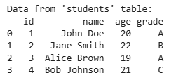 | The retrieved records from the students table confirm that data insertion and retrieval operations were executed properly. The displayed values verify that the database stores and fetches information accurately.

Conclusion: -
This experiment helped us understand how Python can be used to read and handle data from different file formats such as CSV, Excel, text files, JSON files, and SQLite databases. It improved our understanding of file handling techniques and data storage methods. Overall, the experiment showed how data from various sources can be efficiently accessed, processed, and prepared for further analysis using Python.

Signature of faculty in-charge with date

