Course Name: | Principles of Data Science | Semester: | IV
Date of Performance: | 22-01-2026 | Batch No: | A3
Grade/Marks: | /25 | Roll No: | 16010324044

EXPT 2
TITLE: Data Pre-processing and Exploratory Data Analysis (EDA) for Handling Raw Datasets

AIM: To learn how to pre-process raw datasets, explore their structure, clean them, handle missing values, detect outliers, and prepare the data for analysis.

OUTCOME: By the end of this experiment, students will:

1. Understand the importance of data pre-processing in data science.
2. Perform EDA tasks like:
- Loading raw datasets.
- Identifying data issues (missing values, outliers, duplicates, etc.).
- Handling data inconsistencies.
3. Use Python libraries like pandas, numpy, matplotlib and seborn to preprocess and visualize the data.

Procedure Steps:
- Load and Explore the dataset:
  - Import data from CSV files using Python.
  - Display the first few rows using .head() and summarize the dataset using .info() and .describe().
- Check for missing values:
  - Identify missing data using .isnull().sum().
  - Handle missing data using imputation or removal.
- Handle duplicates:
  - Check for duplicate rows using .duplicated().
  - Remove duplicates using .drop_duplicates().
- Handle outliers:
  - Visualize outliers using boxplots.
  - Use techniques to remove or transform outliers.
- Standardize or normalize data:
  - Scale numerical columns to prepare them for further processing.
- Feature engineering:
  - Create new meaningful features.
  - Encode categorical variables.
- Visualize and clean data
  - Use histograms, scatter plots, and correlation heatmaps.
  - Save the cleaned dataset for further analysis

Observation : Use Data set : customer_data_large.csv
Task 1

Summary Function/ Descriptive Analysis
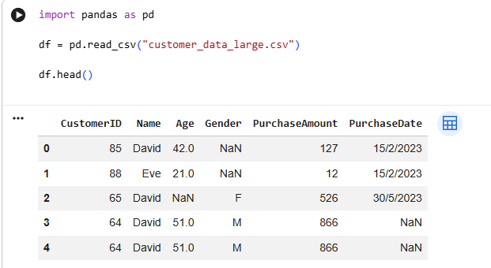
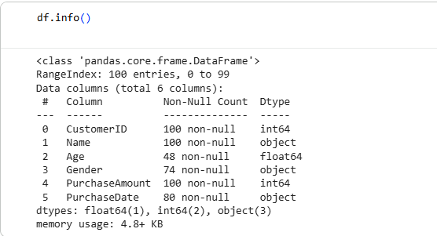
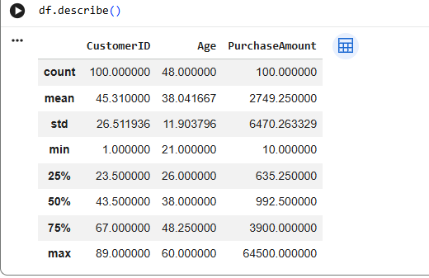

Interpretation/remark
The summary statistics provided a quick overview of the dataset by showing key values such as count, mean, minimum, and maximum. This helped in understanding the overall data distribution and identifying any abnormal or unexpected values at an early stage.

Task 2

Summary Function/ Descriptive Analysis
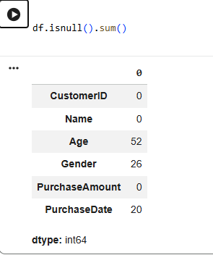
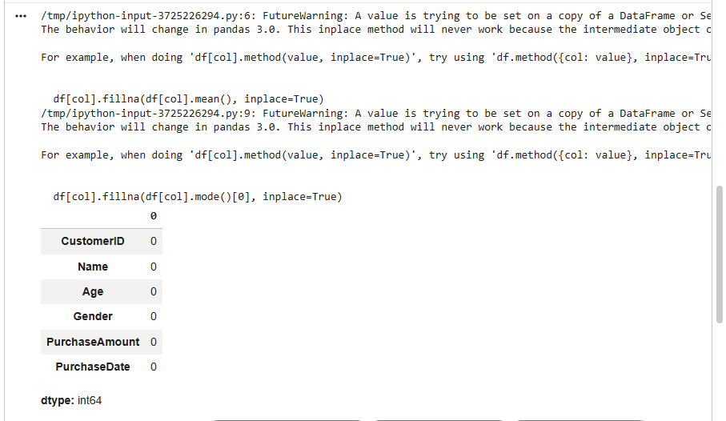

Interpretation/remark
Missing values were detected using null value checks. Handling these missing entries was important to improve data quality and ensure that further analysis and visualization could be performed without errors or misleading results.
Task 3

Summary Function/ Descriptive Analysis
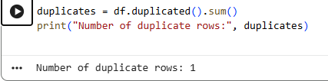
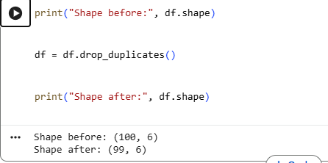

Interpretation/remark
The dataset was checked for duplicate rows to avoid repetition of data. Removing duplicate entries helped maintain data accuracy and ensured that the analysis results were reliable and unbiased.

Task 4

Summary Function/ Descriptive Analysis
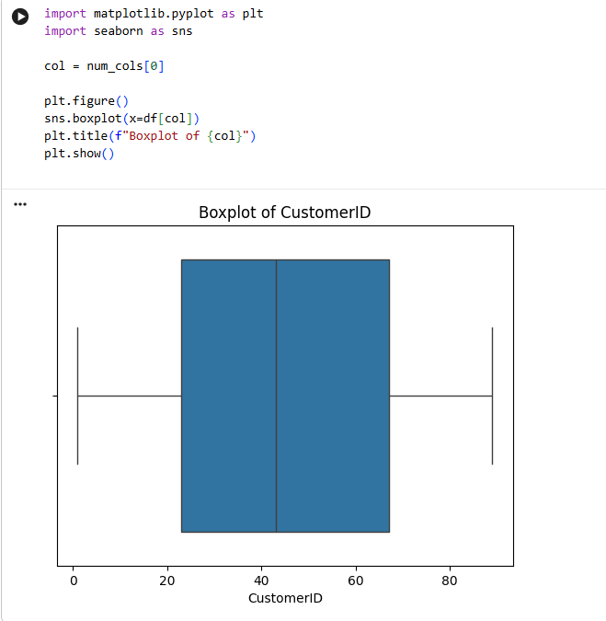
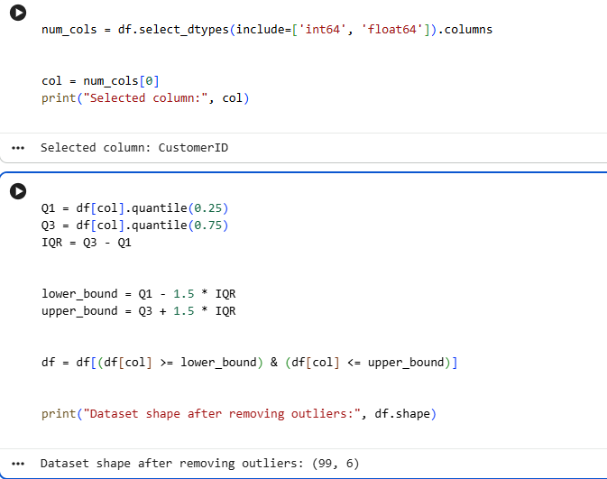

Interpretation/remark
Outliers were identified using boxplots, which made it easier to visually spot extreme values. Detecting and handling outliers is necessary because they can negatively impact statistical analysis and machine learning model performance.

Task 5

Summary Function/ Descriptive Analysis
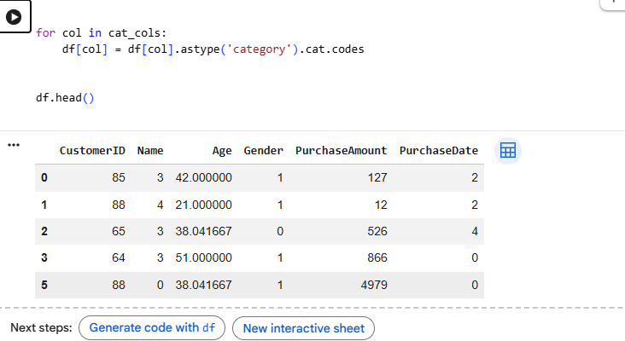

Interpretation/remark
Numerical features were scaled so that all values lie within a similar range. This step is important for algorithms that are sensitive to feature magnitude, as it improves performance and convergence.

Task 6

Summary Function/ Descriptive Analysis
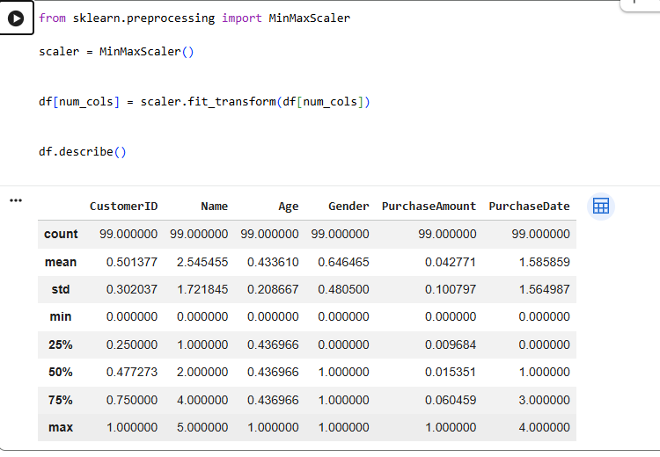

Interpretation/remark
New meaningful features were created, and categorical variables were encoded into numerical form. This step prepared the dataset for machine learning models and made it suitable for further predictive analysis.

Task 7

Summary Function/ Descriptive Analysis
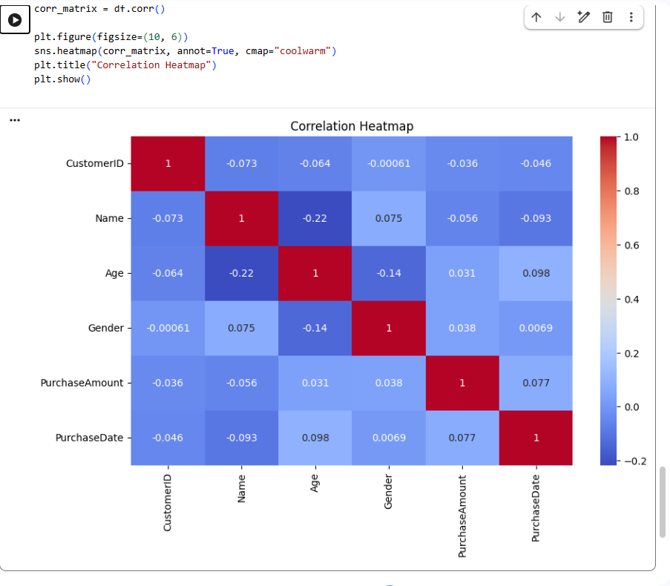
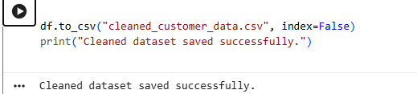

Interpretation/remark
Data visualization techniques such as histograms, scatter plots, and correlation plots were used to understand patterns and relationships within the data. Visual analysis made it easier to interpret trends and draw meaningful insights.

Conclusion:
In this experiment, I learnt about data pre-processing and exploratory data analysis was successfully performed. Through this experiment, we learned how to clean raw datasets, handle missing values and outliers, remove duplicates, scale features, and visualize data effectively. Overall, this experiment helped in understanding the importance of data pre-processing as a crucial step before applying any data analysis or machine learning techniques.

